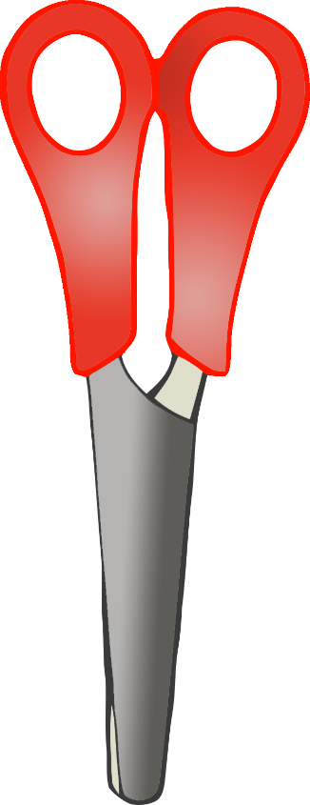

© 2021 Little Owls Resources

Float or Sink