Sink

Float

or

Activity

Science

p2: Activity Card (detailed breakdown of the activity, vocabulary, questions, etc.)

p3: ‘Family Fun’ Activity Cards (shorthand version of the activity to send home)

p4: ‘Float or Sink’ poster (for use with our Science ‘Activity Space’ Banners)

p5-8: A4 Float/Sink posters

p9-11: Float and Sink recording sheets x3

p12-13: Float and Sink *blank* recording sheets x2

p14-16: Float and Sink word cards

p17-19: ‘What did we do?’ sheets (for writing, drawing, or adding a photograph)

p20-22: ‘What did we find out?’ sheets (for writing, drawing, or adding a photograph)

This pack includes…

© 2022 Little Owls Resources



Sink

Float

or

Science

Activity

*Float, sink, heavy, light*

Materials: *metal, wood, plastic, cork*

*Dense, hollow*

Use a water tray in your outdoor area or fill a bowl with water. Put different objects into the water. See above section for suggestions.

Allow young children (under close supervision) to explore playing with appropriate objects in the water. This will give them hands on experience of floating and sinking. Let them repeat the actions and consolidate their experiences. Use the key words ‘sink’ and ‘float’ as each phenomenon is occurring.

Slightly older children will love the build-up of an experiment and the excitement of wondering whether the next item will float or not. They may also enjoy recording their findings by making a mark in the correct box on sheets provided. In addition, children may enjoy sorting the objects after they are tested; creating a pile of ‘float objects’ and ‘sink objects’ or placing them in boxes labelled accordingly.

As older children build up experience, ask them to make predictions. ‘Do you think/predict this metal spoon will sink or float?’ ‘Why?’ ‘What makes you think that?’ ‘What material is the object made from?’ ‘’How heavy/light is it?’ ‘What shape is it?’

As a further development children will love to explore making boats from different materials. Can children explore their own ideas and find something that works?

Extra Challenge!

Investigate density. Test two objects that are about the same size and shape, but one will sink because it is very dense and the other will float as it is not, e.g. ping pong ball vs golf ball.

(Understanding the World)

Key Questions:

(Progressing in difficulty)

Key Vocabulary:

(Progressing in difficulty)

Further resources within this pack. Plus, more ‘Water Play’ resources at

<https://littleowls-premium.com/outdoor-area-water-play>

Did it float? Did it sink? Do you think/predict this object will sink or float? Why do you think that? What is the object made from? How heavy/light is the object? What shape is it? How dense is it?

Additional Resources:

**Birth to 3 –** Repeat actions that have an effect. – Explore materials with different properties. – Explore and respond to natural phenomena in their setting and on trips.

**3 and 4 –** Explore collections of materials with similar and/or different properties. – Talk about what they see using a wide vocabulary. – Explore how things work. – Explore and talk about different forces they can feel. – Talk about the differences between materials and changes they notice.

**Reception –** Explore the natural world around them. **ELG:** Explore the natural world around them, *making observations* and drawing pictures of animals and plants.

Development Matters:

© 2022 Little Owls Resources

Activity Description:

Outdoor water tray or large bowl of water

Objects to test in the water. Examples *(choose objects appropriate for you children and level of supervision):* pencil, cork, wooden spoon, metal spoon, apple, orange, sponge, tin foil, small world toys, balls (various densities will show different outcomes e.g. ping pong vs golf), plastic tub (e.g. empty margarine tub), lolly sticks, lids, leaf, toy brick, stone, stick.

You will need:

Family Fun!

Can you make a boat that floats on water?

Will it allow passengers, e.g. small world toys or a family of leaves?

Before making your boat, perhaps you might like to test some different materials: lolly sticks, sticks, corks, plastic tubs (e.g. margarine), hollowed out fruit with thick skin (e.g. lemon, lime, melon), tin foil.

Good luck! Have fun exploring!

© 2022 Little Owls Resources

Sink

Float

or



Family Fun!

Can you make a boat that floats on water?

Will it allow passengers, e.g. small world toys or a family of leaves?

Before making your boat, perhaps you might like to test some different materials: lolly sticks, sticks, corks, plastic tubs (e.g. margarine), hollowed out fruit with thick skin (e.g. lemon, lime, melon), tin foil.

Good luck! Have fun exploring!

© 2022 Little Owls Resources

Sink

Float

or



Family Fun!

Can you make a boat that floats on water?

Will it allow passengers, e.g. small world toys or a family of leaves?

Before making your boat, perhaps you might like to test some different materials: lolly sticks, sticks, corks, plastic tubs (e.g. margarine), hollowed out fruit with thick skin (e.g. lemon, lime, melon), tin foil.

Good luck! Have fun exploring!

© 2022 Little Owls Resources

Sink

Float

or



Family Fun!

Can you make a boat that floats on water?

Will it allow passengers, e.g. small world toys or a family of leaves?

Before making your boat, perhaps you might like to test some different materials: lolly sticks, sticks, corks, plastic tubs (e.g. margarine), hollowed out fruit with thick skin (e.g. lemon, lime, melon), tin foil.

Good luck! Have fun exploring!

© 2022 Little Owls Resources

Sink

Float

or



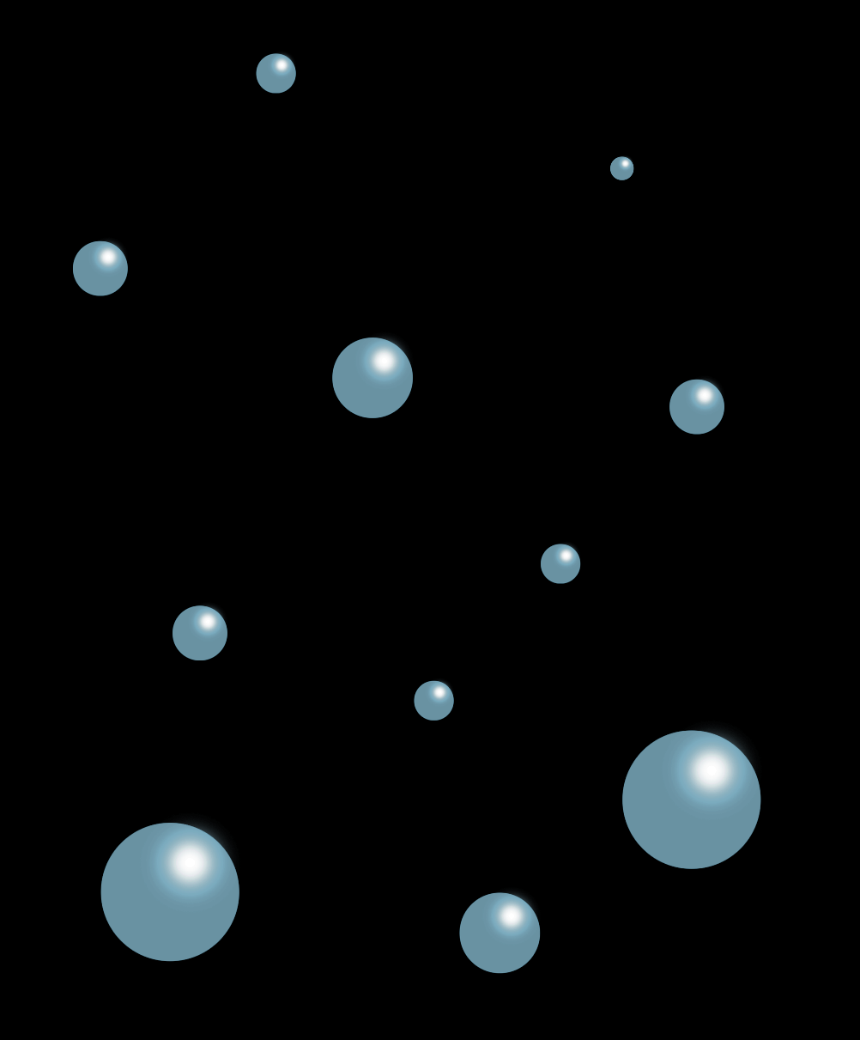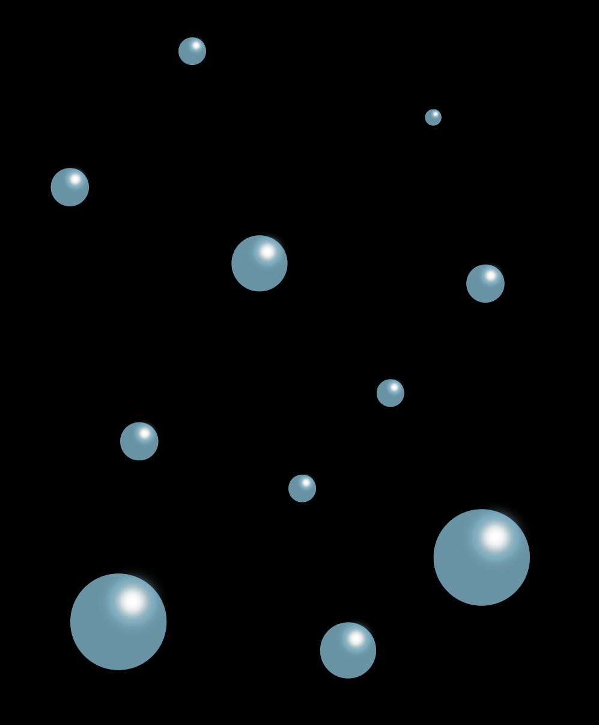

Float

Sink

or

© 2022 Little Owls Resources

*\*For use with the ‘Science Banner’ display.*

Float or Sink

© 2022 Little Owls Resources

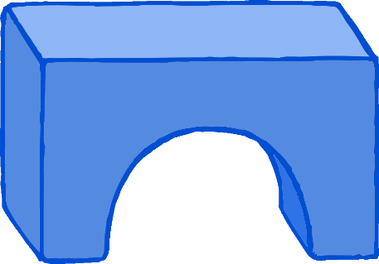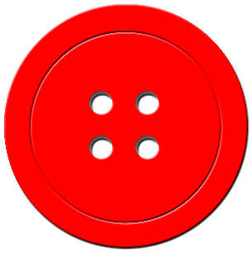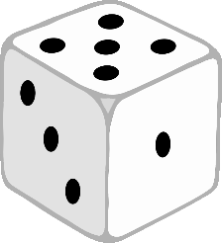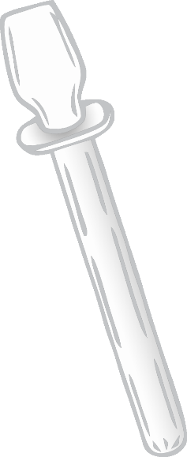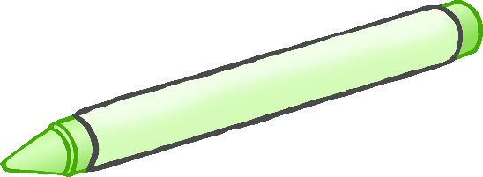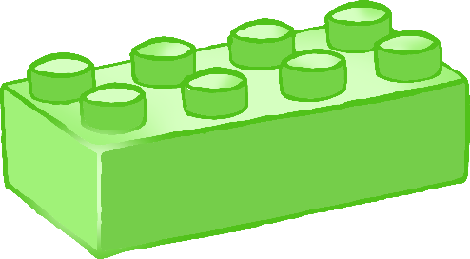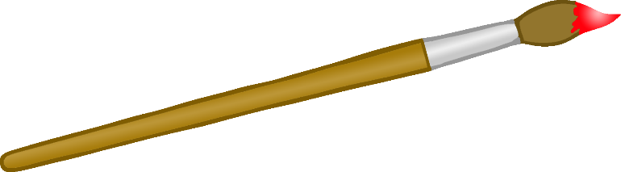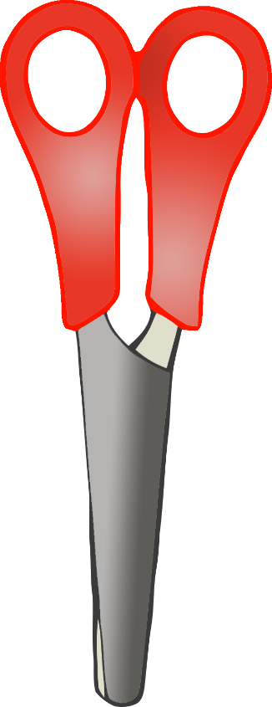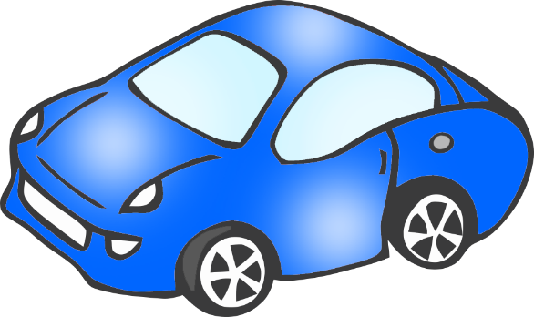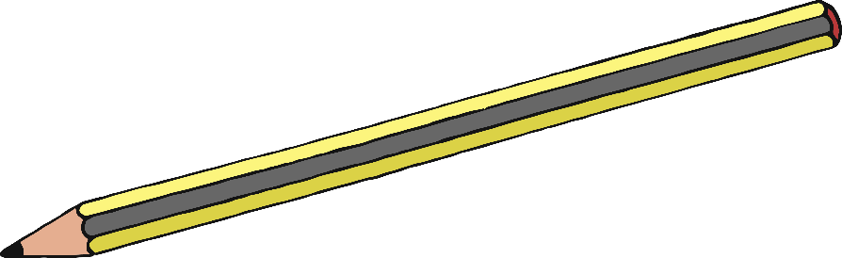

© 2022 Little Owls Resources

Does it… Float?

© 2022 Little Owls Resources

Does it… Sink?

© 2022 Little Owls Resources

Does it…

FloatorSink?

Float or Sink

© 2022 Little Owls Resources

Name:

Sink

Float

Tick Sheet

apple

building brick

toy car

spoon

stone

stick

Float or Sink

© 2022 Little Owls Resources

Name:

Sink

Float

Tick Sheet

plastic tub

wooden spoon

scissors

coin

lolly stick

colander

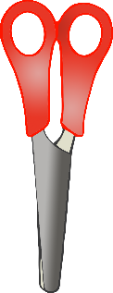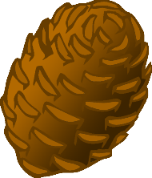

Float or Sink

© 2022 Little Owls Resources

Name:

Sink

Float

Tick Sheet

coin

magnet

cork

pine cone

toy train

foil

Float or Sink

© 2022 Little Owls Resources

Name:

Sink

Float

Tick Sheet

**Float or Sink**

**Tick Sheet**

Name:

© 2022 Little Owls Resources

**Sink**

**Float**

**Sink**

**Float**

sink

© 2022 Little Owls Resources

float

© 2022 Little Owls Resources

heavy

© 2022 Little Owls Resources

light

© 2022 Little Owls Resources

cork

© 2022 Little Owls Resources

plastic

© 2022 Little Owls Resources

metal

© 2022 Little Owls Resources

wood

© 2022 Little Owls Resources

© 2022 Little Owls Resources

__________________________________________________________________

What did we do?

Sink

Float

or

What did we do?

Sink

Float

or



____________________________

© 2022 Little Owls Resources

What did we do?

Sink

Float

or



© 2022 Little Owls Resources

What did we find out?

Sink

Float

or

__________________________________________________________________

© 2022 Little Owls Resources

What did we find out?

Sink

Float

or

____________________________

© 2022 Little Owls Resources

What did we find out?

Sink

Float

or

© 2022 Little Owls Resources