© 2020 Little Owls Resources

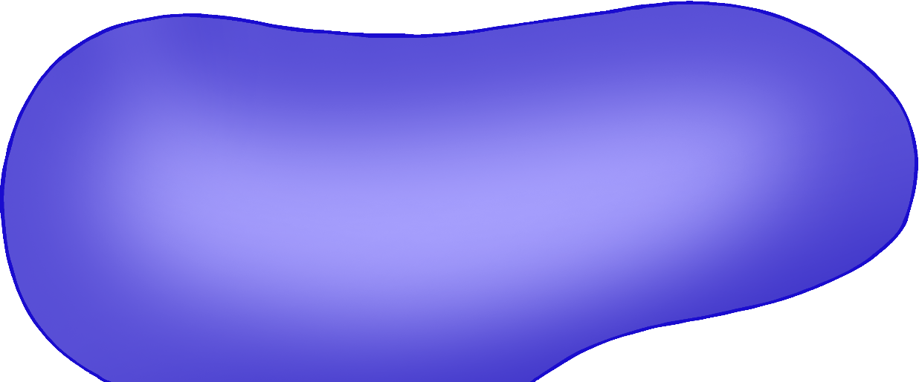

**FIVE** little speckled frogs sat on a speckled log eating some most delicious grubs,

**YUM! YUM!**

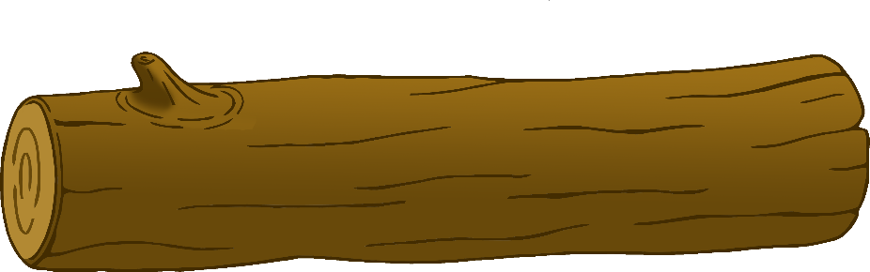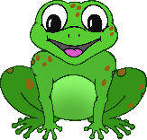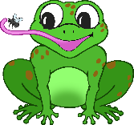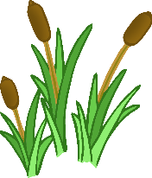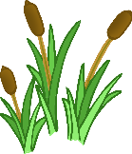

© 2020 Little Owls Resources



One jumped into the pool, where it was nice and cool, then there were **FOUR** green speckled frogs. GLUB! GLUB!

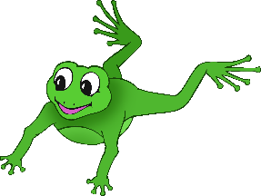

© 2020 Little Owls Resources



**FOUR** little speckled frogs sat on a speckled log eating some most delicious grubs,

**YUM! YUM!**



© 2020 Little Owls Resources



One jumped into the pool, where it was nice and cool, then there were **THREE** green speckled frogs. GLUB! GLUB!



© 2020 Little Owls Resources



**THREE** little speckled frogs sat on a speckled log eating some most delicious grubs,

**YUM! YUM!**



© 2020 Little Owls Resources



One jumped into the pool, where it was nice and cool, then there were **TWO** green speckled frogs. GLUB! GLUB!



© 2020 Little Owls Resources



**TWO** little speckled frogs sat on a speckled log eating some most delicious grubs,

**YUM! YUM!**



© 2020 Little Owls Resources



One jumped into the pool, where it was nice and cool, then there was **ONE** green speckled frog. GLUB! GLUB!



© 2020 Little Owls Resources



**ONE** little speckled frog sat on a speckled log eating some most delicious grubs,

**YUM! YUM!**



© 2020 Little Owls Resources



It jumped into the pool, where it was nice and cool, then there were **NO** green speckled frogs. GLUB! GLUB!

grubs,

**YUM! YUM!**

