Five Little Speckled Frogs - Lollipop Puppets

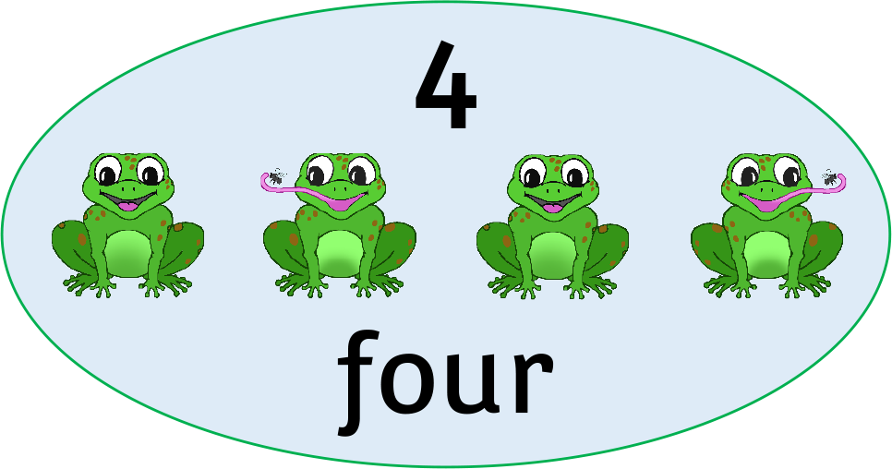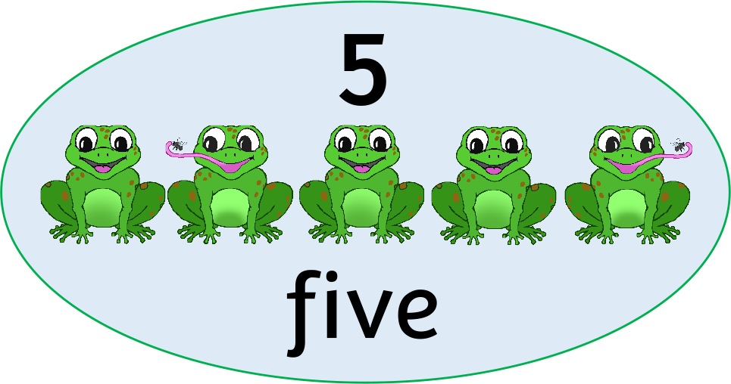

**5**

three

**3**

**4**

four

five

one

**1**

two

**2**