© 2022 Little Owls Resources

**Five** little speckled frogs sat on a speckled log eating some most delicious grubs.

Five Little Speckled Frogs

Illustration Activity

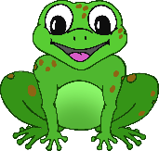

**5**

© 2022 Little Owls Resources

**Four** little speckled frogs sat on a speckled log eating some most delicious grubs.

Five Little Speckled Frogs

Illustration Activity



**4**

© 2022 Little Owls Resources

**Three** little speckled frogs sat on a speckled log eating some most delicious grubs.

Five Little Speckled Frogs

Illustration Activity



**3**

© 2022 Little Owls Resources

**Two** little speckled frogs sat on a speckled log eating some most delicious grubs.

Five Little Speckled Frogs

Illustration Activity



**2**

© 2022 Little Owls Resources

**One** little speckled frogs sat on a speckled log eating some most delicious grubs.

Five Little Speckled Frogs

Illustration Activity



**1**