**Fireworks**

Draw and Write

These sheets are intended to encourage children to record their fireworks experiences. They are differentiated by amounts of expected writing.

© 2022 Little Owls Resources

**Fireworks**

Draw and Write

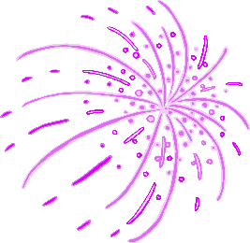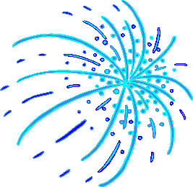

© 2022 Little Owls Resources

**Fireworks**

Draw and Write



© 2022 Little Owls Resources

________­­­­­­­­­­­­­­­­­­­______________________

______________________________

______________________________

______________________________

­______________________________

______________________________

­______________________________

______________________________

**Fireworks**

Draw and Write



© 2022 Little Owls Resources

**________­­­­­­­­­­­­­­­­­­­______________________**

**______________________________**

**______________________________**

**______________________________**

**­______________________________**

**______________________________**

**­______________________________**

**Fireworks**

Draw and Write



© 2022 Little Owls Resources

**______________________________________________________**

­**______________________________________________________**

**______________________________________________________**

**______________________________________________________**

**______________________________________________________**

**______________________________________________________**

**______________________________________________________**