1

Crouch down small… wait… then stretch up tall with a **WOOOOSH!**

2

**2**

© 2019 Little Owls Resources

© 2019 Little Owls Resources

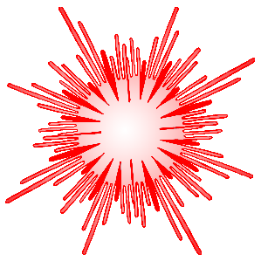

Fireworks

Activity

Challenge!

**Rocket**

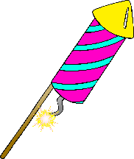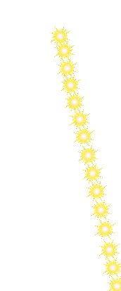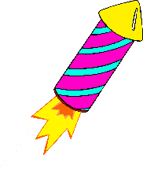

Fireworks

Activity

Challenge!

Pretend you have a sparkler in your hand. Move your arm in circles!

**Sparkler**



3

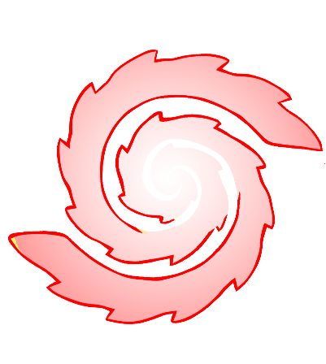

4

**2**

Put your hands together above your head and shimmer left and right like… **flickering flames**

Put your arms out wide then twirl 3 times…

**Twirl! Twirl!**

**Catherine Wheel**

© 2019 Little Owls Resources

© 2019 Little Owls Resources

Fireworks

Activity

Challenge!

Fireworks

Activity

Challenge!

**Bonfire**

5

6

**2**

Start small… stretch tall… then…

Stretch your body WIDE!!

**BOOM!**

Stretch your arms up and then out wide. Then flick your fingers like popping fireworks…

**Pop! Pop! Pop! Pop!**

**Big Boom**

**Popping Fireworks**

© 2019 Little Owls Resources

© 2019 Little Owls Resources

Fireworks

Activity

Challenge!

Fireworks

Activity

Challenge!