**Firework Safety**

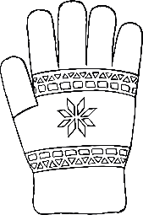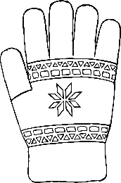

© 2019 Little Owls Resources

ALWAYS stand back from fireworks and stay close to an adult.

NEVER pick up a sparkler if you drop it.

ALWAYS wear gloves for holding sparklers.

NEVER go near a firework after it is lit, even if the spark goes out.