Fold along here before laminating

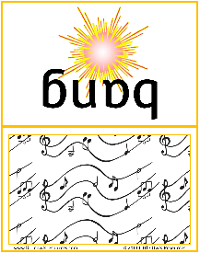

**Firework Rhythm Music**

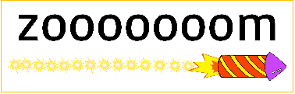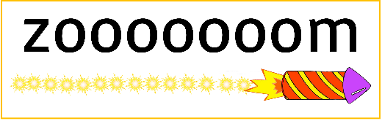

These cards are intended to be used to engage the children’s sense of rhythm and their enjoyment of making sounds!

The cards are different lengths to illustrate the length of the sound to be made; from the longest (zooooooom) to the shortest (pop).

*(For those that are musically minded, the ‘zooooooom’ is a minim, the ‘bang’ is a crotchet, the ‘pop’ is a quaver and the blank card is a crotchet rest.)*

You could introduce the sounds to the children first, for example getting them to say the long sound ‘zoooooom’ a few times in a row. Then showing them that the ‘bang’ sound is shorter and two bangs are equal to one zoooooom! You could follow this by showing the cards so that they have a visual cue as you develop different rhythms with them.

A repeating pattern would be a good place to start. For example…

**HAVE FUN!**

When the children are comfortable with ‘zooooooom’ and ‘bang’. Try introducing the short ‘pop’ sound and the rest card…

zooooooom



© 2019 Little Owls Resources

zooooooom



© 2019 Little Owls Resources



bang



bang

© 2019 Little Owls Resources

© 2019 Little Owls Resources



bang



bang

© 2019 Little Owls Resources

© 2019 Little Owls Resources

pop



pop



pop



pop



© 2019 Little Owls Resources

© 2019 Little Owls Resources

© 2019 Little Owls Resources

© 2019 Little Owls Resources

pop



pop



pop



pop



© 2019 Little Owls Resources

© 2019 Little Owls Resources

© 2019 Little Owls Resources

© 2019 Little Owls Resources

© 2019 Little Owls Resources

© 2019 Little Owls Resources

rest

rest

© 2019 Little Owls Resources

© 2019 Little Owls Resources

rest

rest