Whooooosh!

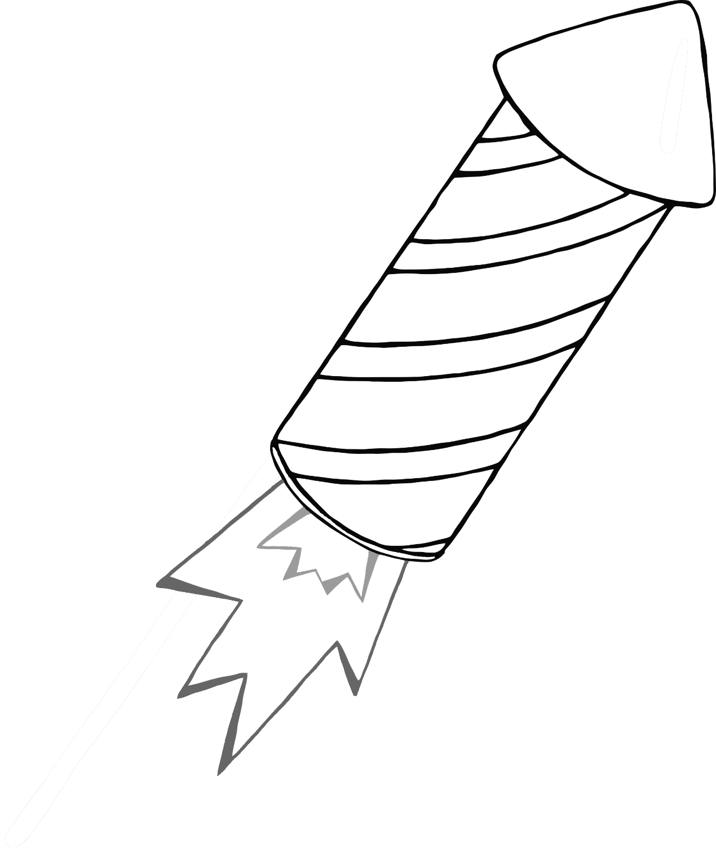

Bang!

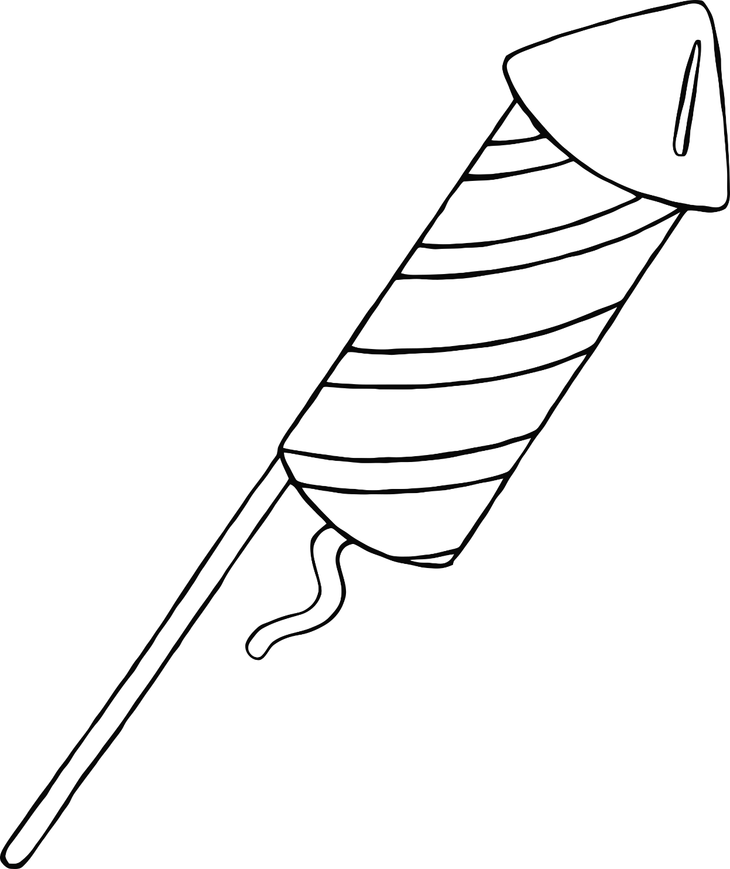

Fzzzzzzzzzzz!

**Reeeeeeeeeeeeeeeeeee!**

BOOM!

Crack!

Pop!