**Firework Checklist** ✔️✔️✔️

What colour fireworks did you see?

© 2020 Little Owls Resources

**Firework Checklist** ✔️✔️✔️

leaves

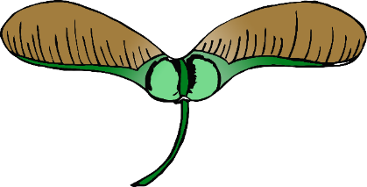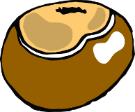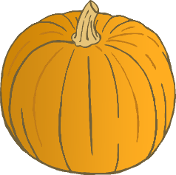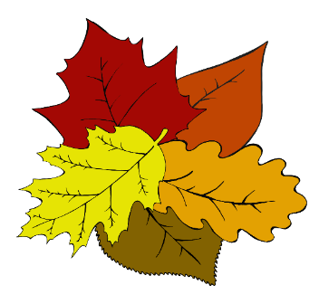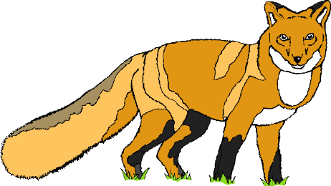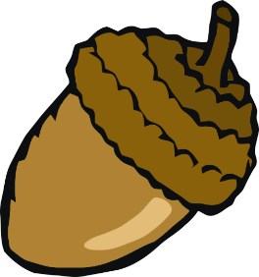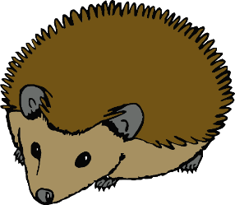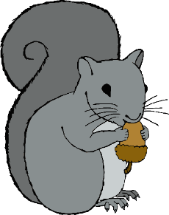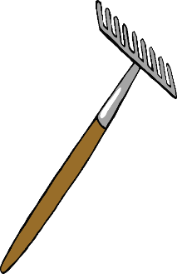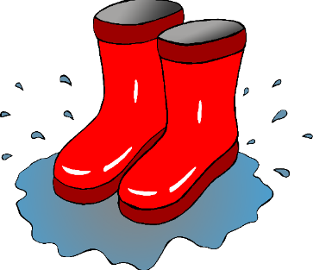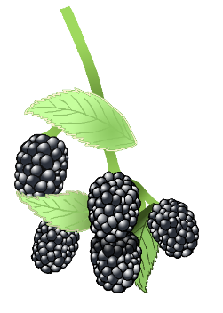

orange

purple

green

yellow

blue

red

What colour fireworks did you see?

© 2020 Little Owls Resources

conker

sycamore seeds

pumpkin

fox

acorn

hedgehog

squirrel

rake

fungus

blackberries

wellies