**Fingerprint Autumn Leaves**

Add leaves on the tree outline by fingerprinting using autumnal colours; red, yellow, brown, orange, etc.

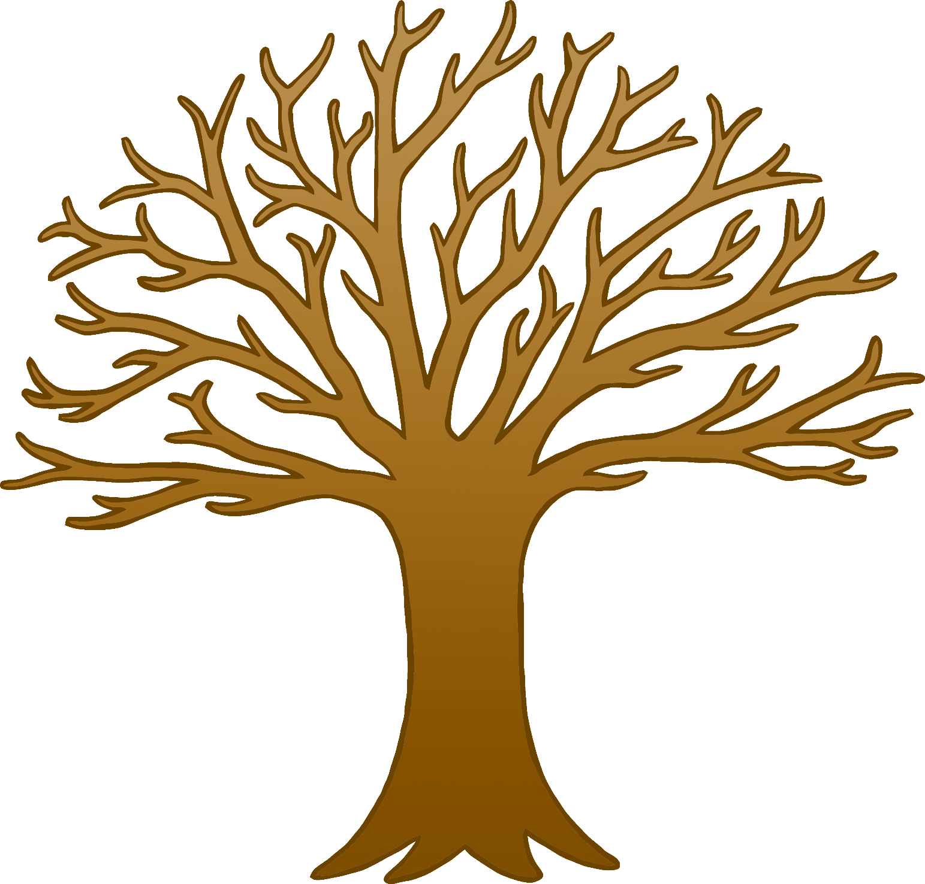

© 2020 Little Owls Resources

**Fingerprint Autumn Leaves**

