Finger-paint Acorns

7

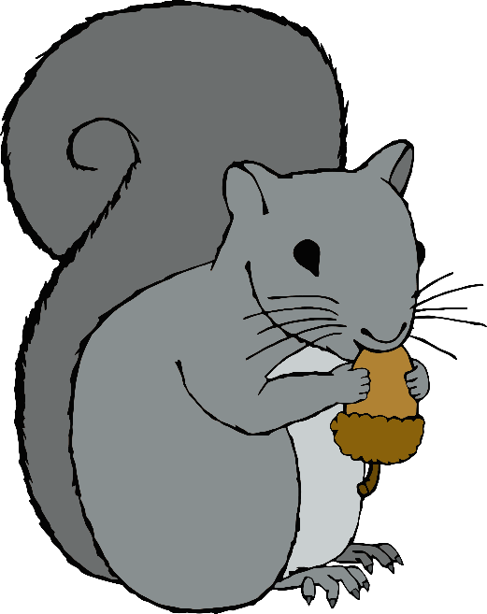

I

2



3



4



5



6



7



8



9

1010