© 2020 Little Owls Resources

Numbered sheets to fingerpaint acorns. Sheets can also be used to draw or collect acorns.

*The third sheet is blank to allow numbers to be written in.*

Fingerpaint Squirrel Acorns

© 2020 Little Owls Resources

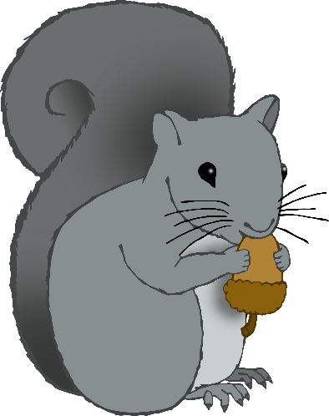

3

5

7

6

**Can you make the right number of acorns for the squirrel?**

© 2020 Little Owls Resources



4

8

6

5

**Can you make the right number of acorns for the squirrel?**

© 2020 Little Owls Resources



**Can you make the right number of acorns for the squirrel?**