Valentine’s Day

© 2022 Little Owls Resources

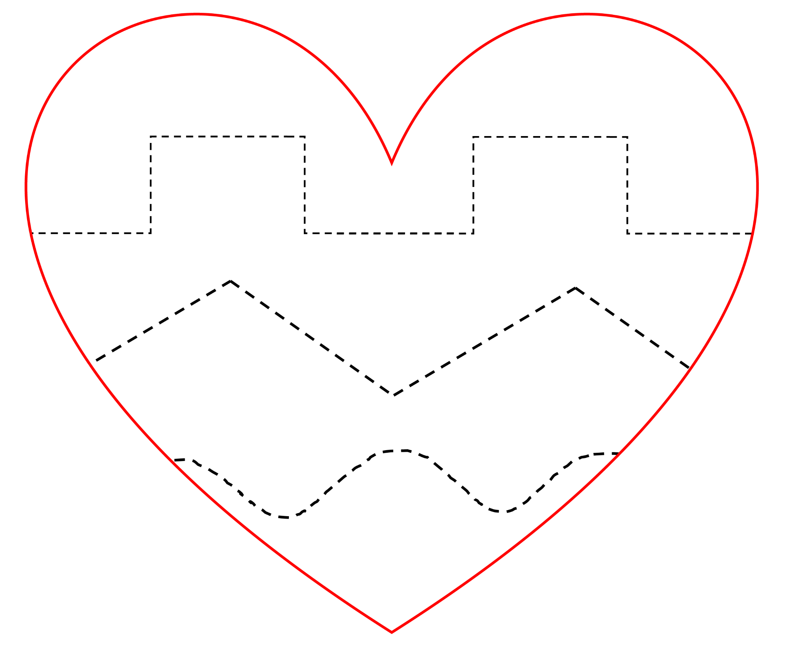

These hearts have dotted lines that can be cut with scissors or traced using a pencil. Alternatively, the sheets can be laminated and then reused with a whiteboard pen.

Fine motor cutting/pencil control

© 2022 Little Owls Resources

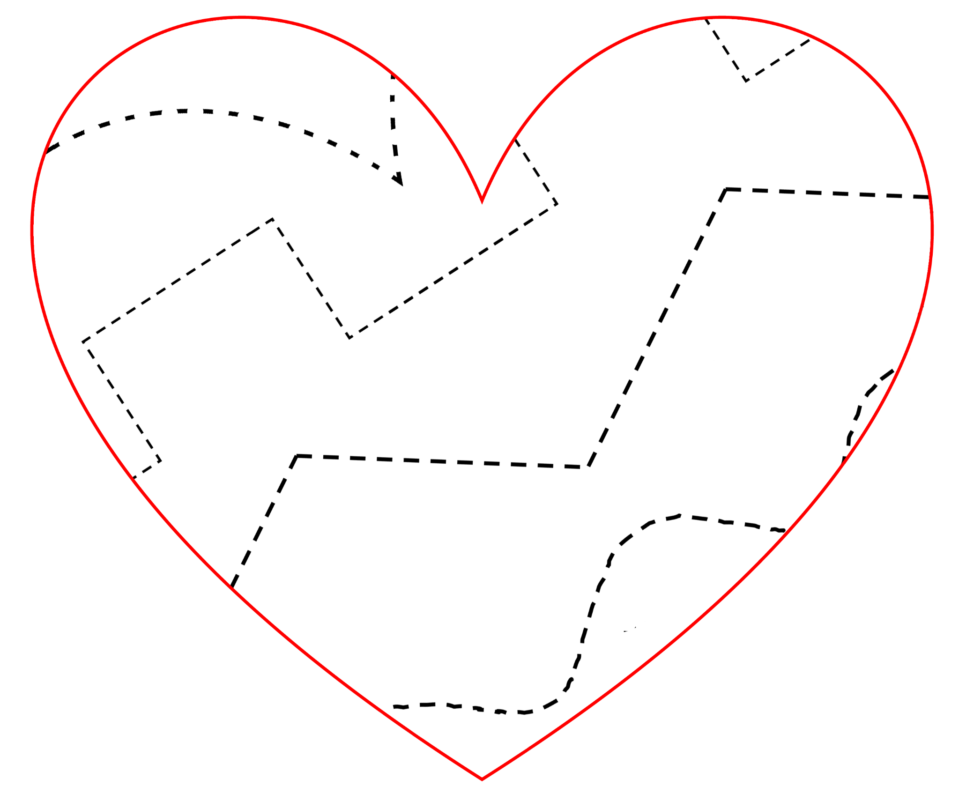

© 2022 Little Owls Resources

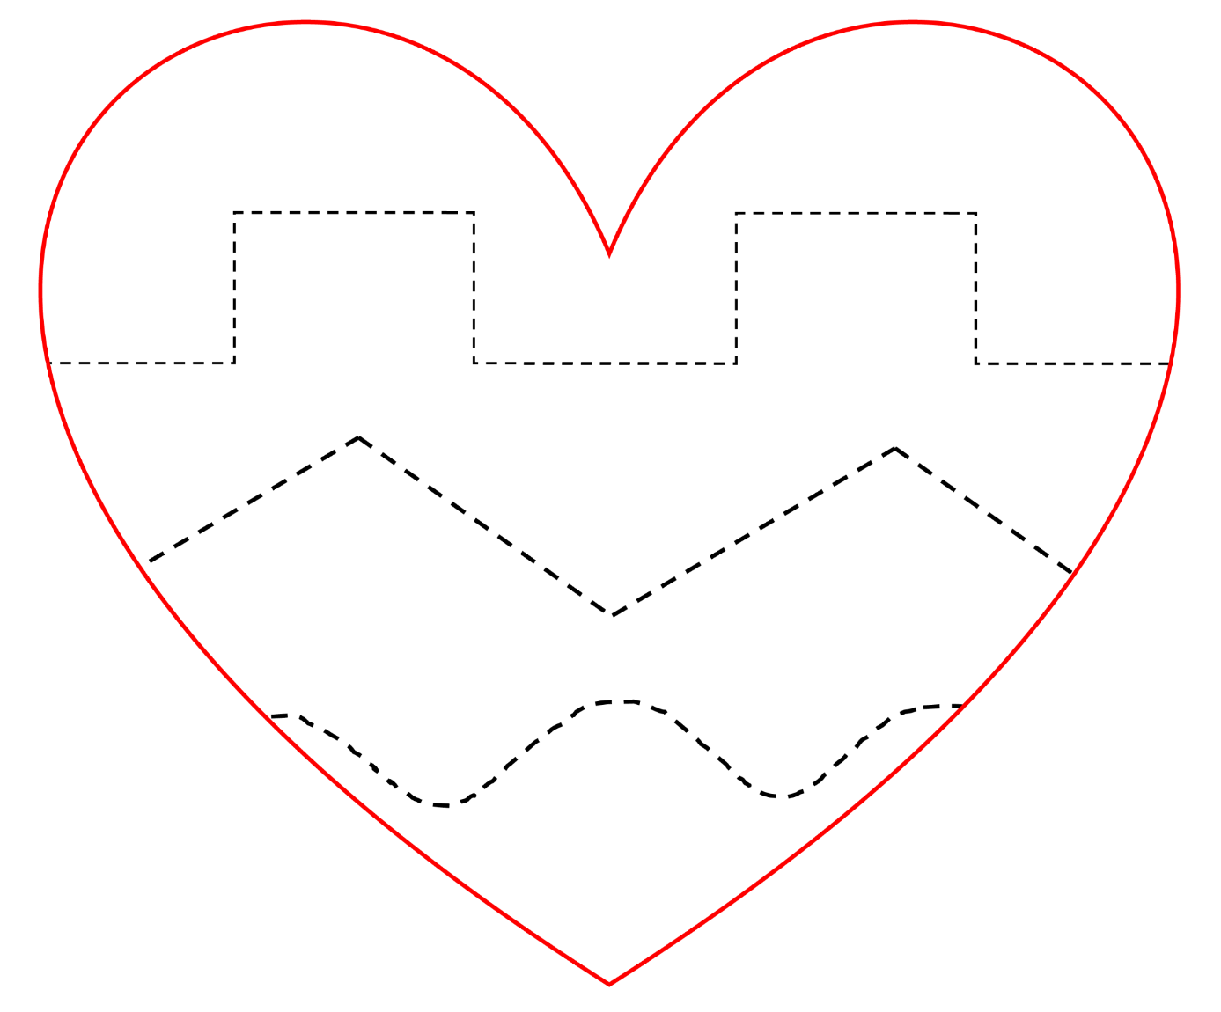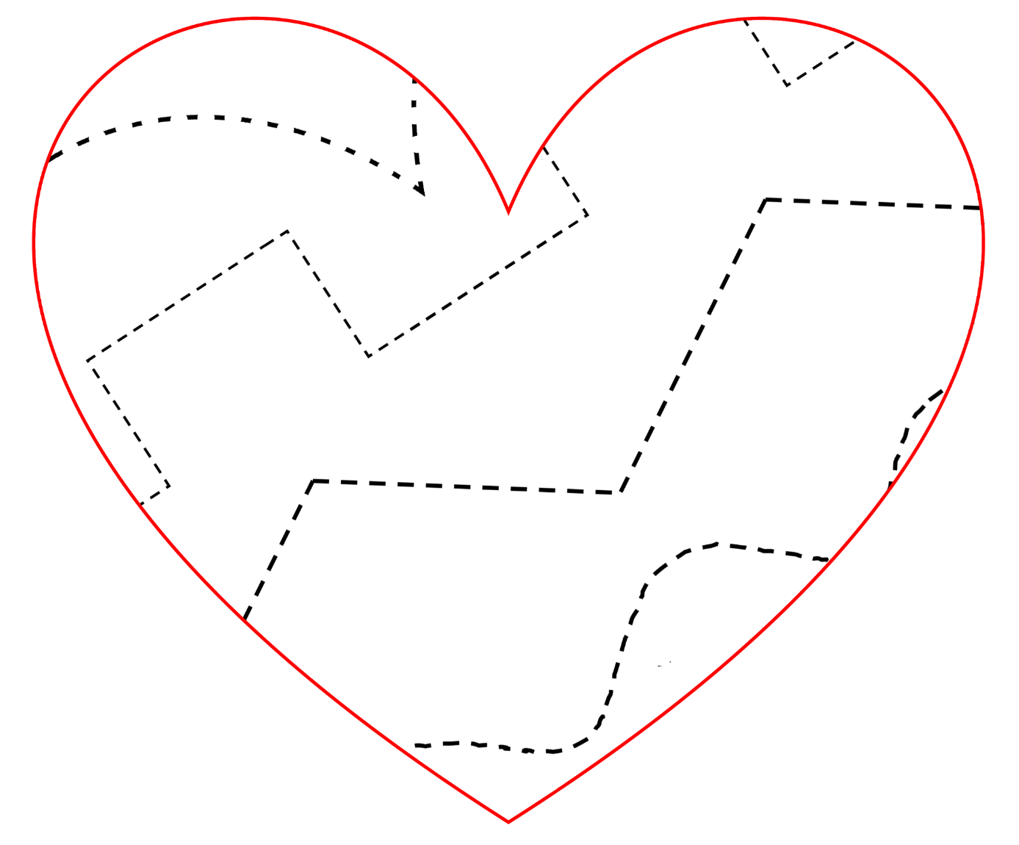

© 2022 Little Owls Resources