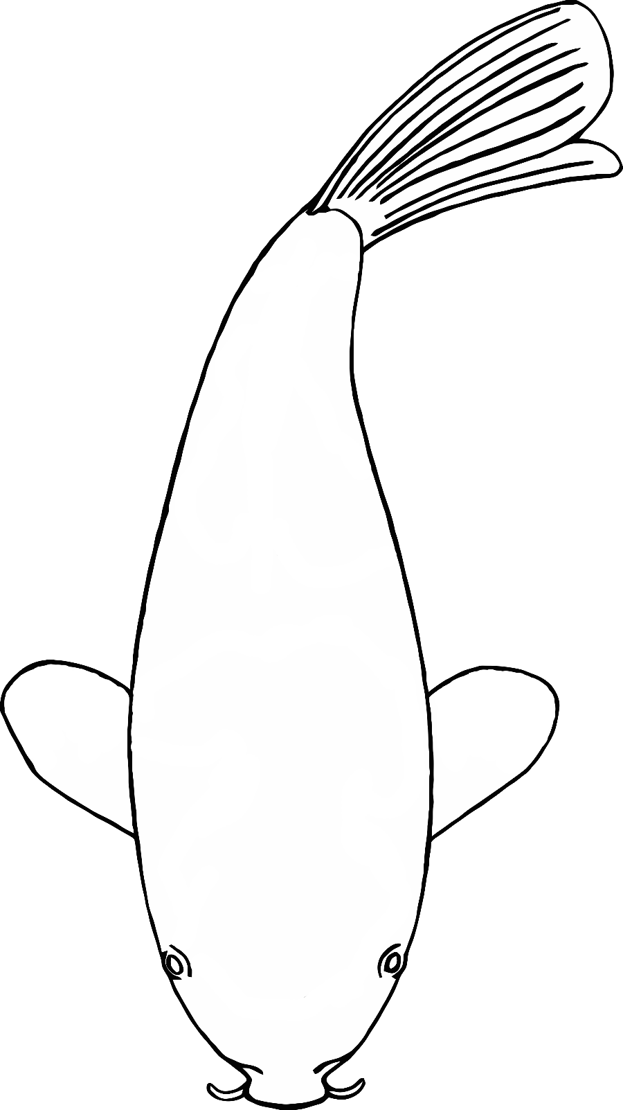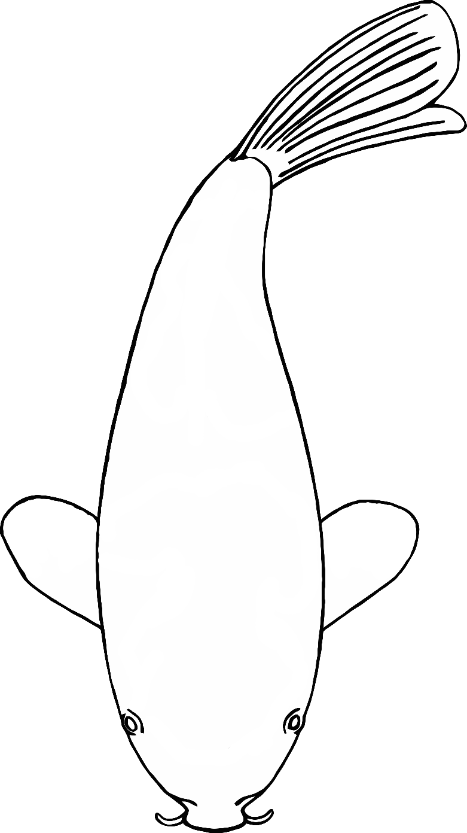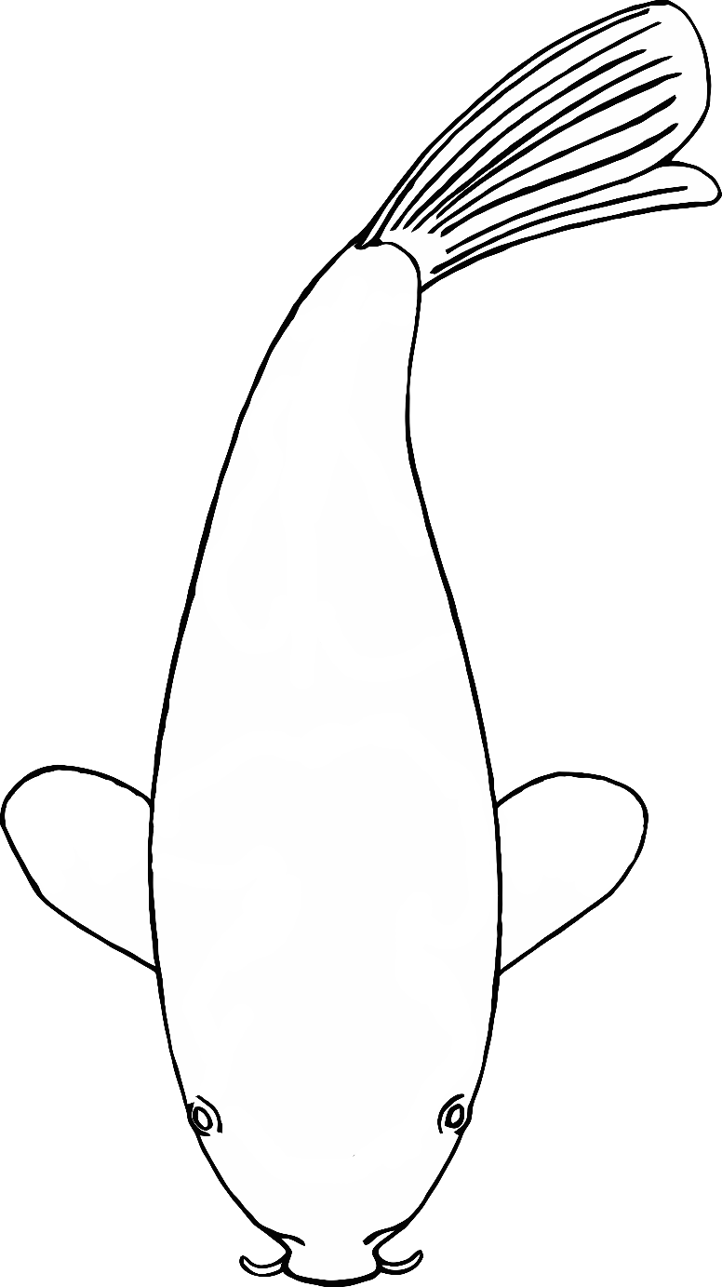

Fine Motor Control Fish (1)

© 2020 Little Owls Resources



© 2020 Little Owls Resources

Fine Motor Control Fish (2)



© 2020 Little Owls Resources

Fine Motor Control Fish (3)



© 2020 Little Owls Resources

Fine Motor Control Fish (4)

Fine Motor Control Fish (5)

© 2020 Little Owls Resources



Fine Motor Control Fish (6)

© 2020 Little Owls Resources