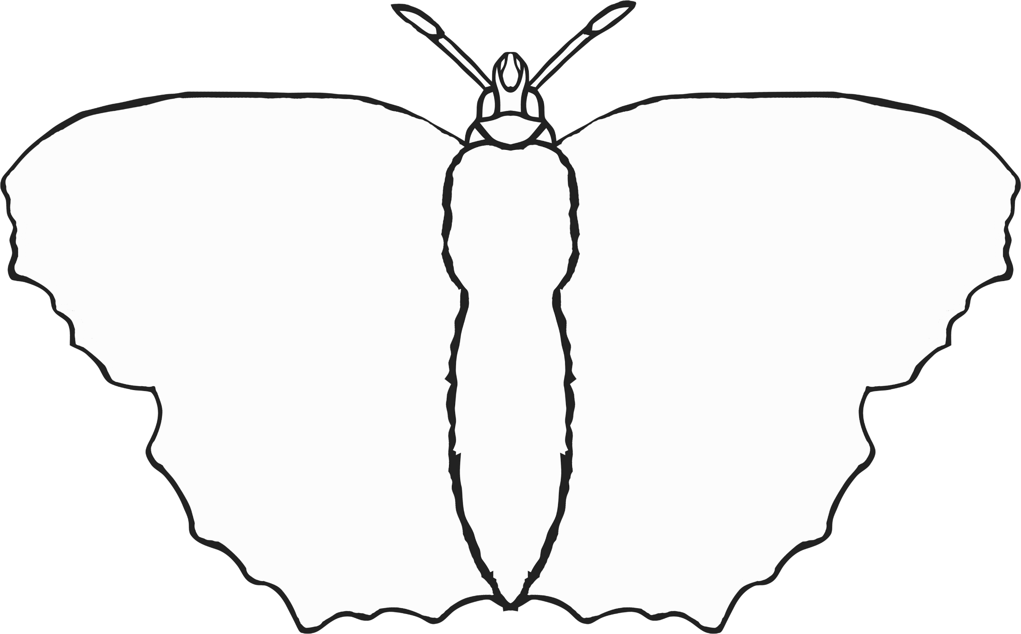

Fine Motor Control (1)

© 2020 Little Owls Resources



Fine Motor Control (2)

© 2020 Little Owls Resources



Fine Motor Control (3)

© 2020 Little Owls Resources



Fine Motor Control (4)

© 2020 Little Owls Resources



Fine Motor Control (5)

© 2020 Little Owls Resources



Fine Motor Control (6)

© 2020 Little Owls Resources