Sand Play

Find in the Sand Cards

Print the cards that match the items you have in your setting and then write a number in the white box if desired.

Hide the items in the sand and then the children can use the cards as a finding challenge.

The children could also set challenges for each other using a whiteboard open to write numbers on the laminated cards.

© 2021 Little Owls Resources

**5**

**3**

© 2021 Little Owls Resources

Find

© 2021 Little Owls Resources

Find a car.

cars.

© 2021 Little Owls Resources

Find

© 2021 Little Owls Resources

Find a building brick.

building bricks.

© 2021 Little Owls Resources

Find

© 2021 Little Owls Resources

Find a die.

dice.

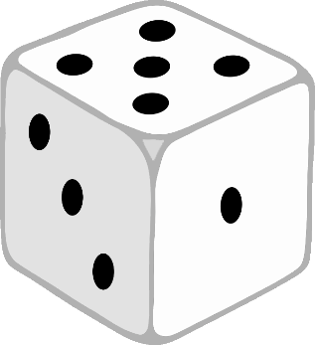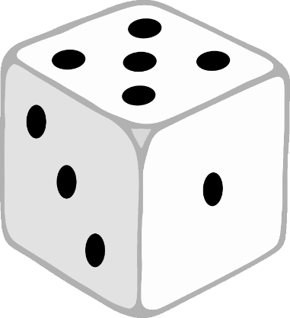

© 2021 Little Owls Resources

Find

© 2021 Little Owls Resources

Find a button.

buttons.

© 2021 Little Owls Resources

Find

© 2021 Little Owls Resources

Find a block.

blocks.

© 2021 Little Owls Resources

Find

© 2021 Little Owls Resources

Find a cup.

cups.

© 2021 Little Owls Resources

Find

© 2021 Little Owls Resources

Find a spoon.

spoons.

© 2021 Little Owls Resources

Find

© 2021 Little Owls Resources

Find a stone.

stones.

© 2021 Little Owls Resources

Find

© 2021 Little Owls Resources

Find a crayon.

crayons.

© 2021 Little Owls Resources

Find

© 2021 Little Owls Resources

Find a pencil.

pencils.

© 2021 Little Owls Resources

Find

© 2021 Little Owls Resources

Find a ruler.

rulers.

© 2021 Little Owls Resources

Find

© 2021 Little Owls Resources

Find