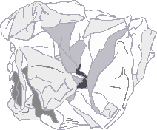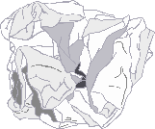

© 2021 Little Owls Resources

Find and draw things that are made of…

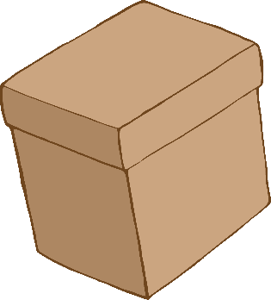

**PAPER** or CARD

© 2021 Little Owls Resources

Find and draw things that are made of…

**PAPER** or CARD