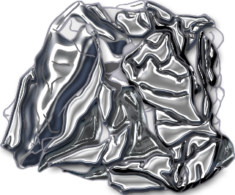

© 2021 Little Owls Resources

Find and draw things that are made of…

**METAL**

© 2021 Little Owls Resources

Find and draw things that are made of…

**METAL**