Water Play

Find Sea Animals Cards

These cards can be used alongside small world sea animal toys for a water play challenge.

Print the cards that match the toys you have in your setting and then write a number in the white box if desired.

Place the sea animal toys in the water and then the children can use the cards as a finding challenge.

Add some bubbles to the water to increase the searching aspect of the task.

© 2021 Little Owls Resources

**3**

**5**

© 2021 Little Owls Resources

Find

© 2021 Little Owls Resources

Find a dolphin.

dolphins.

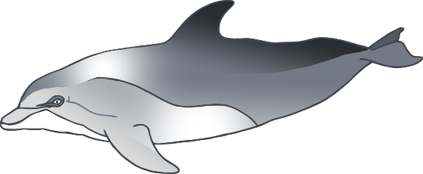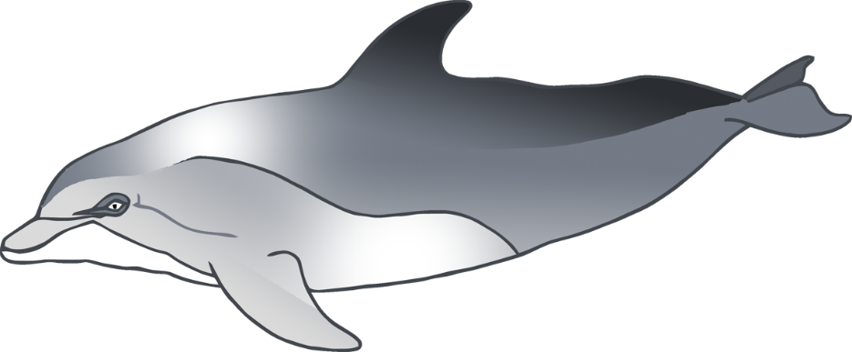

© 2021 Little Owls Resources

Find

© 2021 Little Owls Resources

Find a starfish.

starfish.

© 2021 Little Owls Resources

Find

© 2021 Little Owls Resources

Find a seahorse.

seahorses.

© 2021 Little Owls Resources

Find

© 2021 Little Owls Resources

Find a sea lion.

sea lions.

© 2021 Little Owls Resources

Find

© 2021 Little Owls Resources

Find an octopus.

octopuses.

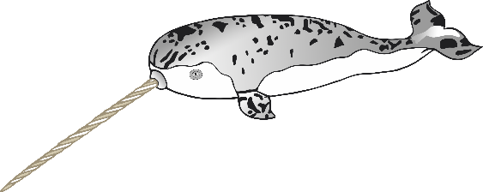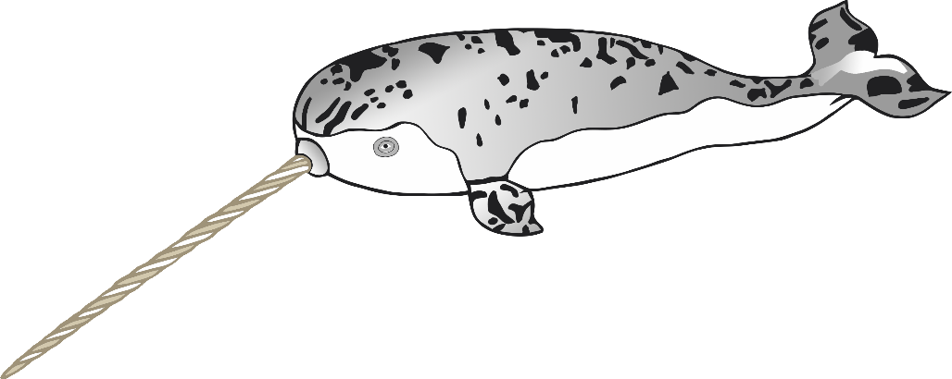

© 2021 Little Owls Resources

Find

© 2021 Little Owls Resources

Find a narwhal.

narwhals.

© 2021 Little Owls Resources

Find

© 2021 Little Owls Resources

Find a jellyfish.

jellyfish.

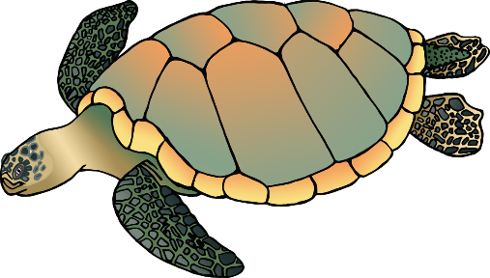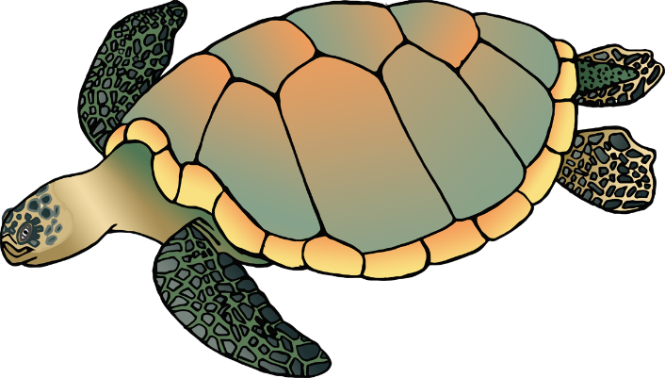

© 2021 Little Owls Resources

Find

© 2021 Little Owls Resources

Find a turtle.

turtles.

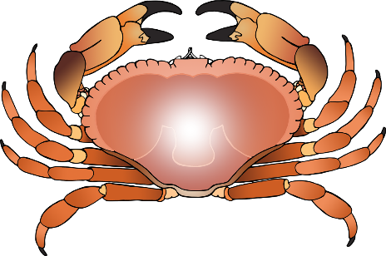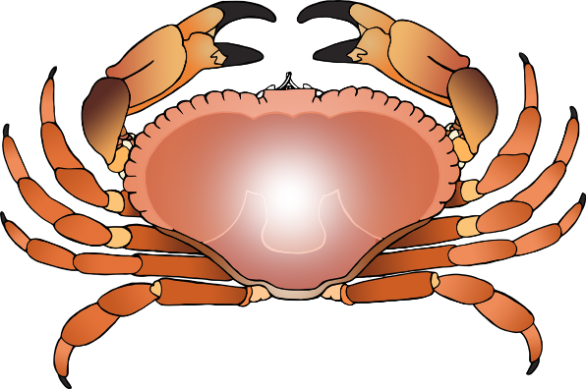

© 2021 Little Owls Resources

Find

© 2021 Little Owls Resources

Find a crab.

crabs.

© 2021 Little Owls Resources

Find

© 2021 Little Owls Resources

Find an eel.

eels.

© 2021 Little Owls Resources

Find

© 2021 Little Owls Resources

Find a fish.

fish.

© 2021 Little Owls Resources

Find

© 2021 Little Owls Resources

Find a shark.

sharks.

© 2021 Little Owls Resources

Find

© 2021 Little Owls Resources

Find a penguin.

penguins.

© 2021 Little Owls Resources

Find

© 2021 Little Owls Resources

Find