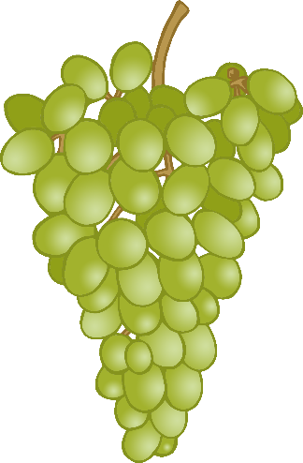

Whole Peanuts

Mixed Seeds

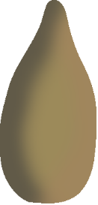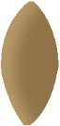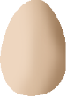

Hazelnuts

Grapes

Boiled Egg

(chopped)

Fruit & Vegetables

(chopped)

Bird Feed

Some foods you could leave in your garden…

You don’t want to leave out so much food that the animals become dependent on it, but a few tasty treats can be helpful in getting them through the winter months.

Feeding Winter Wildlife

© 2020 Little Owls Resources