Feed the Dinosaurs Dice Game

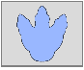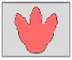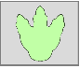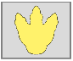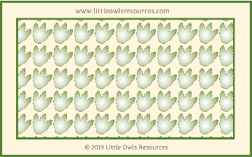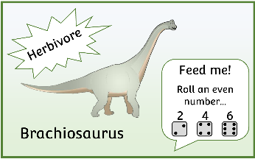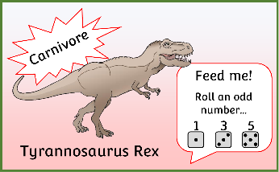

Players: 1-4

(1 x 6-sided dice needed)

* Take turns to turn over a dinosaur card.
* Roll dice to try and feed the dinosaur on the card. Odd numbers for carnivores. Even numbers for herbivores.
* If you roll the correct number, you have fed the dinosaur! Move your coloured footprint one space up the footprint line.
* The first person to get to the end of the line wins!

www.littleowlsresources.com

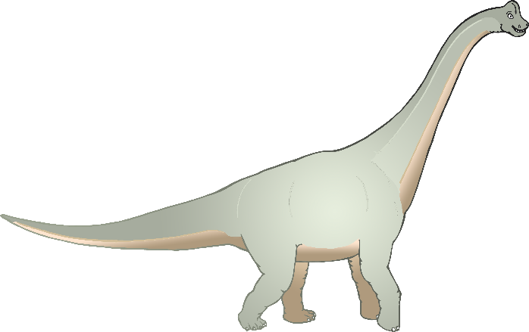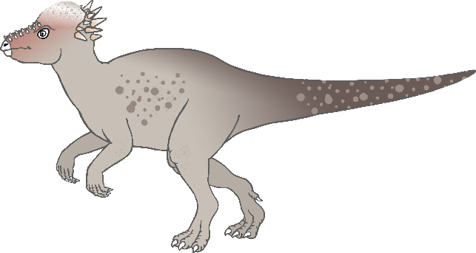

Brachiosaurus

Herbivore

Feed me!

Roll an even number…

2 4 6

© 2019 Little Owls Resources

Pachycephalosaurus

Herbivore

Feed me!

Roll an even number…

2 4 6

www.littleowlsresources.com

© 2019 Little Owls Resources

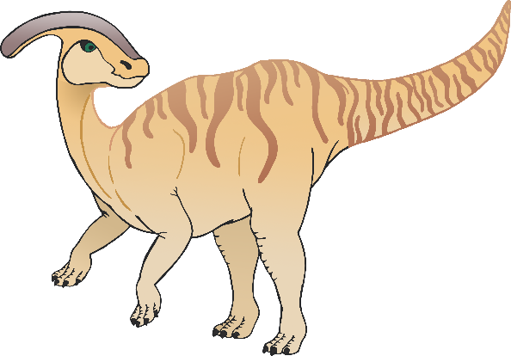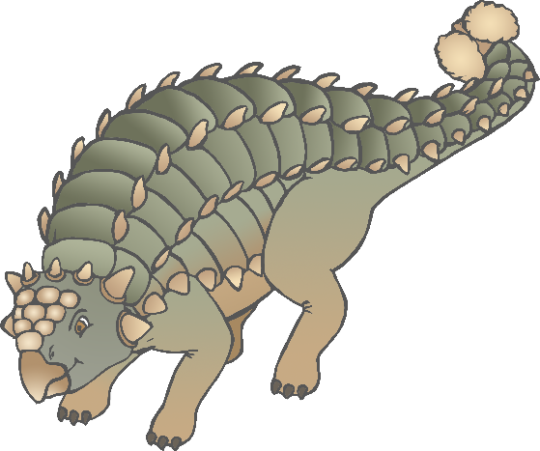

Ankylosaurus

Herbivore

Feed me!

Roll an even number…

2 4 6

www.littleowlsresources.com

© 2019 Little Owls Resources

Parasaurolophus

Herbivore

Feed me!

Roll an even number…

2 4 6

www.littleowlsresources.com

© 2019 Little Owls Resources

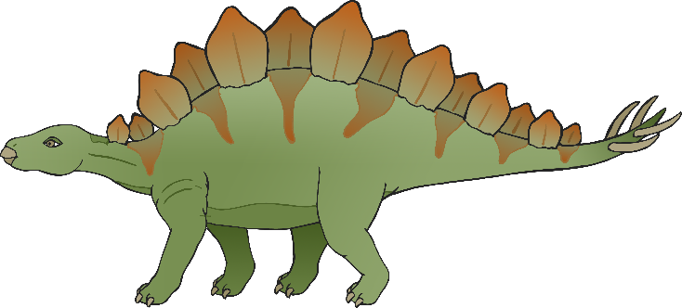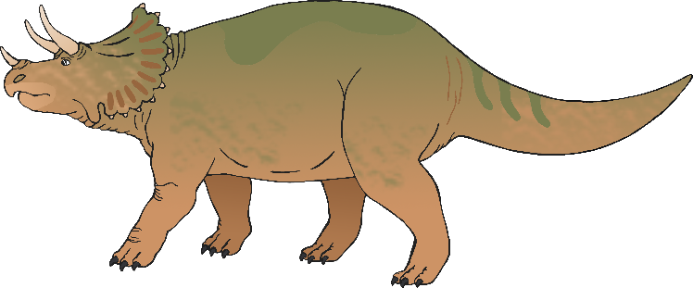

Triceratops

Herbivore

Feed me!

Roll an even number…

2 4 6

www.littleowlsresources.com

© 2019 Little Owls Resources

Stegosaurus

Herbivore

Feed me!

Roll an even number…

2 4 6

www.littleowlsresources.com

© 2019 Little Owls Resources

Plesiosaur

Carnivore

Feed me!

Roll an odd number…

1 3 5

www.littleowlsresources.com

© 2019 Little Owls Resources

Pterodactyl

Carnivore

Feed me!

Roll an odd number…

1 3 5

www.littleowlsresources.com

© 2019 Little Owls Resources

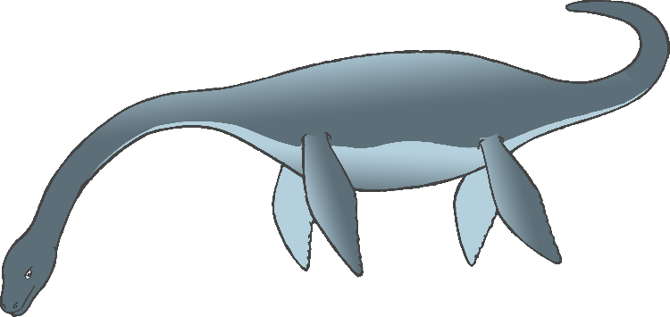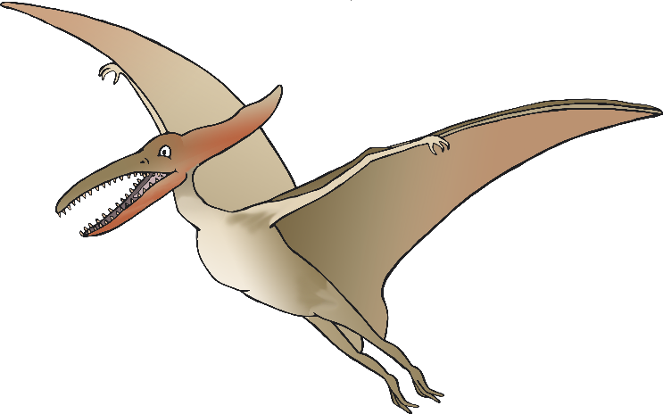

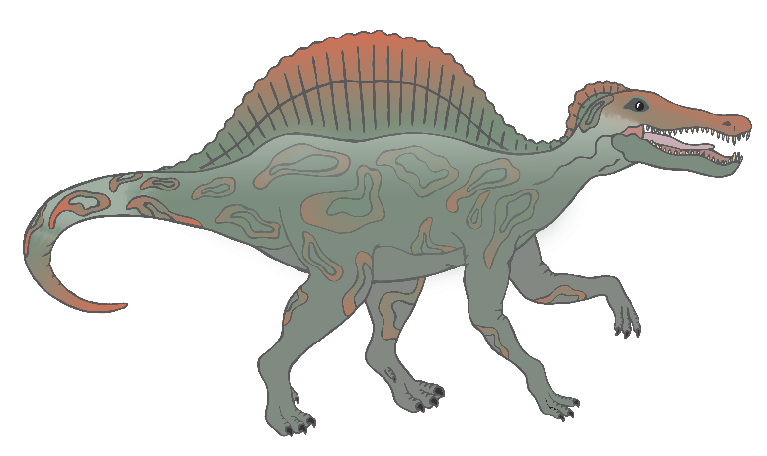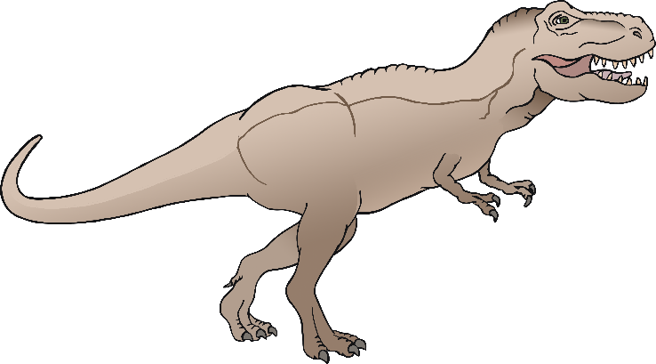

Tyrannosaurus Rex

Carnivore

Feed me!

Roll an odd number…

1 3 5

www.littleowlsresources.com

© 2019 Little Owls Resources

Spinosaurus

Carnivore

Feed me!

Roll an odd number…

1 3 5

www.littleowlsresources.com

© 2019 Little Owls Resources

www.littleowlsresources.com



Brachiosaurus

Herbivore

Feed me!

Roll an even number…

2 4 6

© 2019 Little Owls Resources

Pachycephalosaurus

Herbivore

Feed me!

Roll an even number…

2 4 6

www.littleowlsresources.com

© 2019 Little Owls Resources



Ankylosaurus

Herbivore

Feed me!

Roll an even number…

2 4 6

www.littleowlsresources.com

© 2019 Little Owls Resources

Parasaurolophus

Herbivore

Feed me!

Roll an even number…

2 4 6

www.littleowlsresources.com

© 2019 Little Owls Resources



Triceratops

Herbivore

Feed me!

Roll an even number…

2 4 6

www.littleowlsresources.com

© 2019 Little Owls Resources

Stegosaurus

Herbivore

Feed me!

Roll an even number…

2 4 6

www.littleowlsresources.com

© 2019 Little Owls Resources

Plesiosaur

Carnivore

Feed me!

Roll an odd number…

1 3 5

www.littleowlsresources.com

© 2019 Little Owls Resources

Pteradactyl

Carnivore

Feed me!

Roll an odd number…

1 3 5

www.littleowlsresources.com

© 2019 Little Owls Resources





Tyrannosaurus Rex

Carnivore

Feed me!

Roll an odd number…

1 3 5

www.littleowlsresources.com

© 2019 Little Owls Resources

Spinosaurus

Carnivore

Feed me!

Roll an odd number…

1 3 5

www.littleowlsresources.com

© 2019 Little Owls Resources

START



WIN

START



WIN

START



WIN

START



WIN

