Name:

These are a few of my favourite things!

© 2019 Little Owls Resources

© 2019 Little Owls Resources

My favourite colour

© 2019 Little Owls Resources

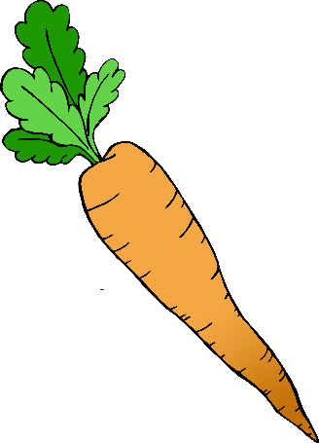

My favourite food

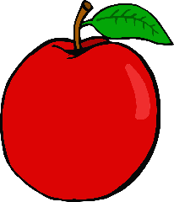

© 2019 Little Owls Resources

My favourite drink

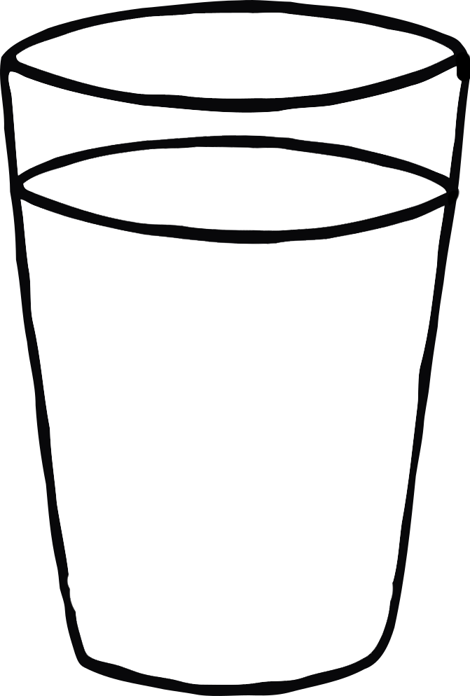

© 2019 Little Owls Resources

My favourite TV show

© 2019 Little Owls Resources

My favourite animal

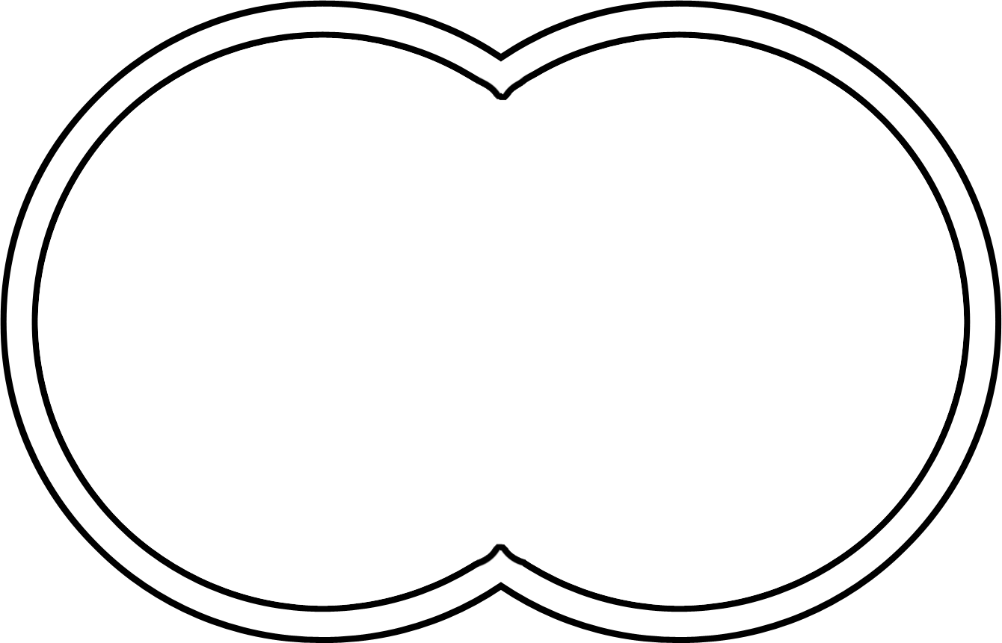

© 2019 Little Owls Resources

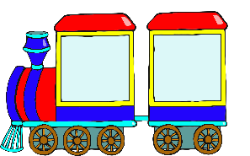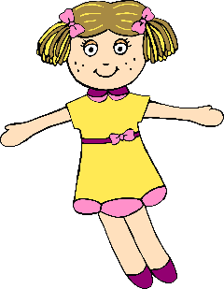

My favourite toy

© 2019 Little Owls Resources