Happy

Father’s

Day!

© 2020 Little Owls Resources

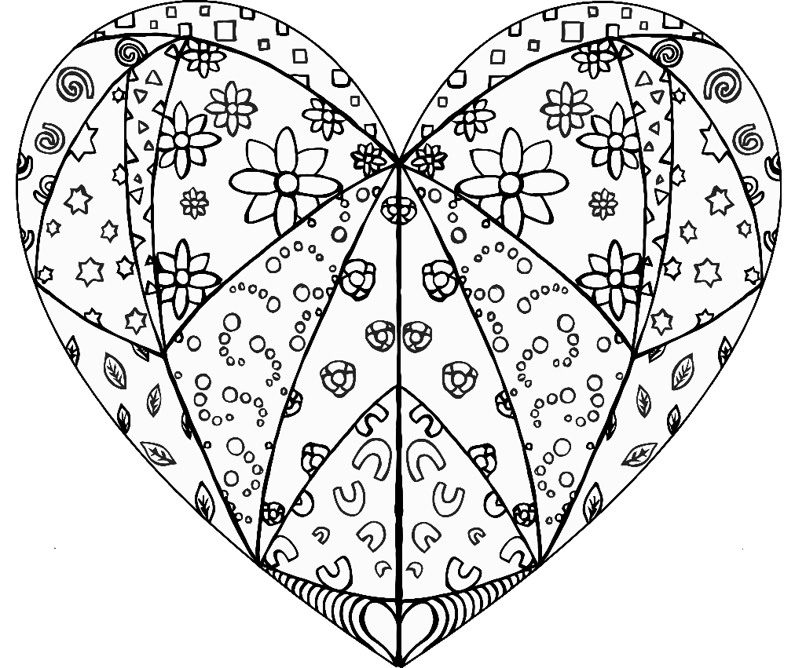

Daddy

© 2020 Little Owls Resources

© 2020 Little Owls Resources

Happy Father’s Day!

I love you Daddy!

© 2020 Little Owls Resources

Dad

© 2020 Little Owls Resources

© 2020 Little Owls Resources

Daddy

© 2020 Little Owls Resources

Daddy

© 2020 Little Owls Resources

Daddy!

Thank-You

Happy

© 2020 Little Owls Resources

Father’s Day!

© 2020 Little Owls Resources