Greeting Cards Activity – Father’s Day

These templates have detailed outlines to be used as a starting point for an art activity.

The outlines can be coloured, painted, or collaged to create an individual card design.

I love you!

I love you!

©2022 Little Owls Resources

I love you!

©2022 Little Owls Resources

Farrrther’s Day!

Happy

©2022 Little Owls Resources

Daddy!

©2022 Little Owls Resources

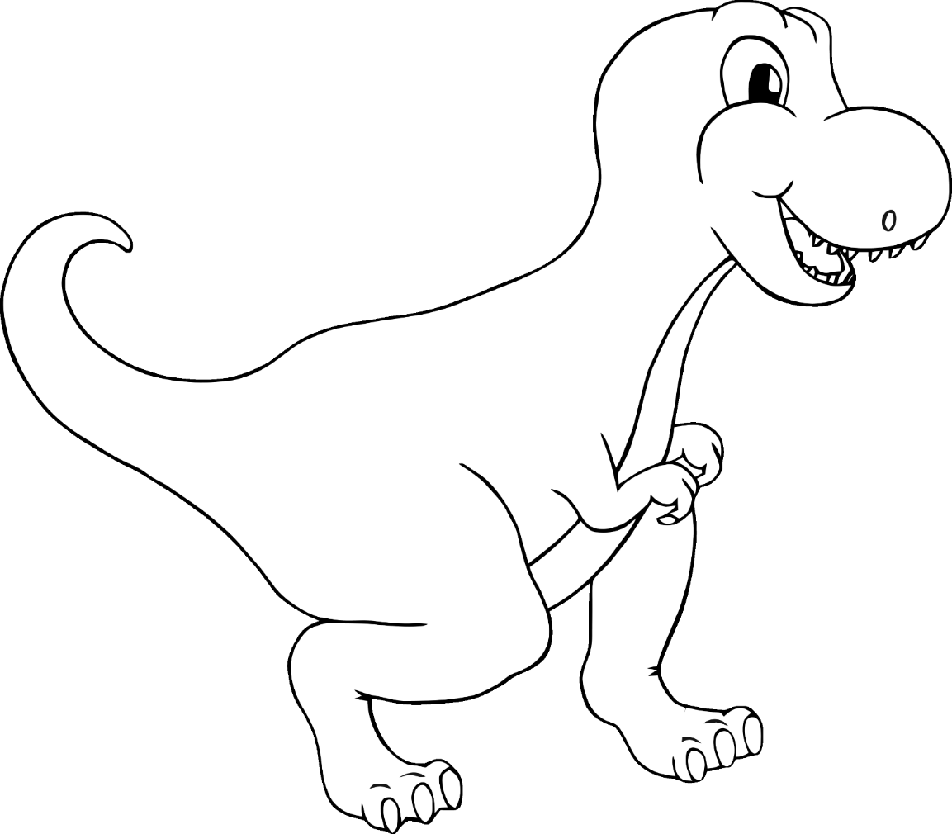

For my

ROARsome daddy!

©2022 Little Owls Resources

**Daddy!**

**Love you**

©2022 Little Owls Resources

Best daddy in the world!

©2022 Little Owls Resources

**I love you**

**daddy!**

©2022 Little Owls Resources

…you’re the best!

DAddy…

©2022 Little Owls Resources

**you daddy!**

©2022 Little Owls Resources

**My daddy!!**

©2022 Little Owls Resources

**Happy Father’s Day!**

©2022 Little Owls Resources

©2022 Little Owls Resources

**Happy Father’s Day!**

**Best daddy in the world!**

©2022 Little Owls Resources

©2022 Little Owls Resources

**I love you daddy!**

Daddy!

©2022 Little Owls Resources