Father’s Day A4 templates

©2022 Little Owls Resources

These templates have detailed outlines to be used as a starting point for an art activity.

The outlines can be coloured, painted, or collaged to create an individual poster design.

They could also be stuck to a folded piece of A3 card to make a large Father’s Day card!

Best daddy in the world!

Best daddy in the world!

Dear Daddy

I love you!

©2022 Little Owls Resources

Farrrrrther’s Day!

Happy

©2022 Little Owls Resources

Daddy!

©2022 Little Owls Resources

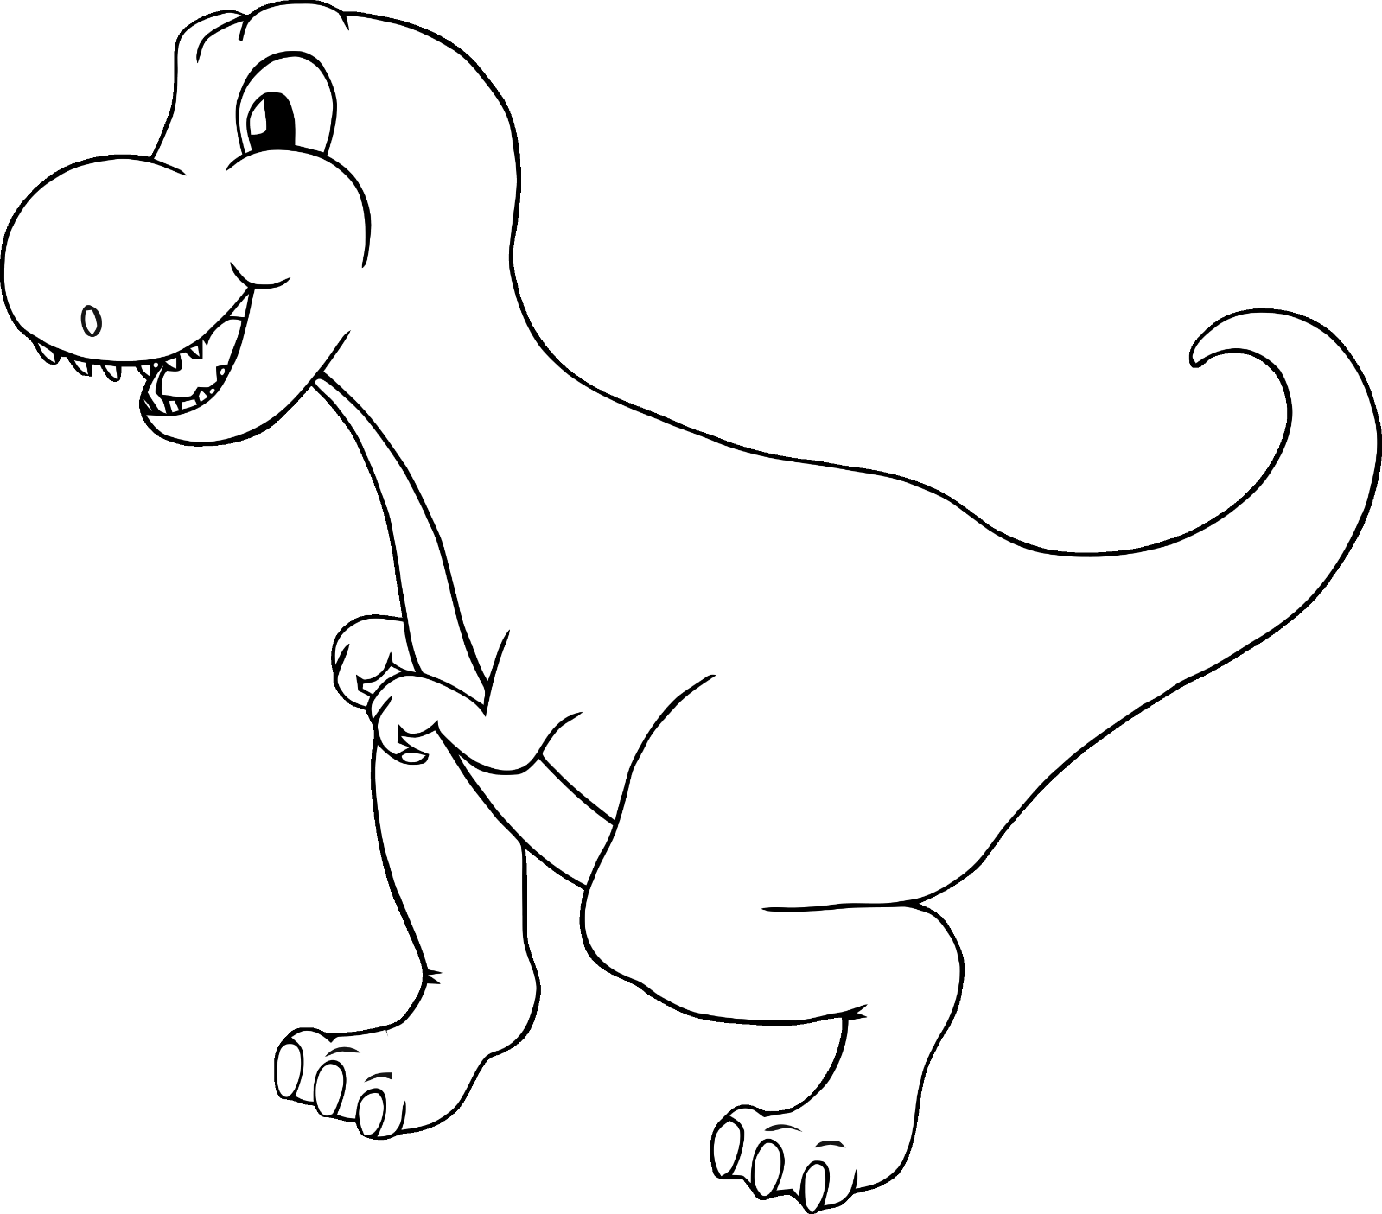

ROARsome daddy!

For my

©2022 Little Owls Resources

**Love you**

**Daddy!**

©2022 Little Owls Resources

Best daddy in the world!

©2022 Little Owls Resources

**I love you**

**daddy!**

©2022 Little Owls Resources

…You’re the best!

DADDy…

©2022 Little Owls Resources

©2022 Little Owls Resources

**you daddy!**

©2022 Little Owls Resources

**My daddy!!**

**Happy Father’s Day!**

©2022 Little Owls Resources

**Happy Father’s Day!**

©2022 Little Owls Resources

**Best daddy in the world!**

©2022 Little Owls Resources

**I love you daddy!**

©2022 Little Owls Resources

Daddy!

©2022 Little Owls Resources