**Farm Word Mat**

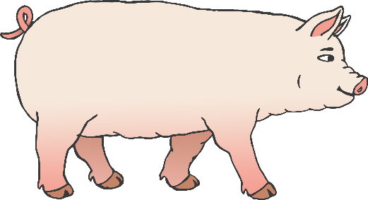

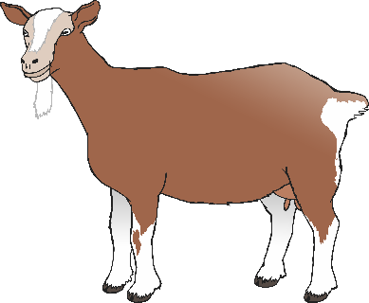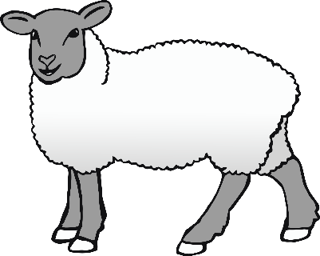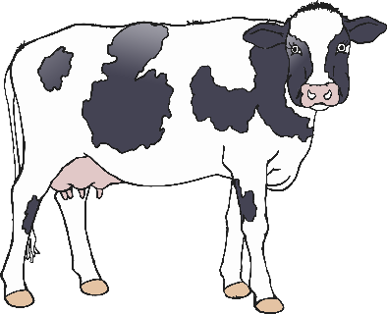

goat

pig

chicken

sheep

dog

farmhouse

tractor

© 2021 Little Owls Resources

cow

hay