**Farm Multimat – Pig**

© 2021 Little Owls Resources

**Farm Multimat – Cow**

© 2021 Little Owls Resources

**Farm Multimat – Chicken**

© 2021 Little Owls Resources

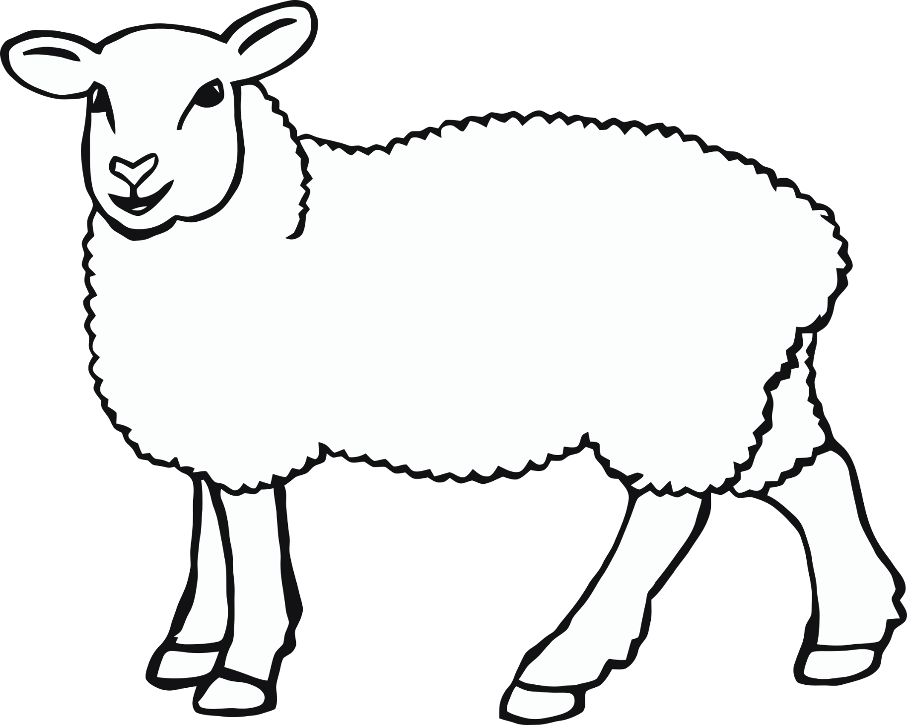

**Farm Multimat – Sheep**

© 2021 Little Owls Resources