**Farm**

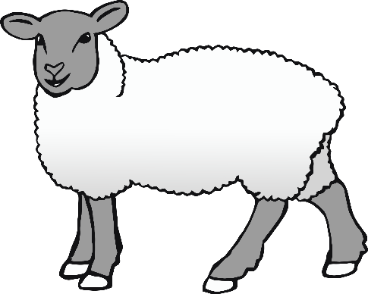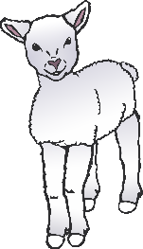

**Animals**

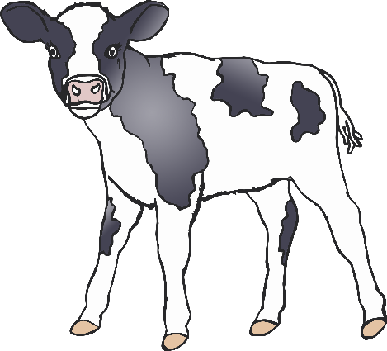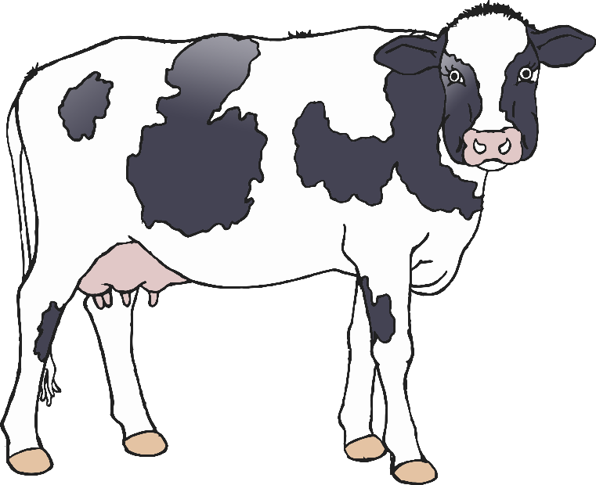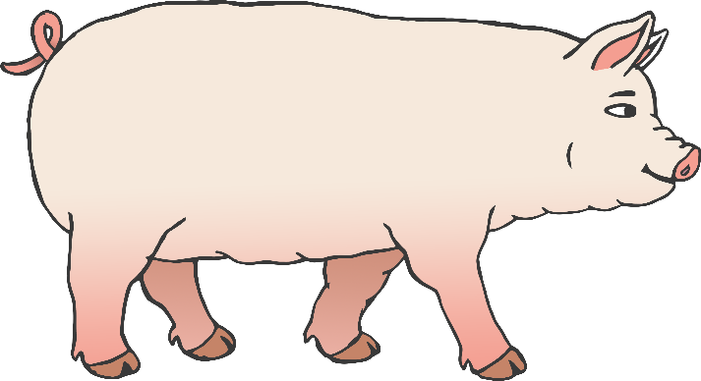

© 2021 Little Owls Resources

**On**

**the Farm**

© 2021 Little Owls Resources