**Puppies Room**

© 2020 Little Owls Resources

Children’s names here…

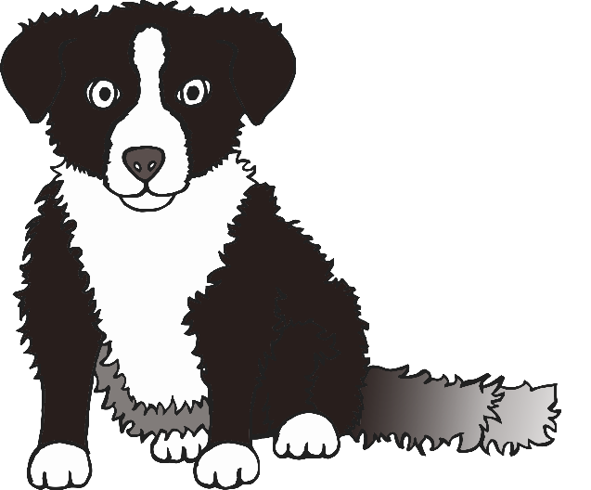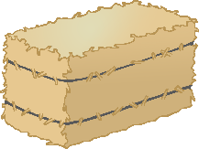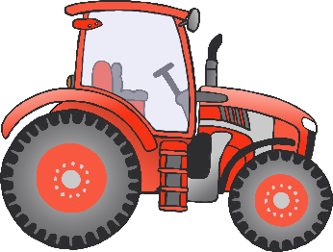

**Chicks Room**

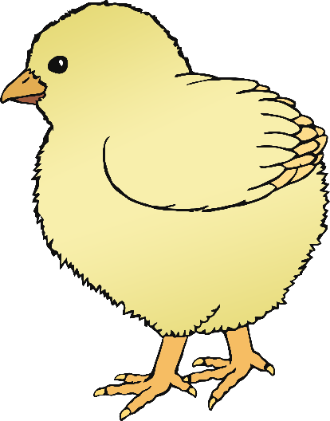

© 2020 Little Owls Resources

Children’s names here…

**Ducklings Room**

© 2020 Little Owls Resources

Children’s names here…

**Foals Room**

© 2020 Little Owls Resources

Children’s names here…

**Lambs Room**

Children’s names here…

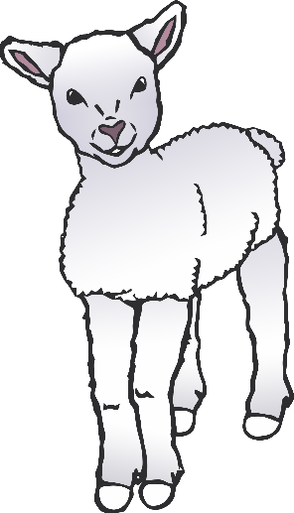

© 2020 Little Owls Resources

**Piglets Room**

Children’s names here…

© 2020 Little Owls Resources

**Puppies Room**



© 2020 Little Owls Resources

**Chicks Room**

© 2020 Little Owls Resources



**Ducklings Room**

© 2020 Little Owls Resources

**Foals Room**

© 2020 Little Owls Resources

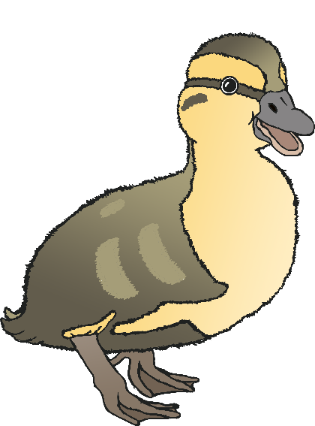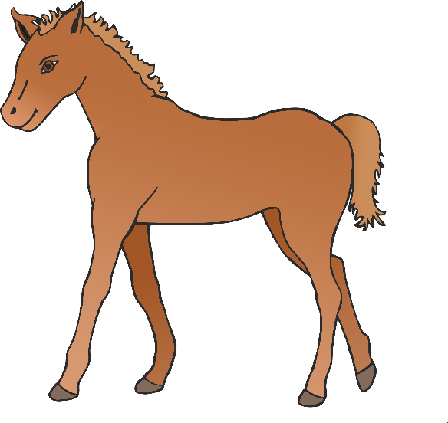

**Lambs Room**

© 2020 Little Owls Resources

**Piglets Room**

© 2020 Little Owls Resources

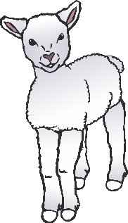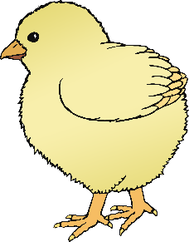

Piglets Room

Lambs Room

Foals Room

Ducklings Room

Chicks Room

Puppies Room

**Nursery Rooms**

Names here….

Names here….

Names here….

Names here….

Names here….

Names here….

© 2020 Little Owls Resources

© 2020 Little Owls Resources

www.littleowls-premium.com *EDITABLE Resource*



© 2020 Little Owls Resources

www.littleowls-premium.com *EDITABLE Resource*



**Chicks Room**

Names here….

**Puppies Room**

Names here….

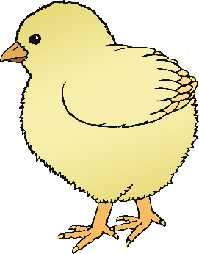

Names here….

Names here….

© 2020 Little Owls Resources

© 2020 Little Owls Resources

© 2020 Little Owls Resources

www.littleowls-premium.com *EDITABLE Resource*



**Foals Room**

Names here….

Names here….

Names here….

**Ducklings Room**

Names here….

© 2020 Little Owls Resources

© 2020 Little Owls Resources

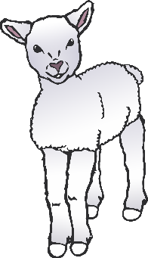

**Piglets Room**

Names here….

**Lambs Room**

Names here….

Names here….

Names here….

© 2020 Little Owls Resources

© 2020 Little Owls Resources

© 2020 Little Owls Resources

www.littleowls-premium.com *EDITABLE Resource*

