**Puppies**

Children’s names here…

© 2020 Little Owls Resources

**Chicks**

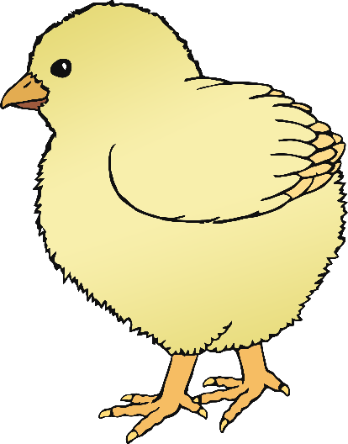

© 2020 Little Owls Resources

Children’s names here…

**Ducklings**

© 2020 Little Owls Resources

Children’s names here…

**Foals**

© 2020 Little Owls Resources

Children’s names here…

**Lambs**

Children’s names here…

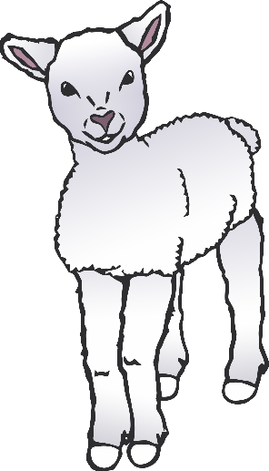

© 2020 Little Owls Resources

**Piglets**

Children’s names here…

© 2020 Little Owls Resources

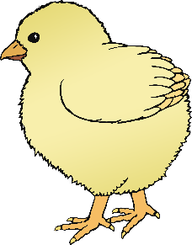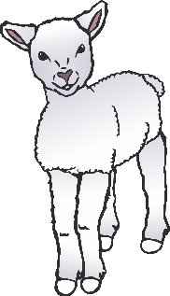

Piglets

Lambs

Foals

Ducklings

Chicks

Puppies

**Topic Groups**

Names here….

Names here….

Names here….

Names here….

Names here….

Names here….

© 2020 Little Owls Resources

© 2020 Little Owls Resources

www.littleowls-premium.com *EDITABLE Resource*



© 2020 Little Owls Resources

www.littleowls-premium.com *EDITABLE Resource*



**Puppies**

Names here….

**Chicks**

Names here….

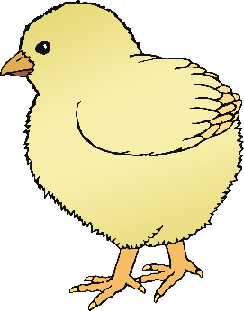

Names here….

Names here….

© 2020 Little Owls Resources

© 2020 Little Owls Resources

© 2020 Little Owls Resources

www.littleowls-premium.com *EDITABLE Resource*



**Foals**

Names here….

Names here….

Names here….

**Ducklings**

Names here….

© 2020 Little Owls Resources

© 2020 Little Owls Resources

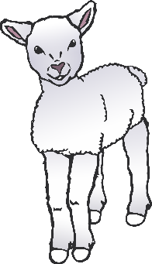

**Piglets**

Names here….

**Lambs**

Names here….

Names here….

Names here….

© 2020 Little Owls Resources

© 2020 Little Owls Resources

© 2020 Little Owls Resources

www.littleowls-premium.com *EDITABLE Resource*

