dog

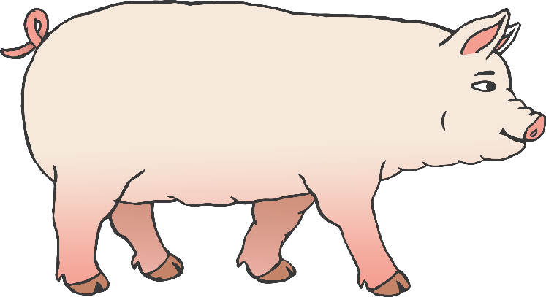

horse

© 2021 Little Owls Resources

© 2021 Little Owls Resources

pig

© 2021 Little Owls Resources

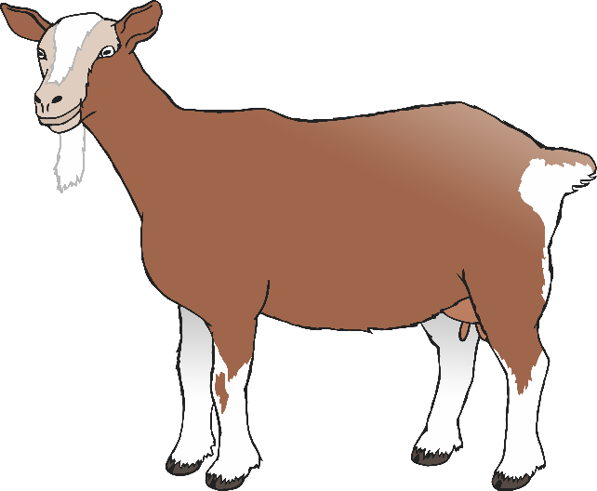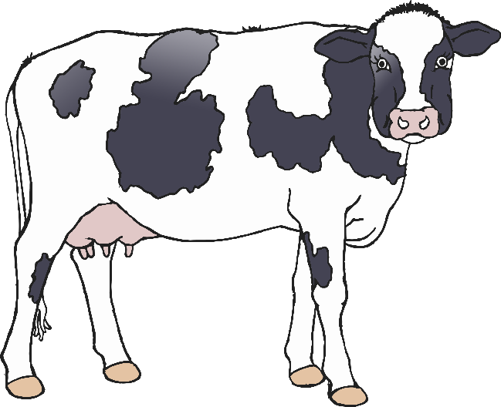

donkey

cow

goat

© 2021 Little Owls Resources

© 2021 Little Owls Resources

© 2021 Little Owls Resources

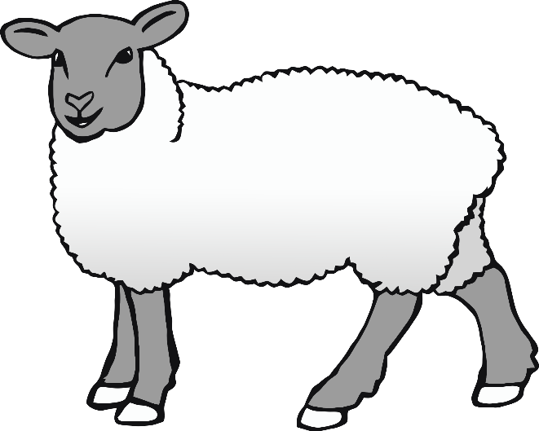

duck

chicken

sheep

© 2021 Little Owls Resources

© 2021 Little Owls Resources

© 2021 Little Owls Resources

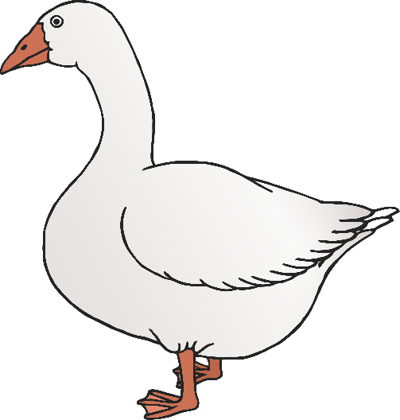

rooster

goose

© 2021 Little Owls Resources

© 2021 Little Owls Resources

© 2021 Little Owls Resources