**Farm Animals Word Mat**

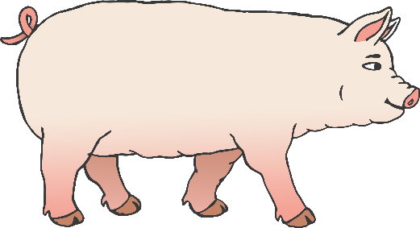

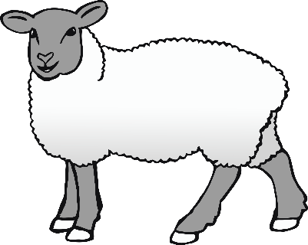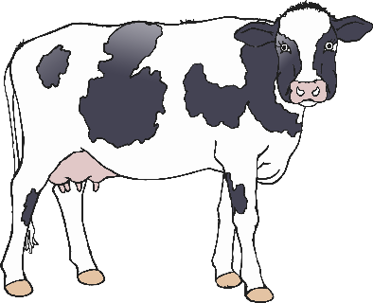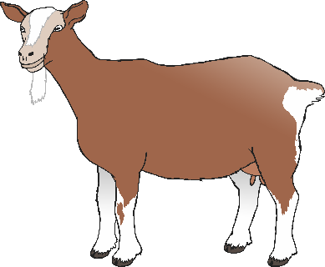

sheep

duck

goose

horse

pig

© 2021 Little Owls Resources

dog

rooster

cow

goat

donkey

chicken