* Eats hay and grain.
* Baby is called a calf.
* Milk is used to make butter, cheese, cream and yoghurt.
* Beef comes from a cow.

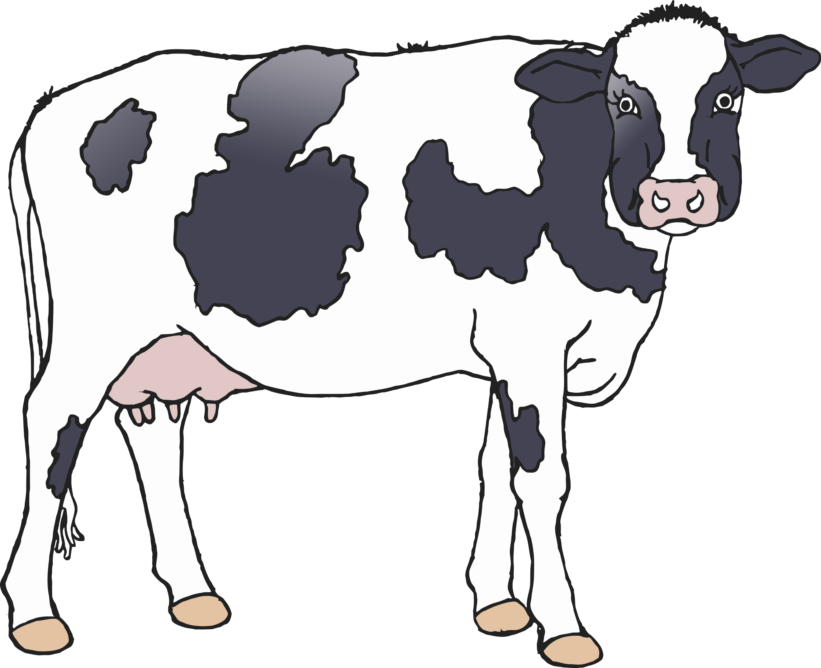

Donkey

Horse

Cow

* Eats hay and grass.
* Baby is called a foal.
* Used for riding and pulling carts.

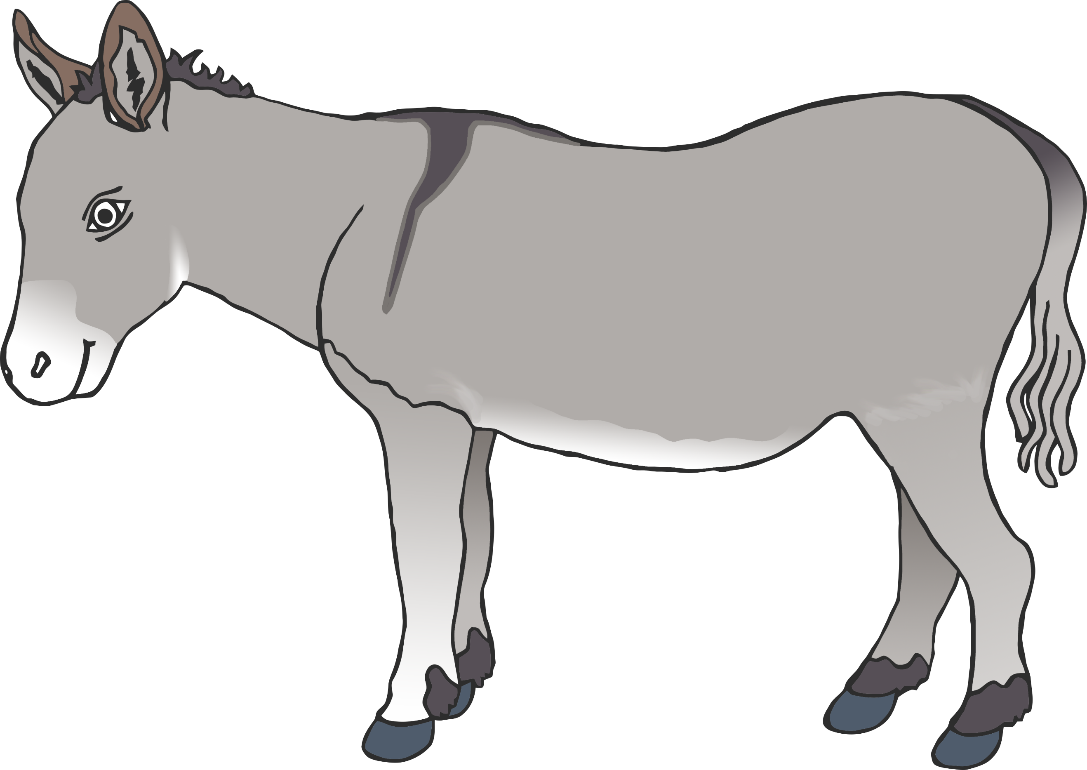

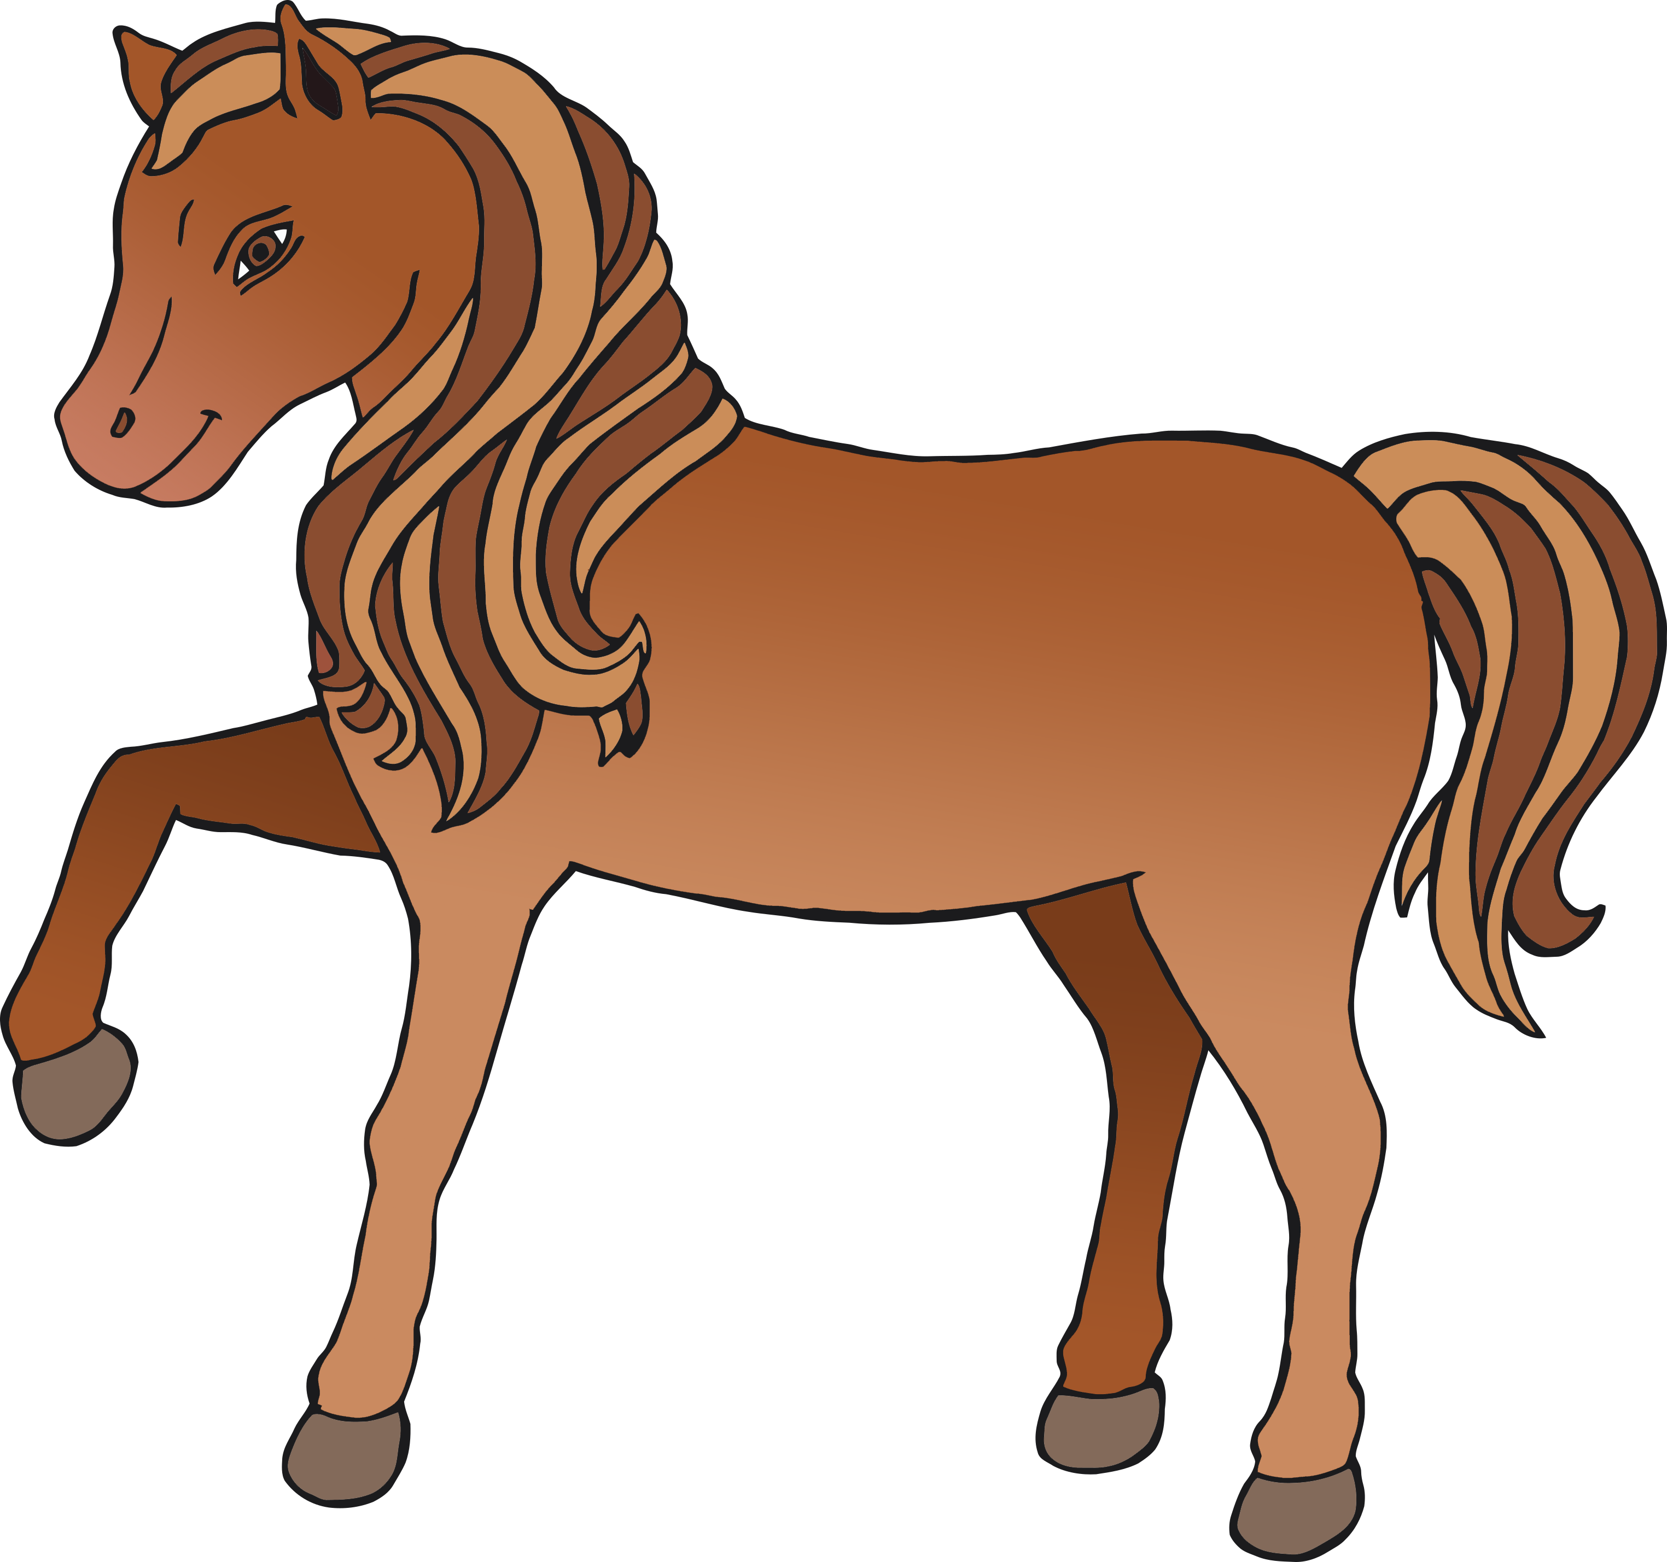

* Eats hay, grass and straw.
* Baby is called a foal.
* Riding, carrying loads and protecting livestock.
* Eats hay and grain.
* Baby is called a kid.
* Milk is used to make butter, cheese, cream and yoghurt.

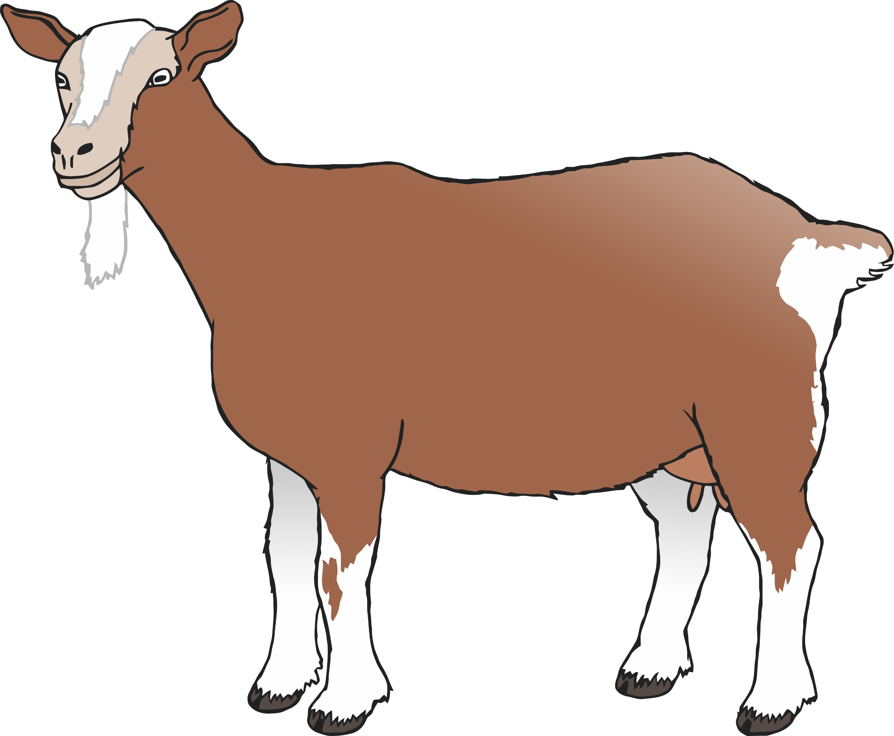

Dog

Pig

Goat

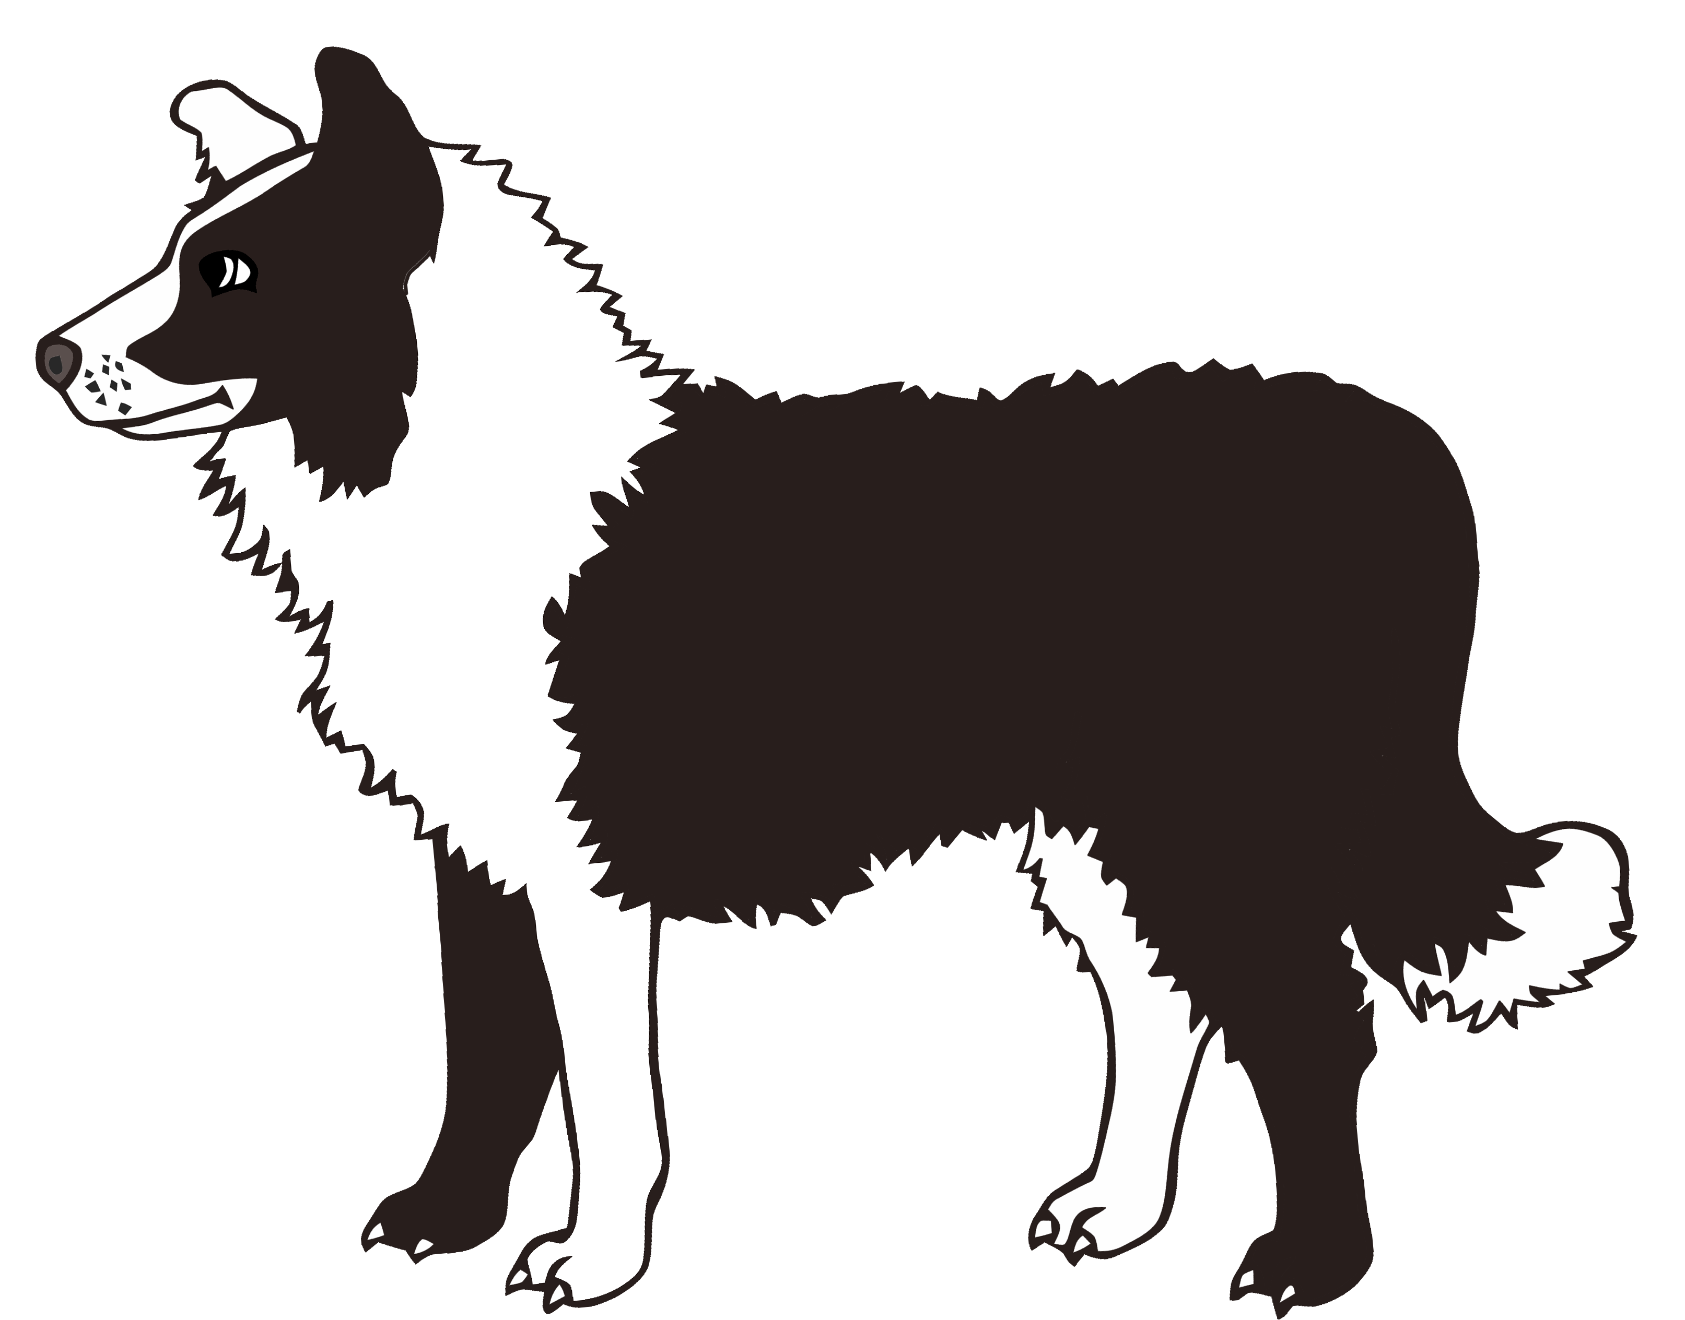

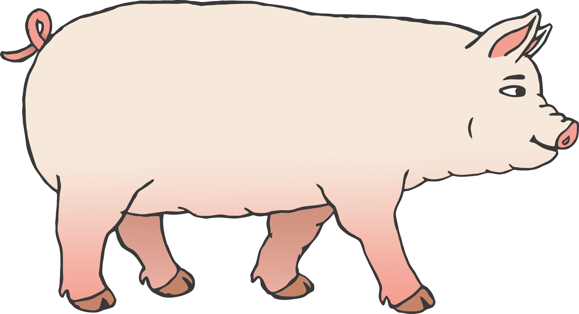

* Eats meat.
* Baby is called a puppy.
* Protects livestock and herds sheep.
* Eats corn or soybean meal.
* Baby is called a piglet.
* Pork comes from a pig.
* Eats grass and green vegetables.
* Baby is called a gosling.
* Eggs, feathers and useful on the farm as an alarm call when predators are near.
* Eats insects, weeds, grass.
* Baby is called a duckling.
* Eggs and feathers are used.
* Eats grass and clover.
* Baby is called a lamb.
* Wool comes from sheep.

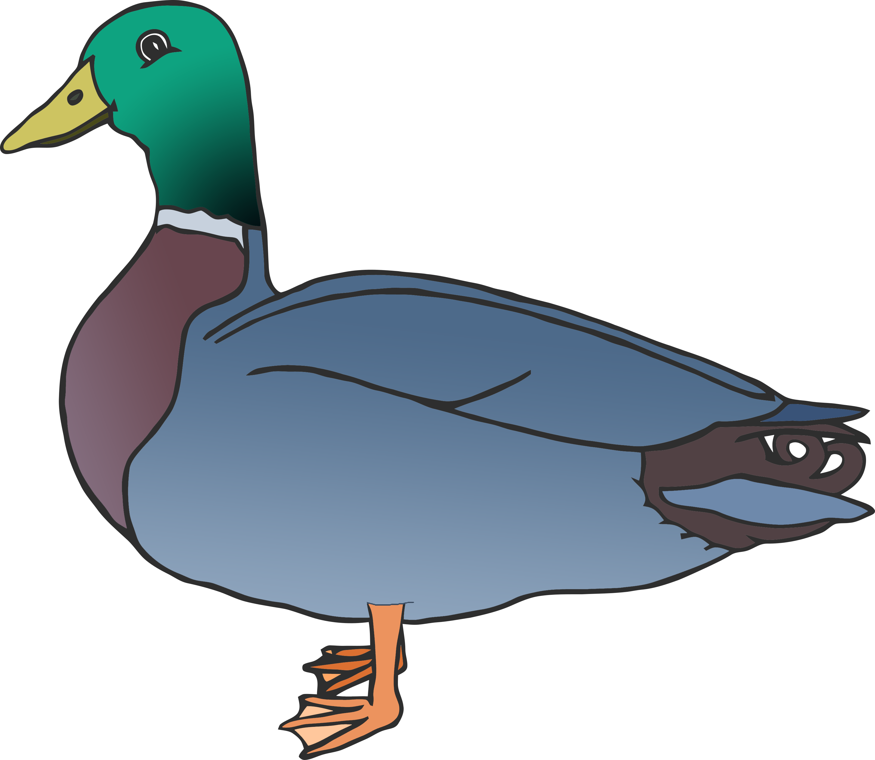

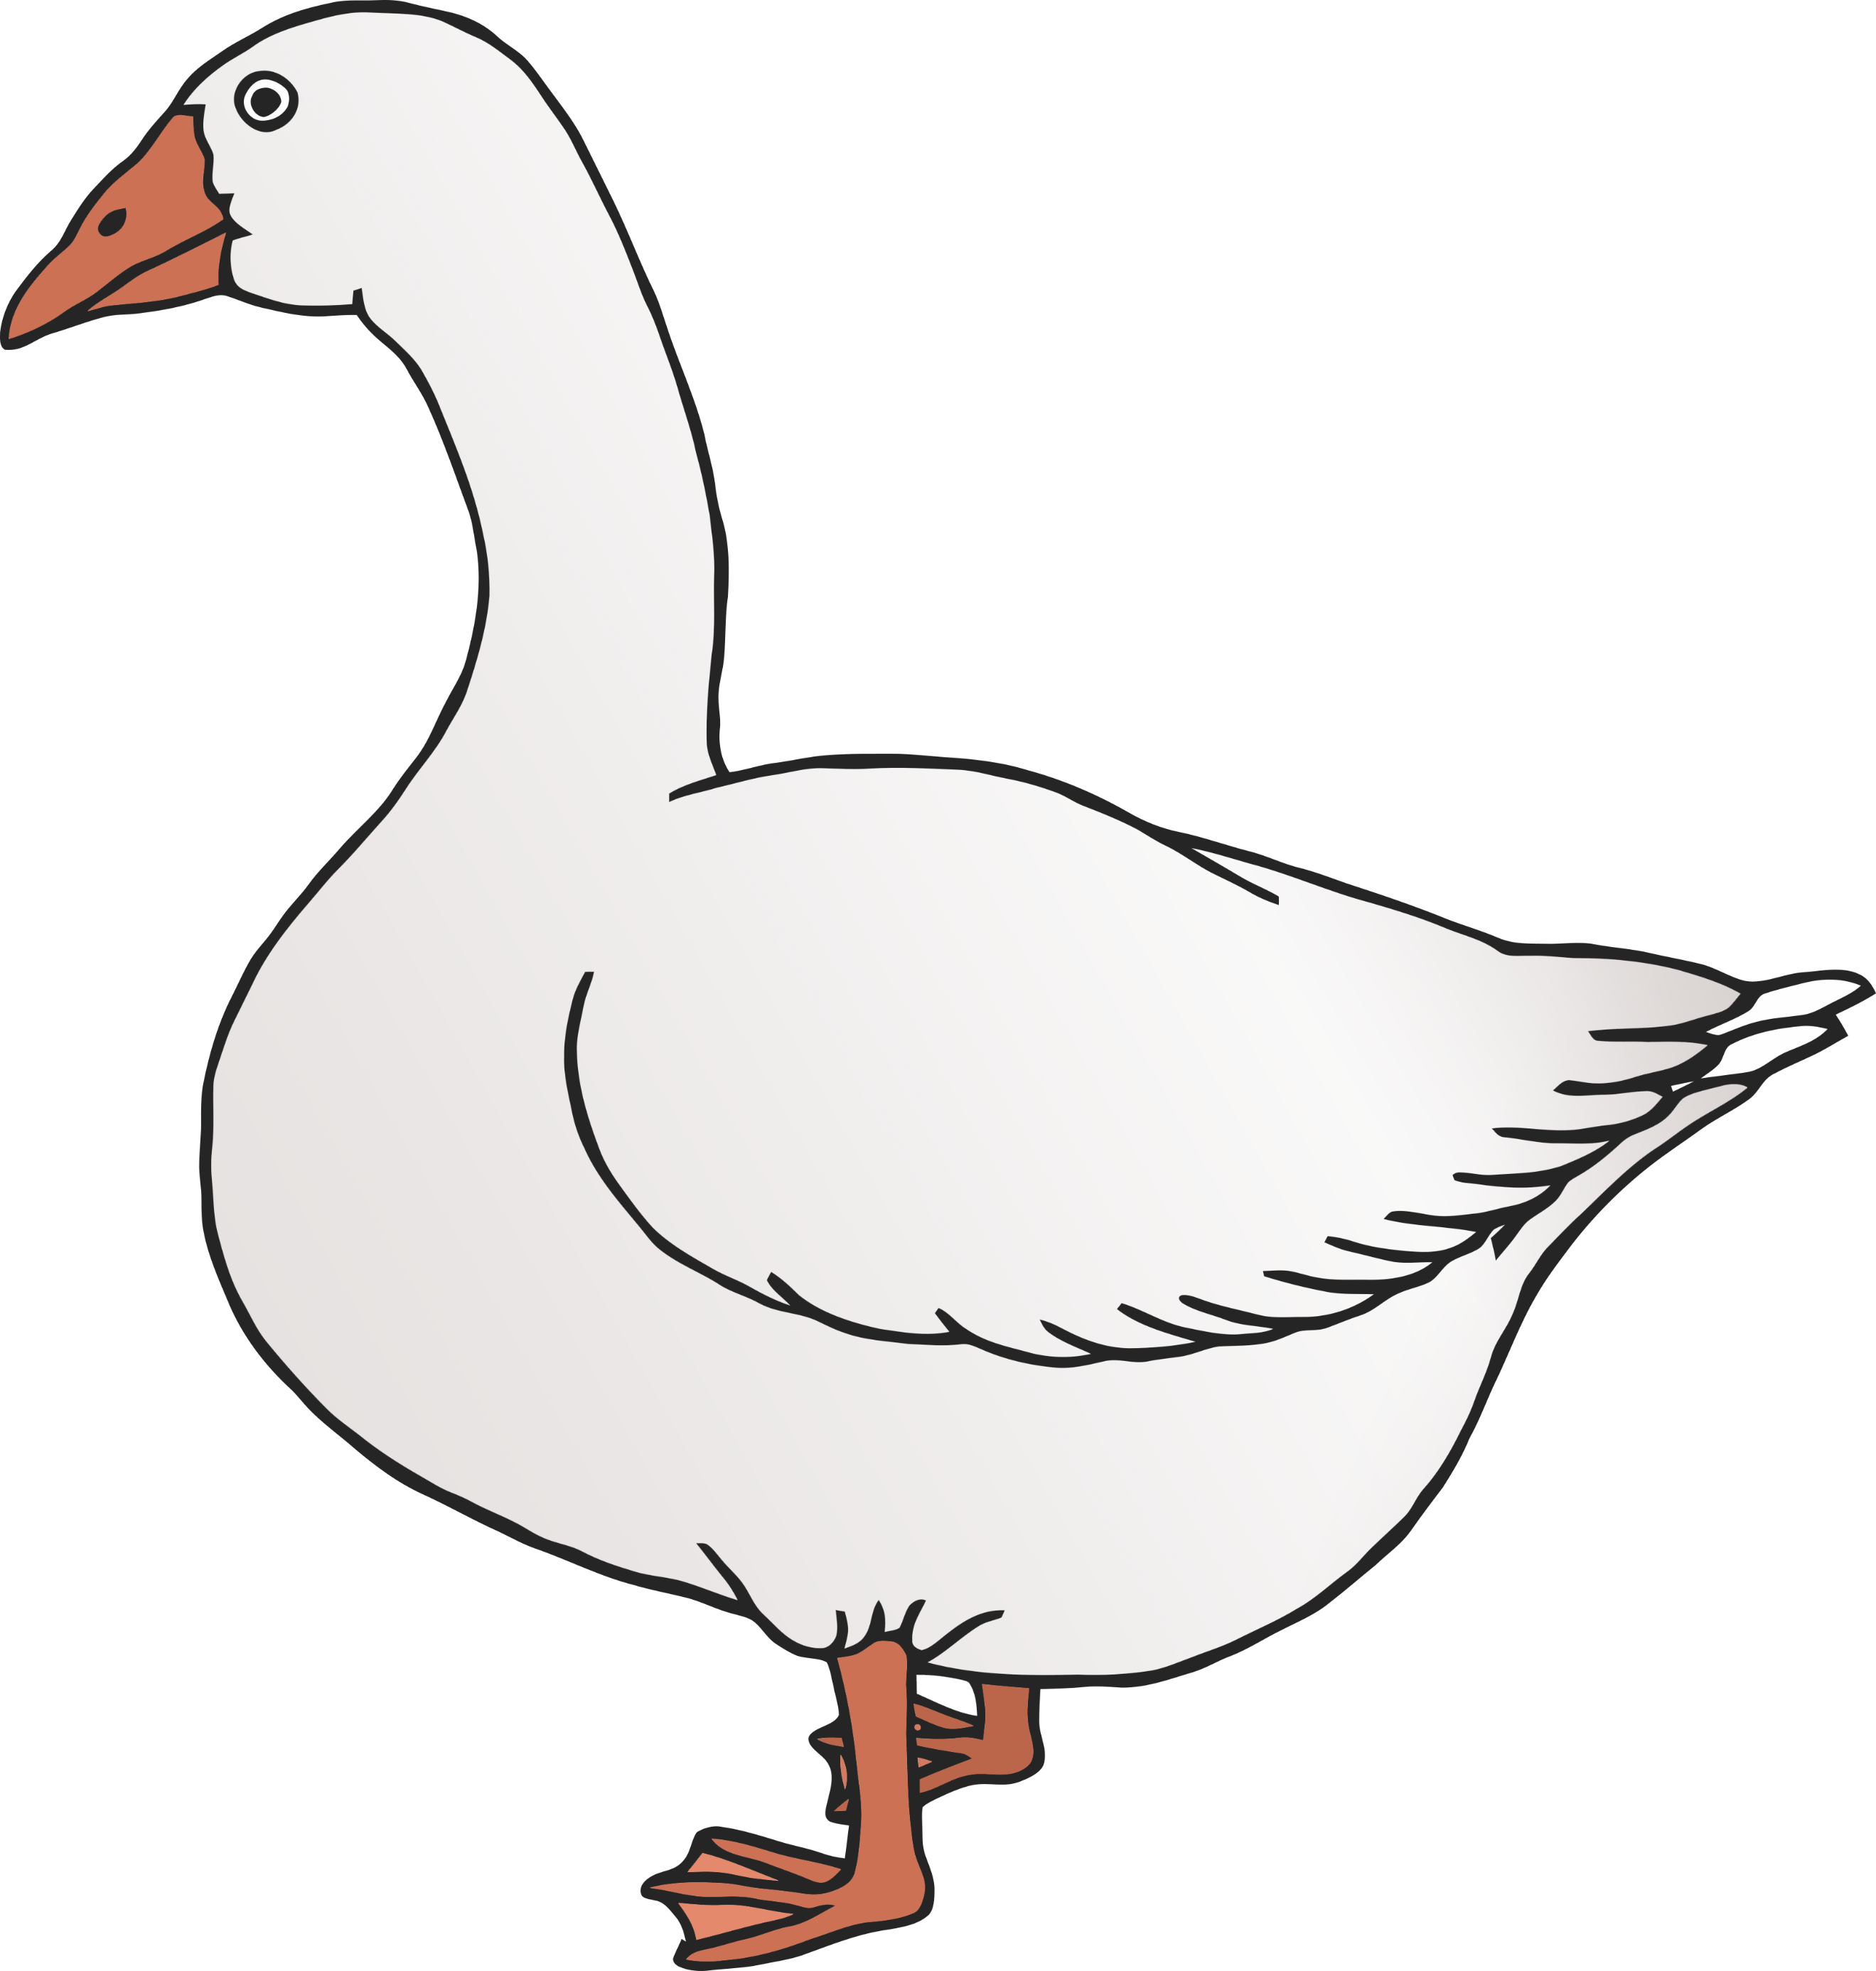

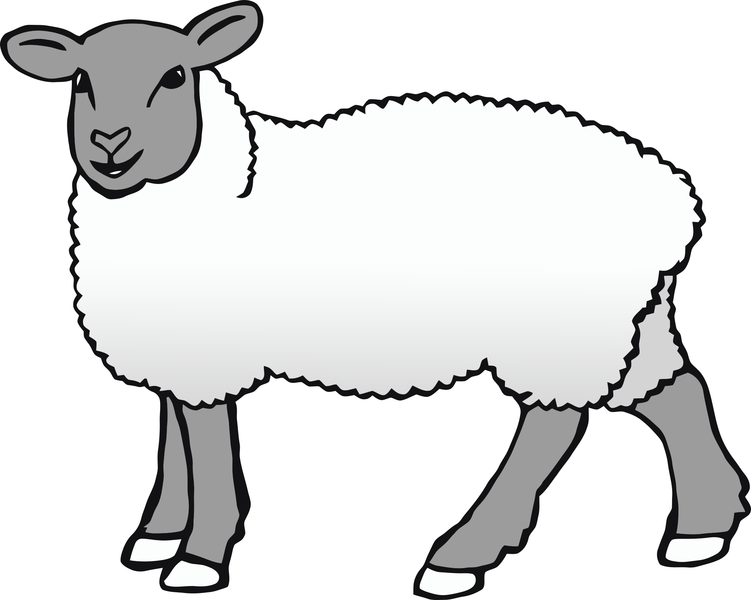

Duck

Goose

Sheep

* Eats insects, weeds, grass.
* Baby is called a chick.
* Eggs and meat are used.

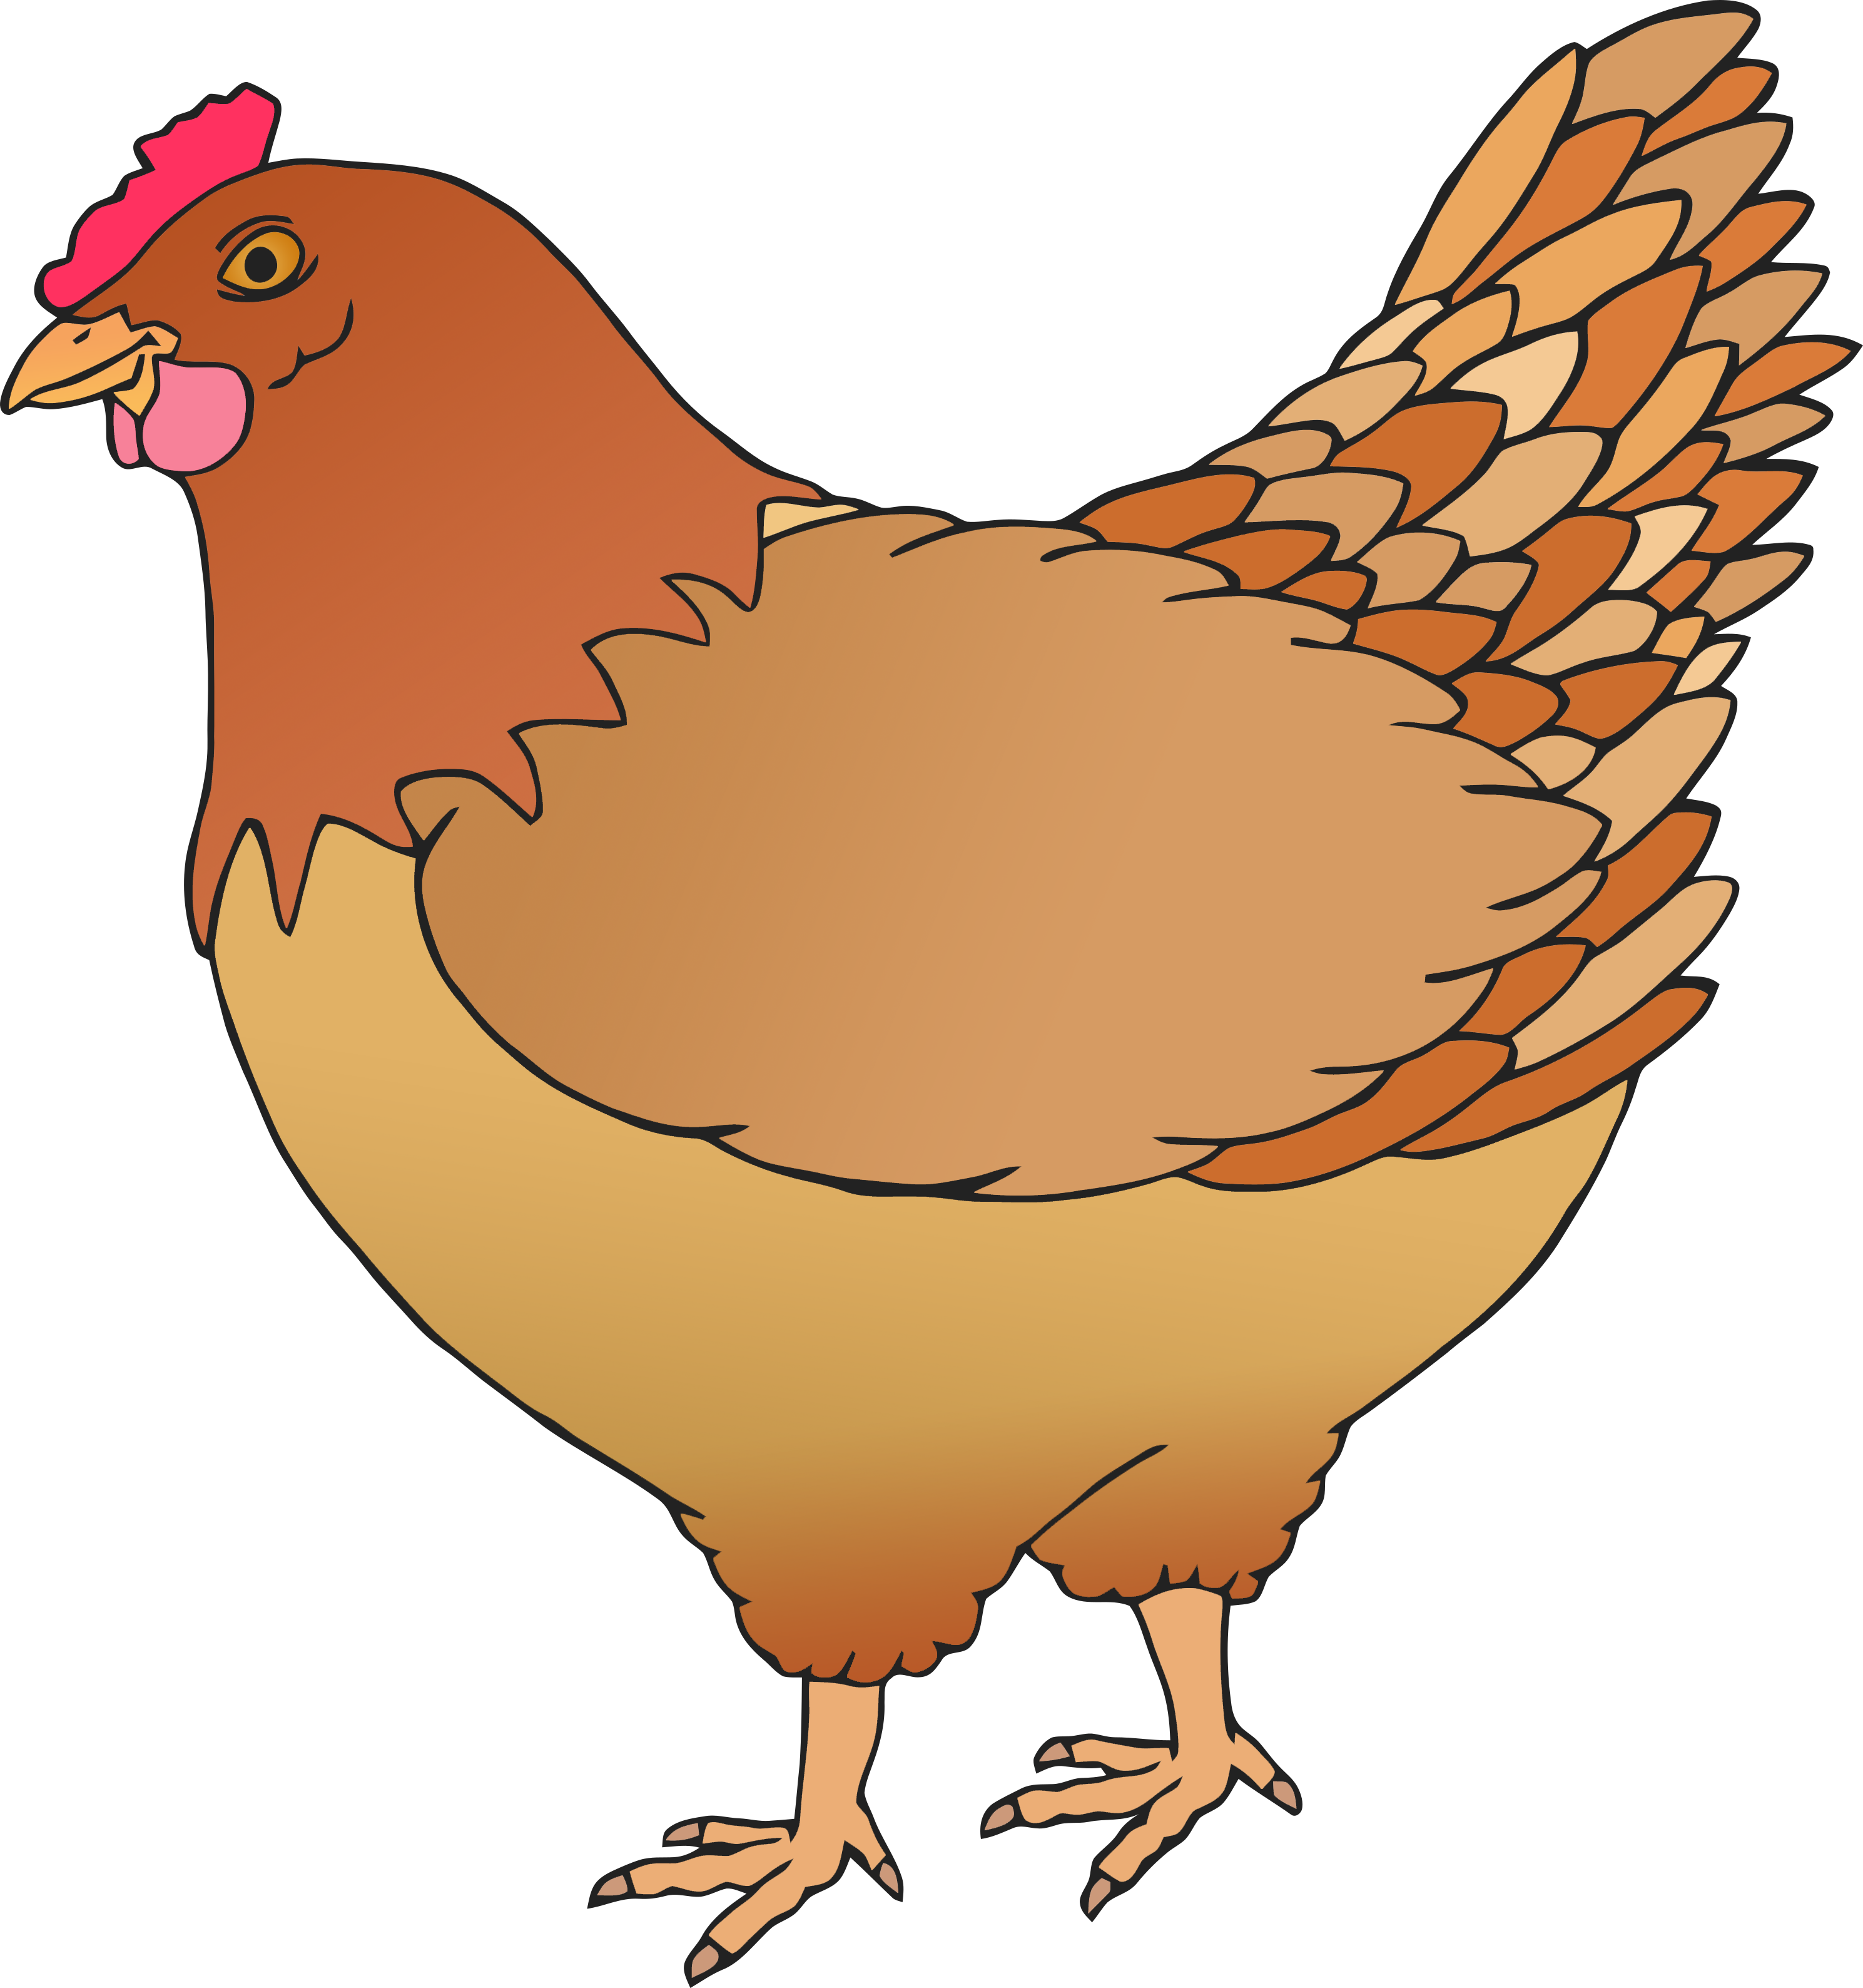

Chicken