**Farm Animals Count & Lift**

(Main sheets can be laminated first if desired. Then the flap covers to be cut and stuck on the main sheets prior to use by the children).

These sheets serve as a counting game in which the children can check their own answers. The game consolidates 1:1 correspondence, number recognition and matching farm animals with their young.

© 2021 Little Owls Resources

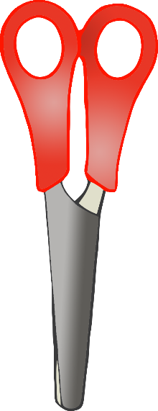

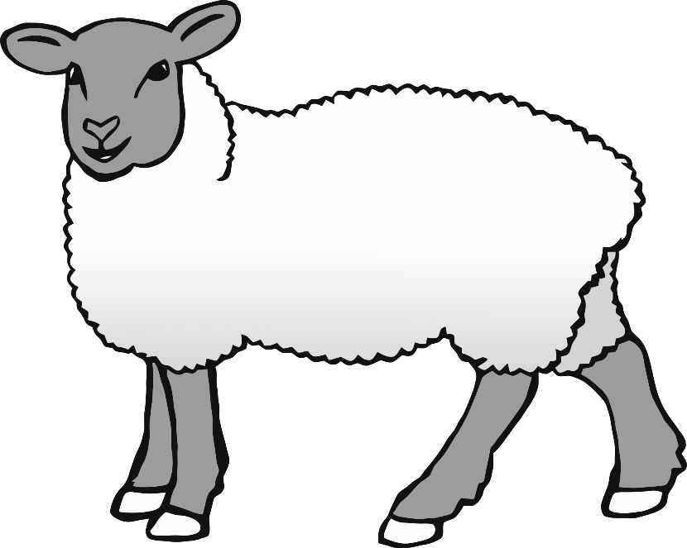

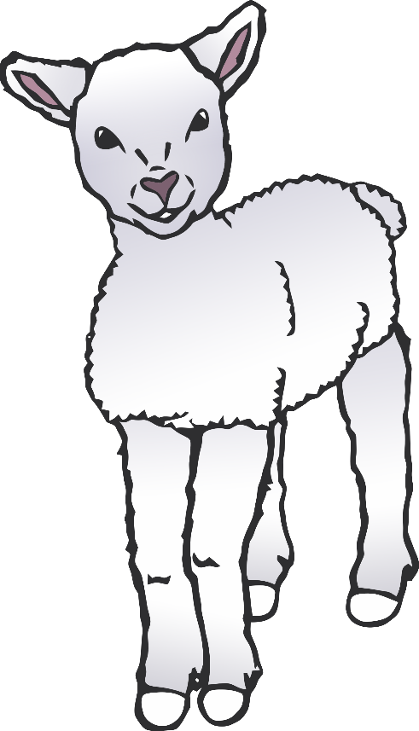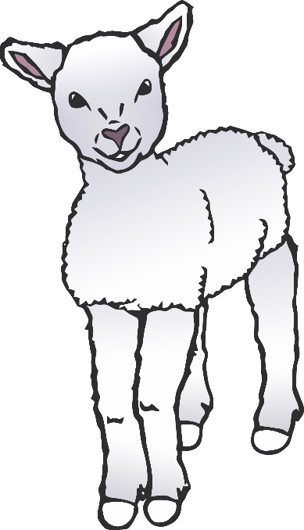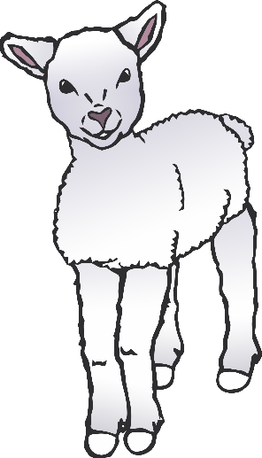

**How many babies do I have?**

© 2021 Little Owls Resources

3

Stick end of cover here.

Lift here to see if

you are right!

© 2021 Little Owls Resources

4

Stick end of cover here.

Lift here to see if

you are right!

**How many babies do I have?**

**How many babies do I have?**

© 2021 Little Owls Resources

5

Stick end of cover here.

Lift here to see if

you are right!

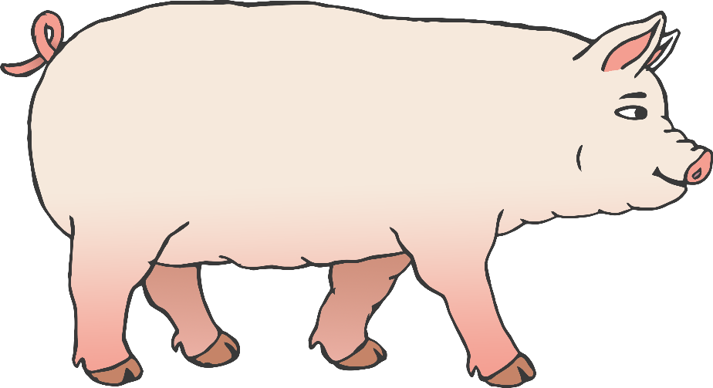

**How many babies do I have?**

© 2021 Little Owls Resources

6

Stick end of cover here.

Lift here to see if

you are right!

**How many babies do I have?**

© 2021 Little Owls Resources

7

Stick end of cover here.

Lift here to see if

you are right!

**How many babies do I have?**

© 2021 Little Owls Resources

8

Stick end of cover here.

Lift here to see if

you are right!