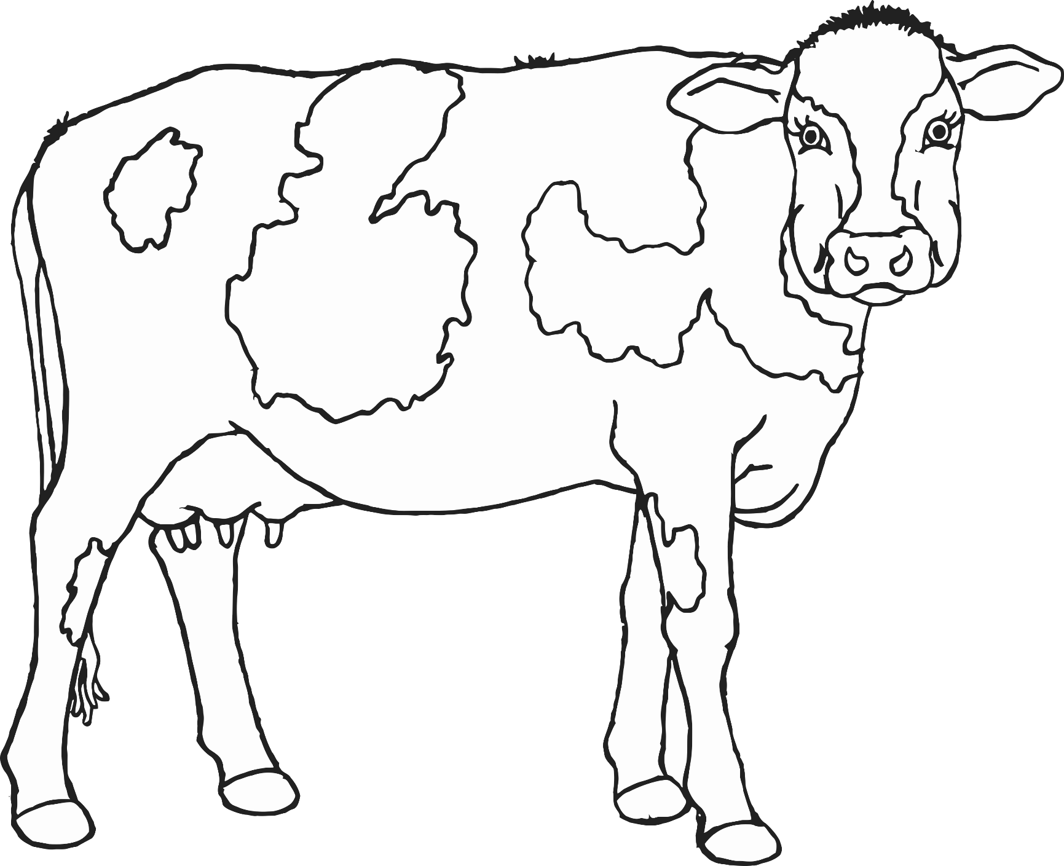

© 2020 Little Owls Resources

cow

© 2020 Little Owls Resources

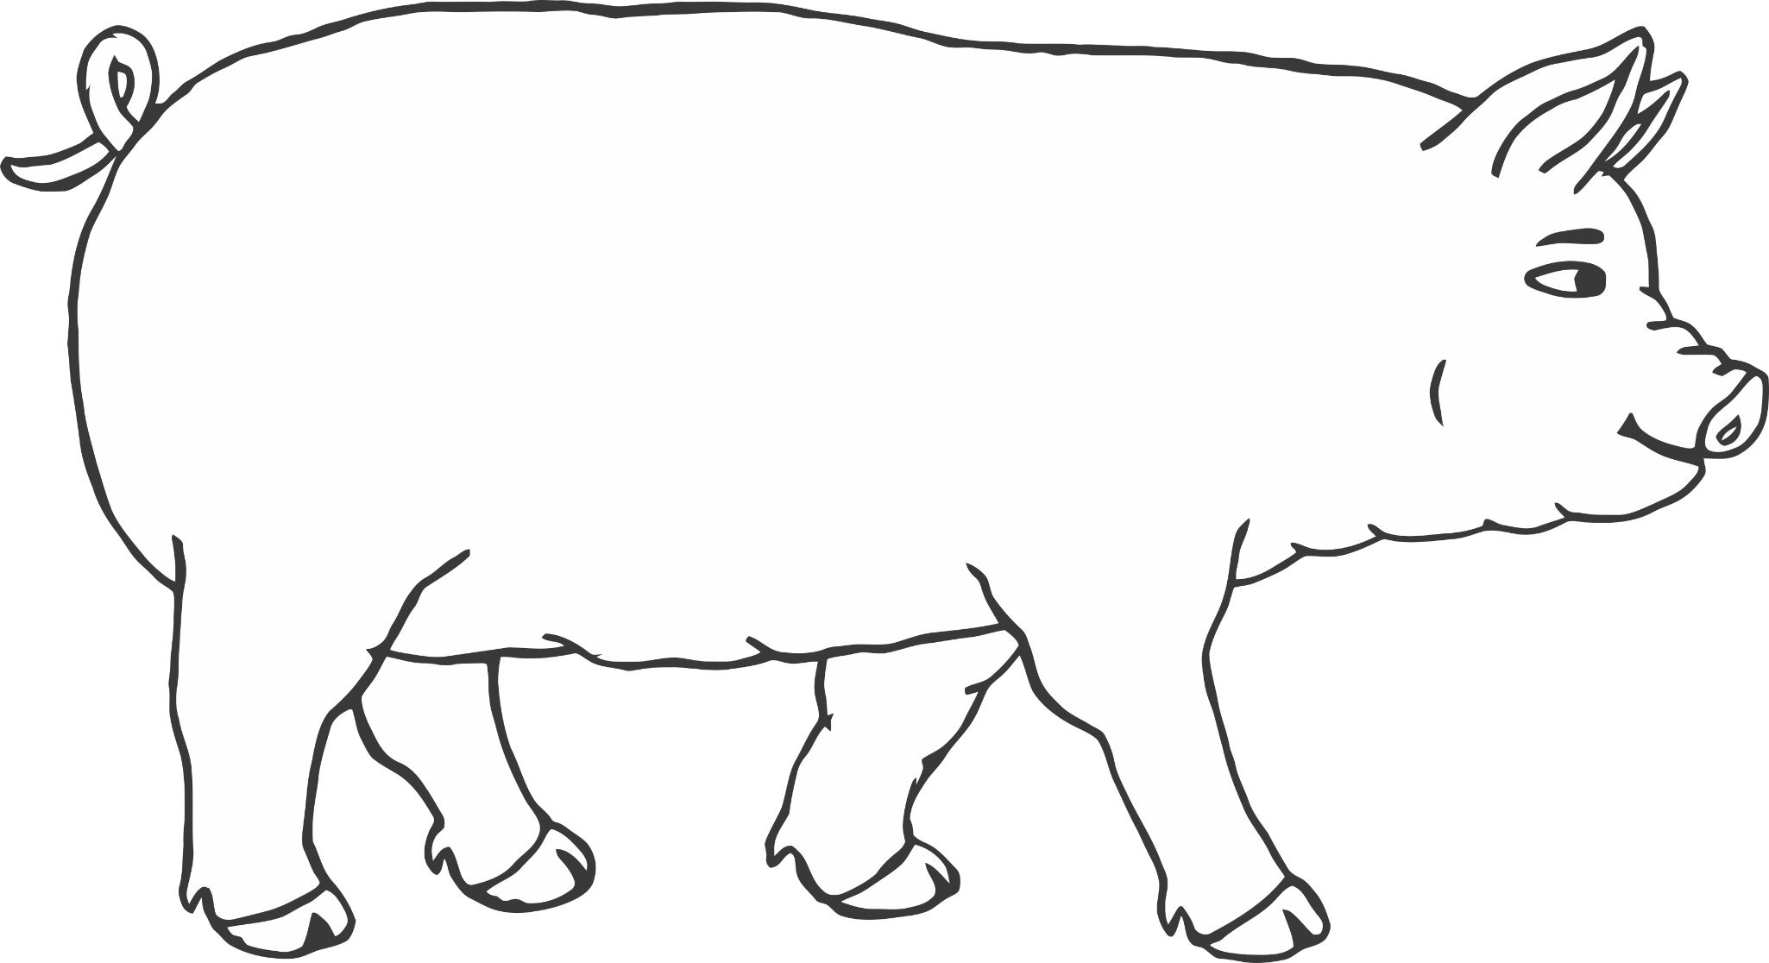

pig

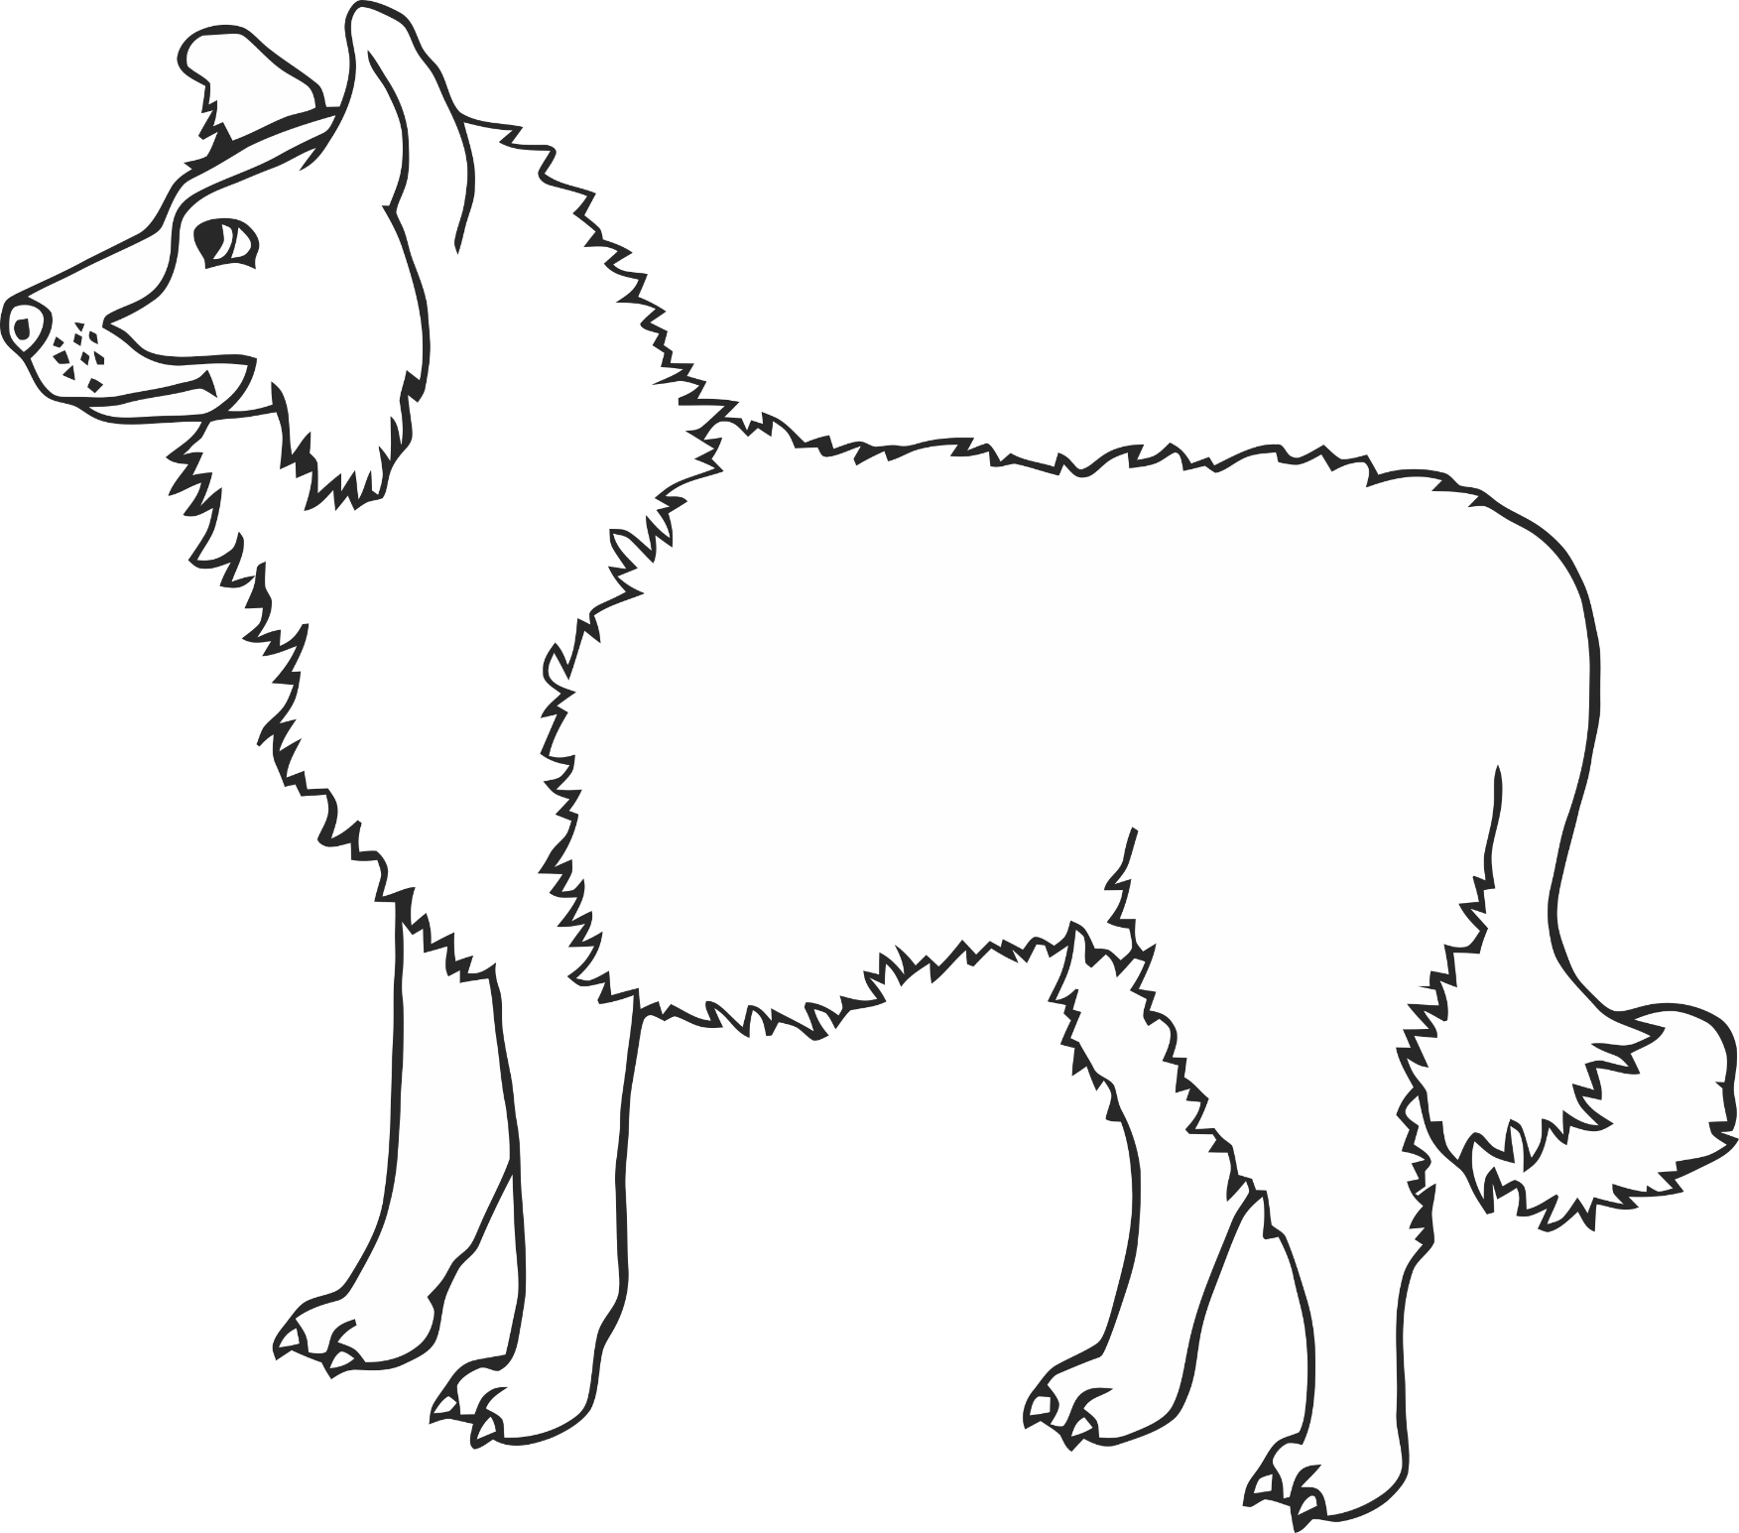

dog

© 2020 Little Owls Resources

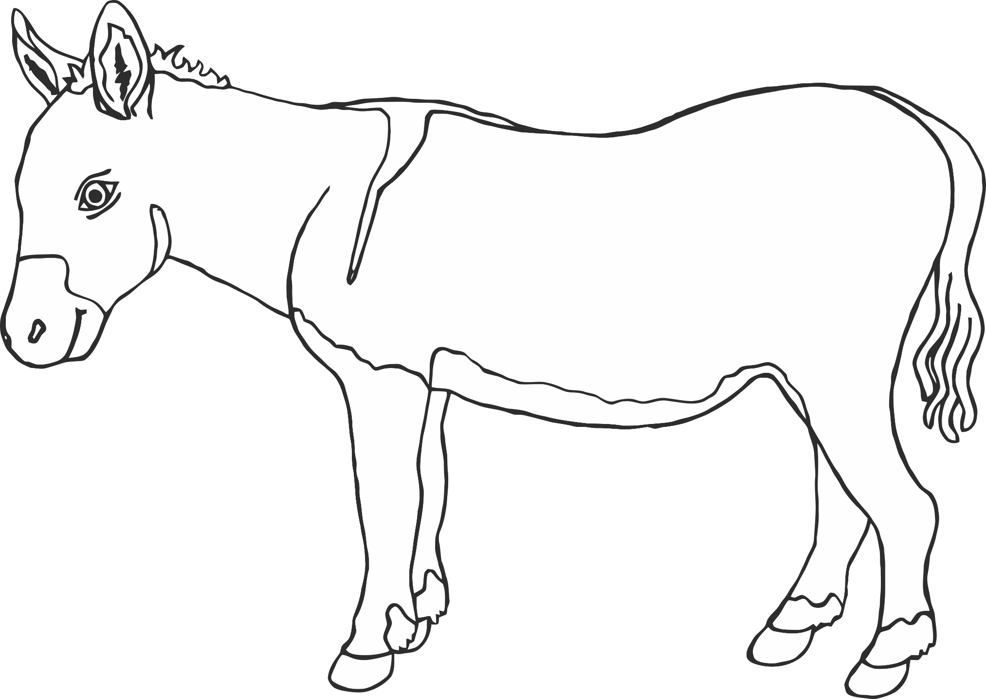

donkey

© 2020 Little Owls Resources

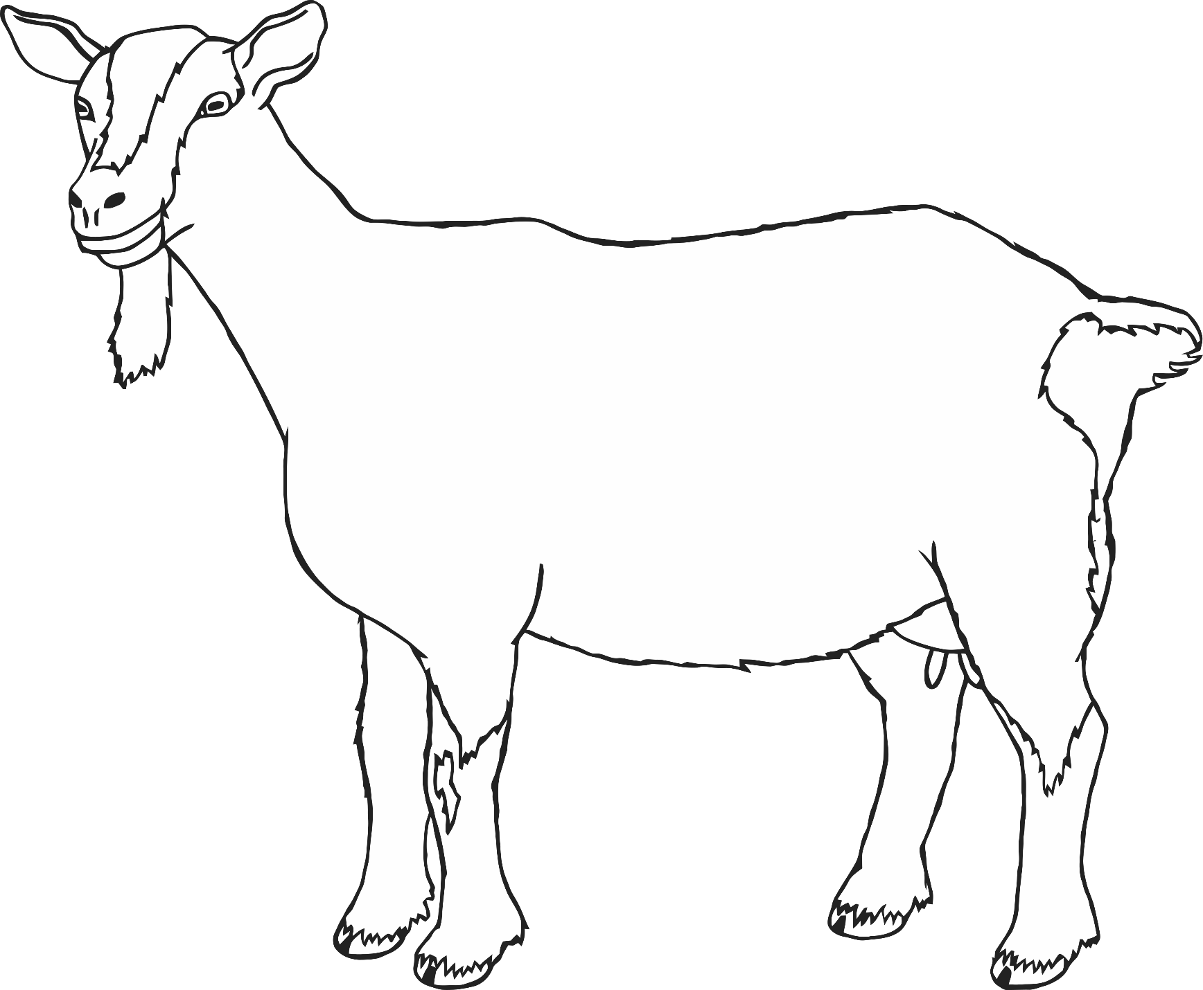

goat

© 2020 Little Owls Resources

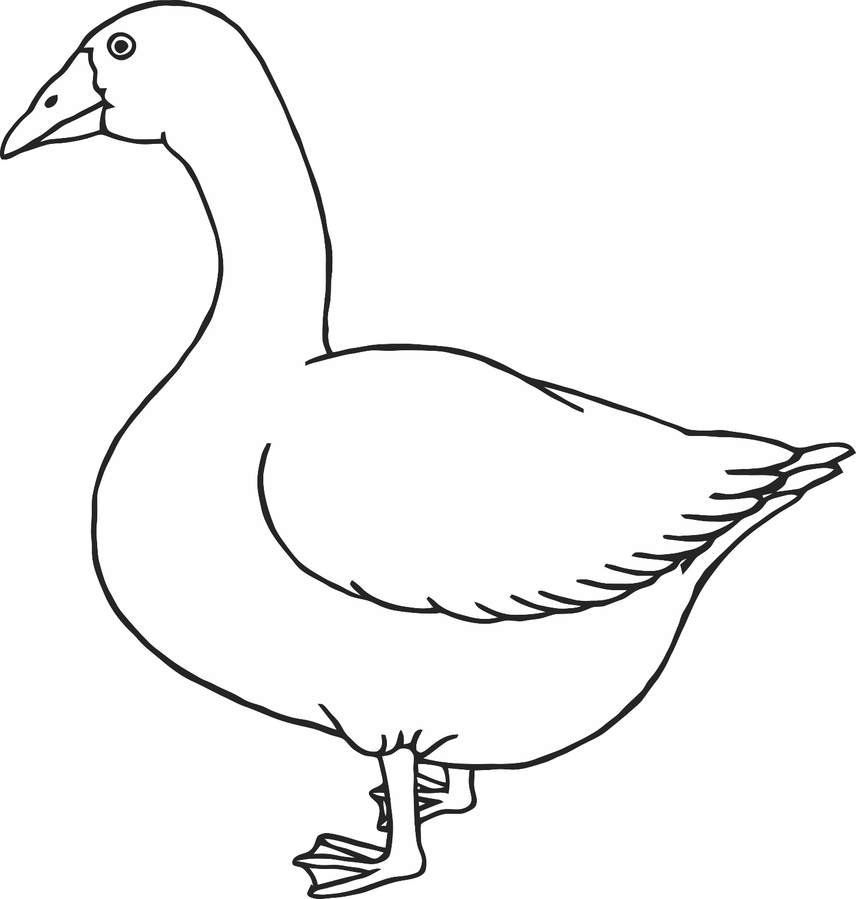

goose

© 2020 Little Owls Resources

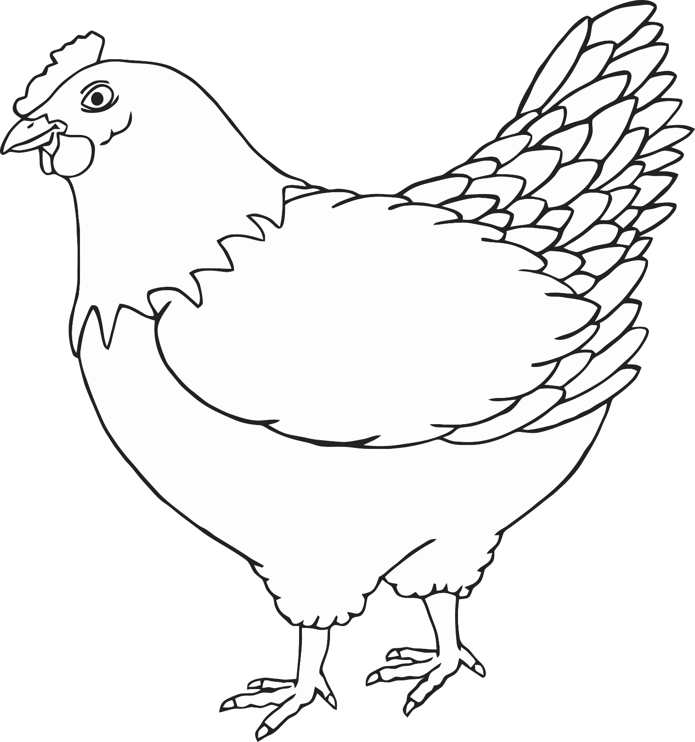

chicken

© 2020 Little Owls Resources

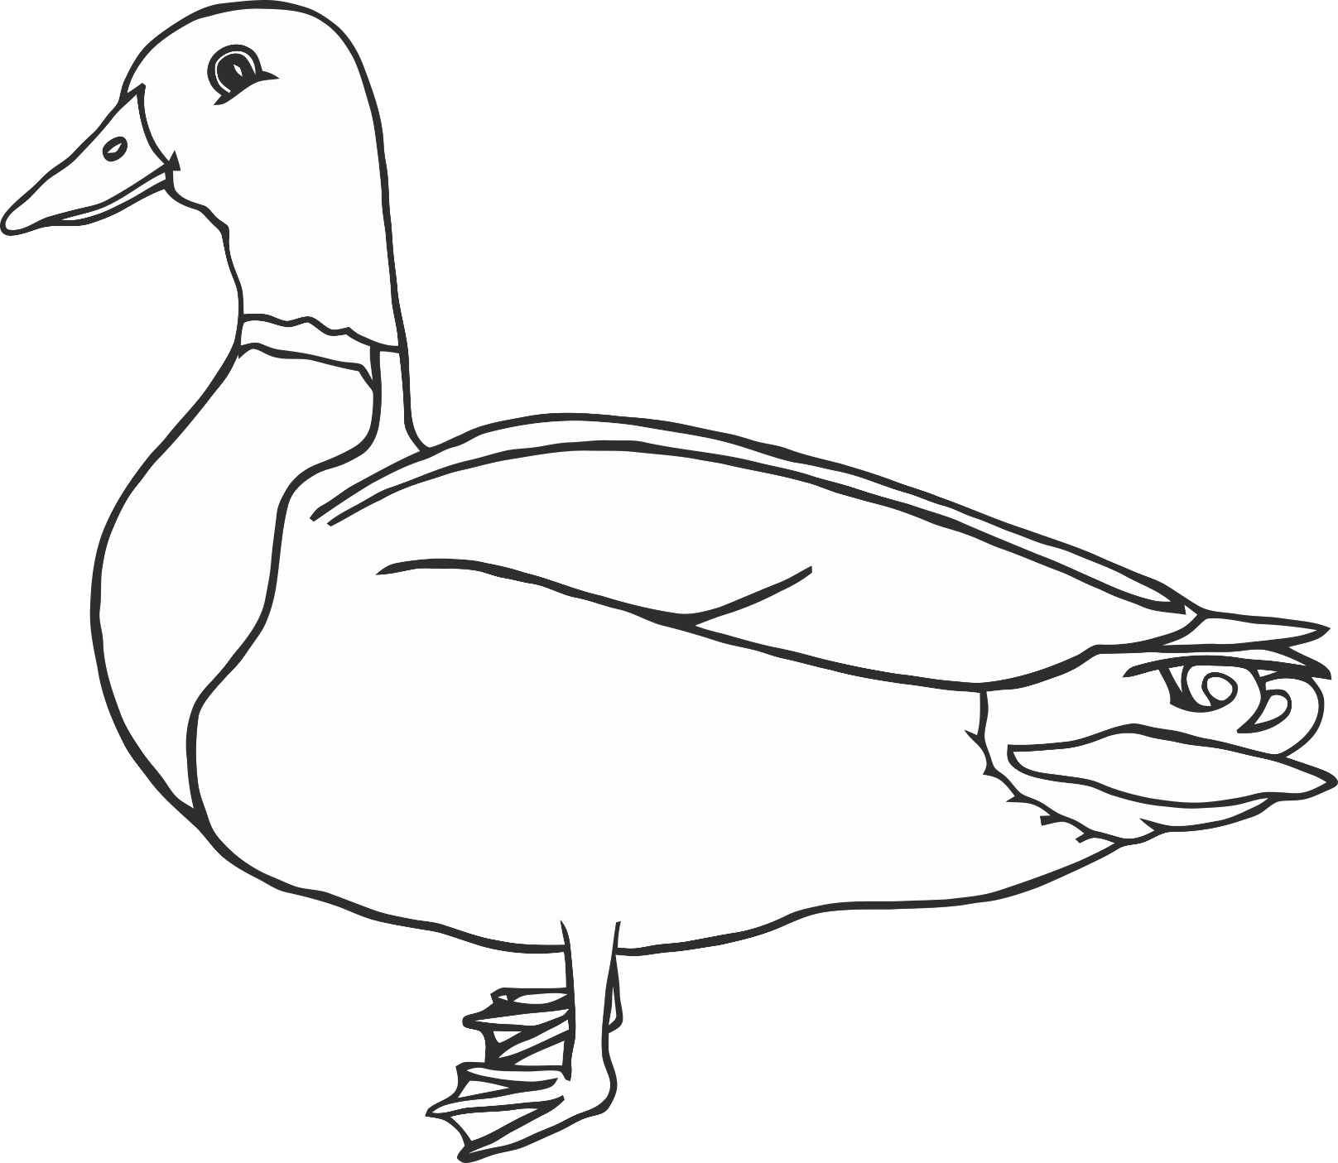

duck

© 2020 Little Owls Resources

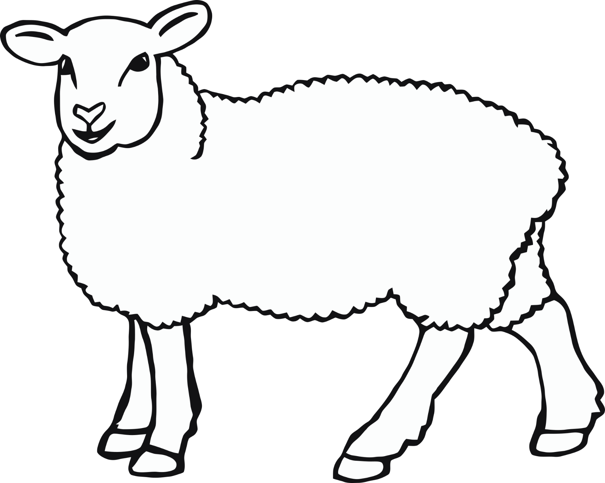

sheep

© 2020 Little Owls Resources

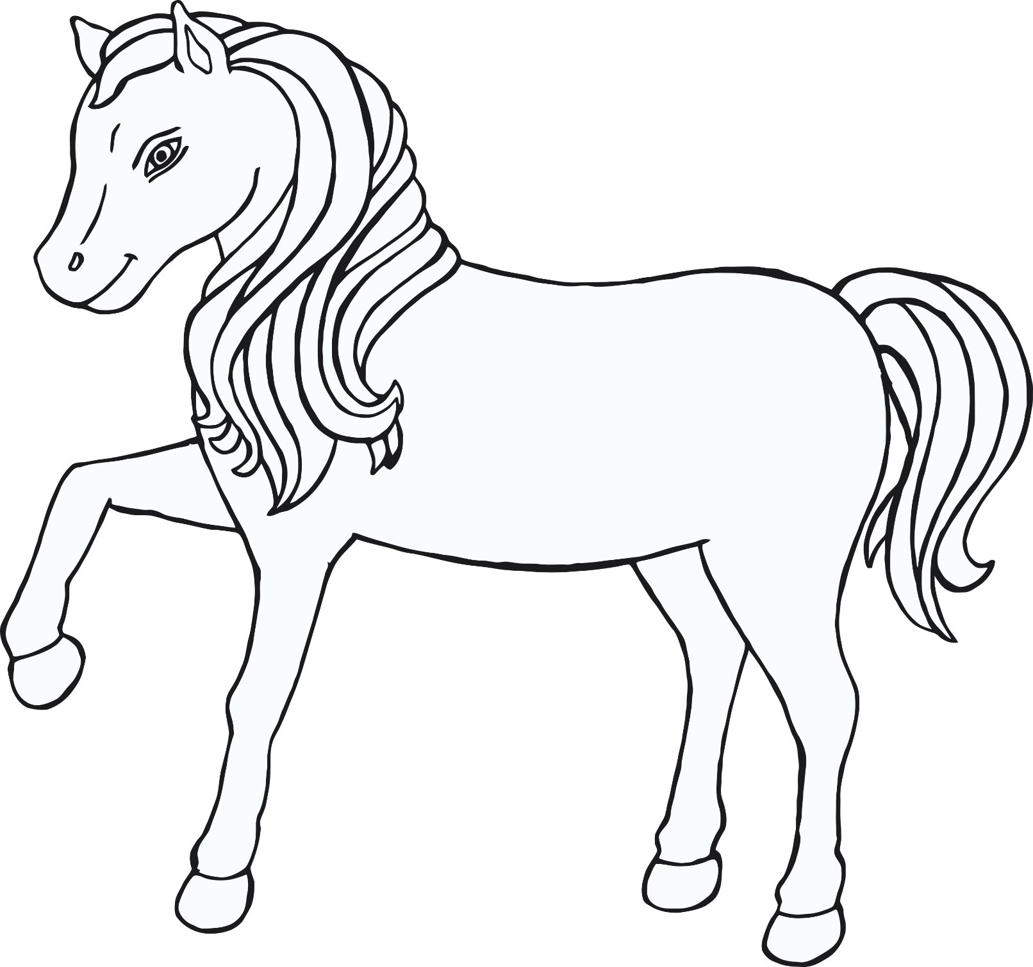

© 2020 Little Owls Resources

horse

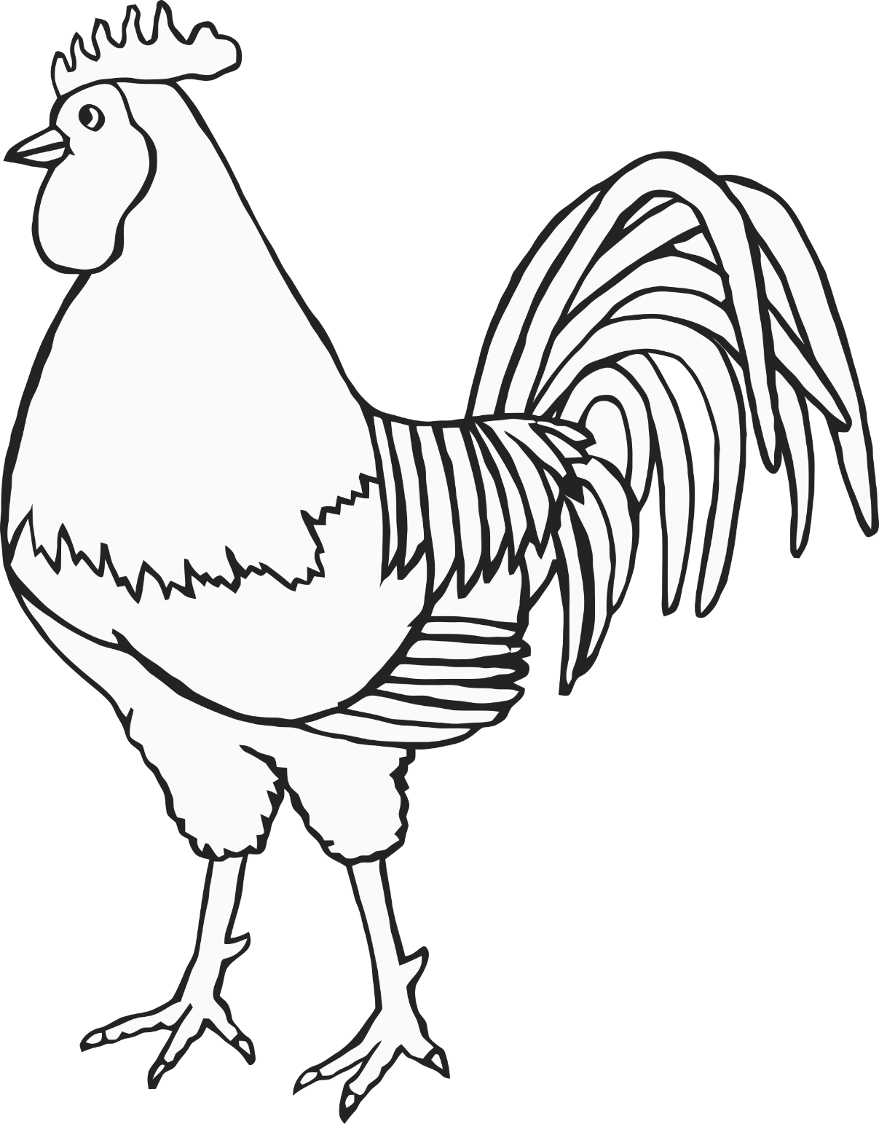

© 2020 Little Owls Resources

cockerel