1

Gather some water carefully with your hands.

© 2021 Little Owls Resources

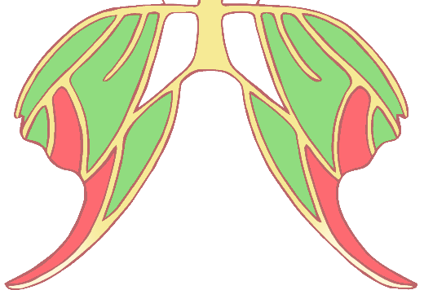

**Fairies Activity**

**Challenge!**

WATER FAIRY

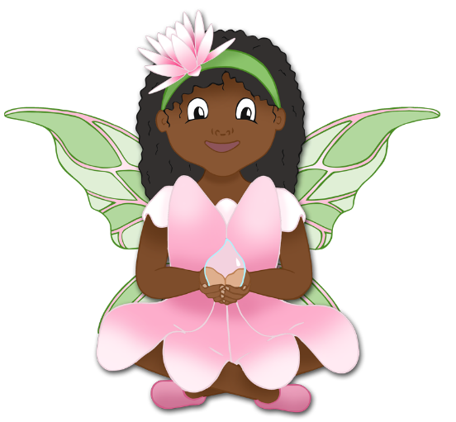

2

Dig into the ground.

**Dig! Dig! Dig!**

© 2021 Little Owls Resources



**Fairies Activity**

**Challenge!**

EARTH FAIRY

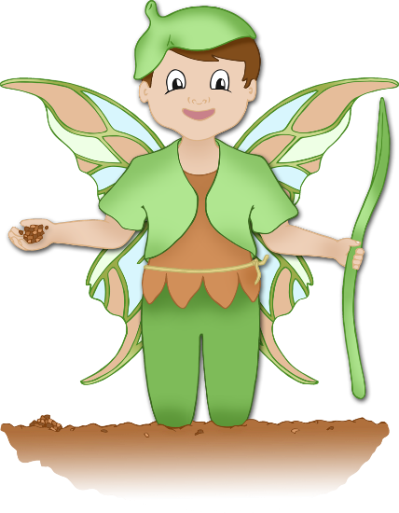

3

Crawl like a minibeast.

**Crawl! Crawl!**

© 2021 Little Owls Resources



**Fairies Activity**

**Challenge!**

MINIBEAST FAIRY

4

Reach up and pick fruit.

**Pick! Pick!**

© 2021 Little Owls Resources



**Fairies Activity**

**Challenge!**

FRUIT FAIRY

5

Plant the seeds! Plant the seeds!

© 2021 Little Owls Resources



**Fairies Activity**

**Challenge!**

FLOWER FAIRY

6

Climb to the top of the tree!

**Climb! Climb!**

© 2021 Little Owls Resources



**Fairies Activity**

**Challenge!**

TREE FAIRY