English/Welsh

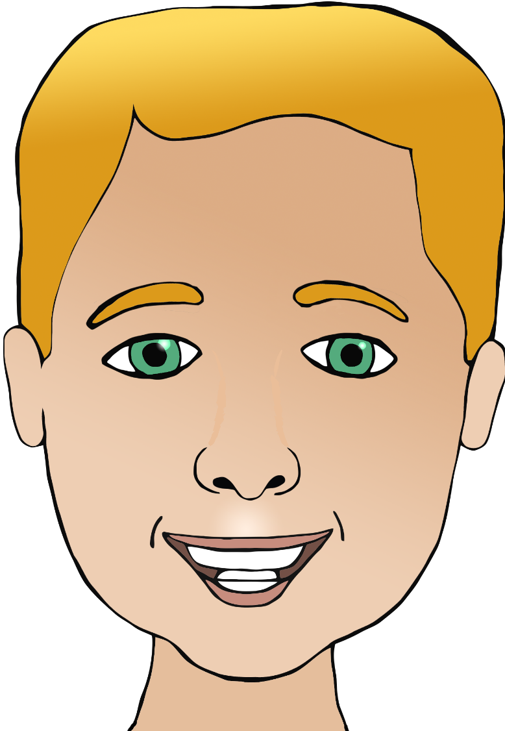

**Parts of the face**

trwyn

(tr-oyn)

pen

(pen)

clust

(klist)

mouth

head

eye/eyes

nose

hair

✱ The sound ‘cch’ has no common English equivalent. It is made in the back of the throat as in the Scots word lo**ch**.

ceg

(kayg)

ear

llygad/llygaid

(lcch-gad/

lcch-g-eye-d)

gwallt

(gw-arccht)

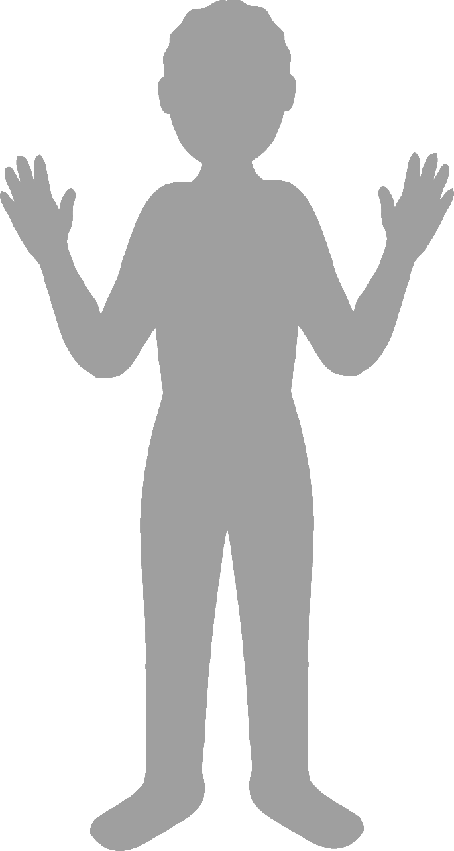

**Body parts**

English/Welsh

face

finger

leg

foot

elbow

troed

(tr-oy-d)

penelin

(pen-eh-lin)

llaw

(lcch-ou)

hand

coes

(coyss)

bys

(bee-ss)

wyneb

(wee-neb)