English/Spanish

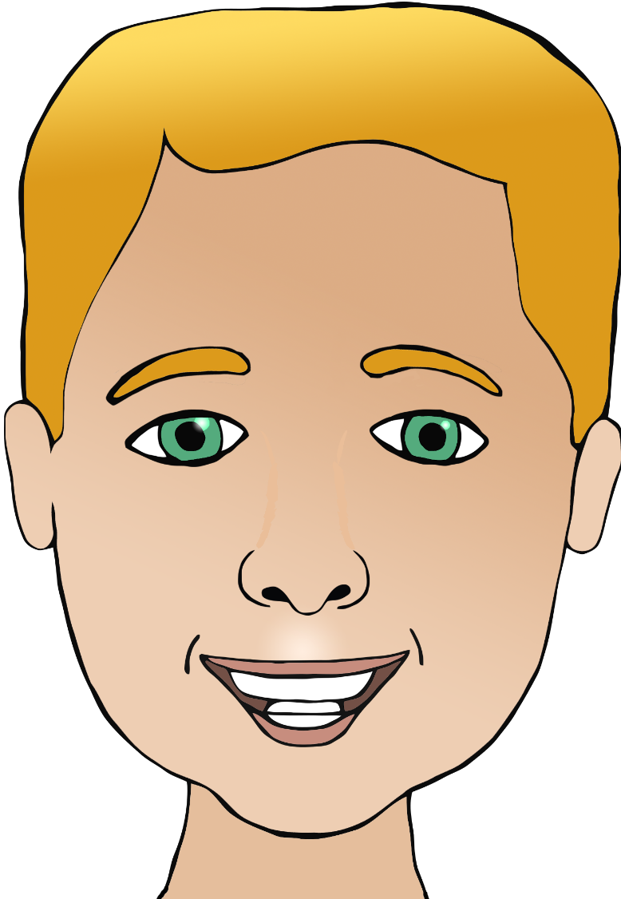

**Parts of the face**

nariz

(nar-ees)

cabeza

(ca-bay-sa)

boca

(bor-ka)

ear/ears

mouth

head

eye/eyes

nose

pelo

(pair-loh)

ojo/ojos

(or-ho/or-hoss)

hair

oreja/orejas

(or-ay-ha/

or-ay-hass)

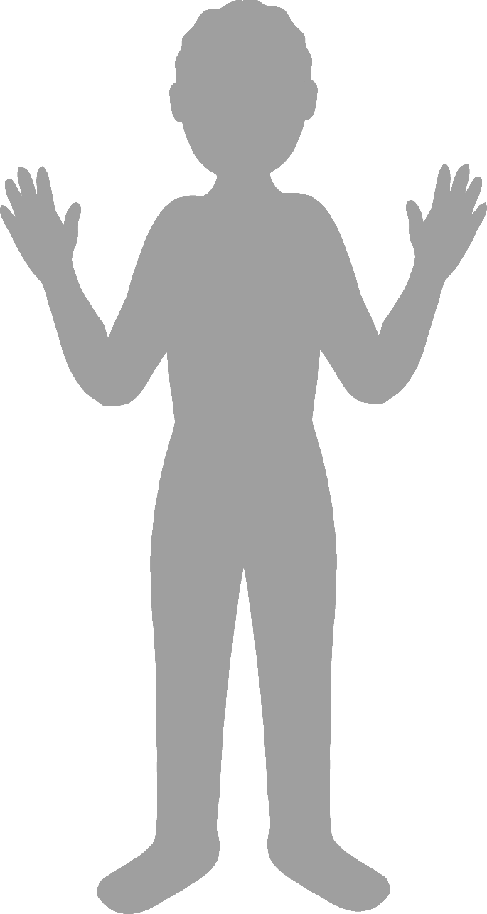

**Body parts**

English/Spanish

face

finger

leg

foot

elbow

pie

(pee-ay)

codo

(cor-thow)

mano

(mar-noh)

hand

pierna

(pee-air-na)

cara

(ca-ra)

dedo de la mano

(daydo-day-la-man-oh)