English/Portuguese

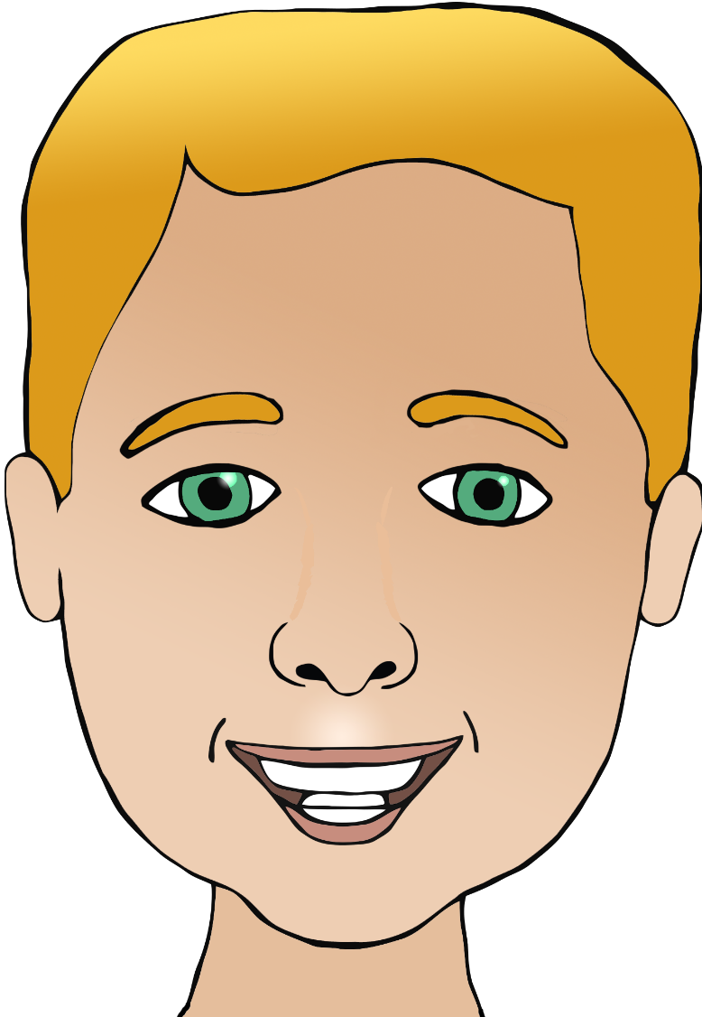

**Parts of the face**

nariz

(na-riss)

cabeça

(cab-eh-sa)

boca

(bow-ka)

orelha

(o-rel-ya)

ear/ears

mouth

head

eye/eyes

nose

cabelo

(ca-bair-low)

olho/olhos

(o-lyo/o-los)

hair

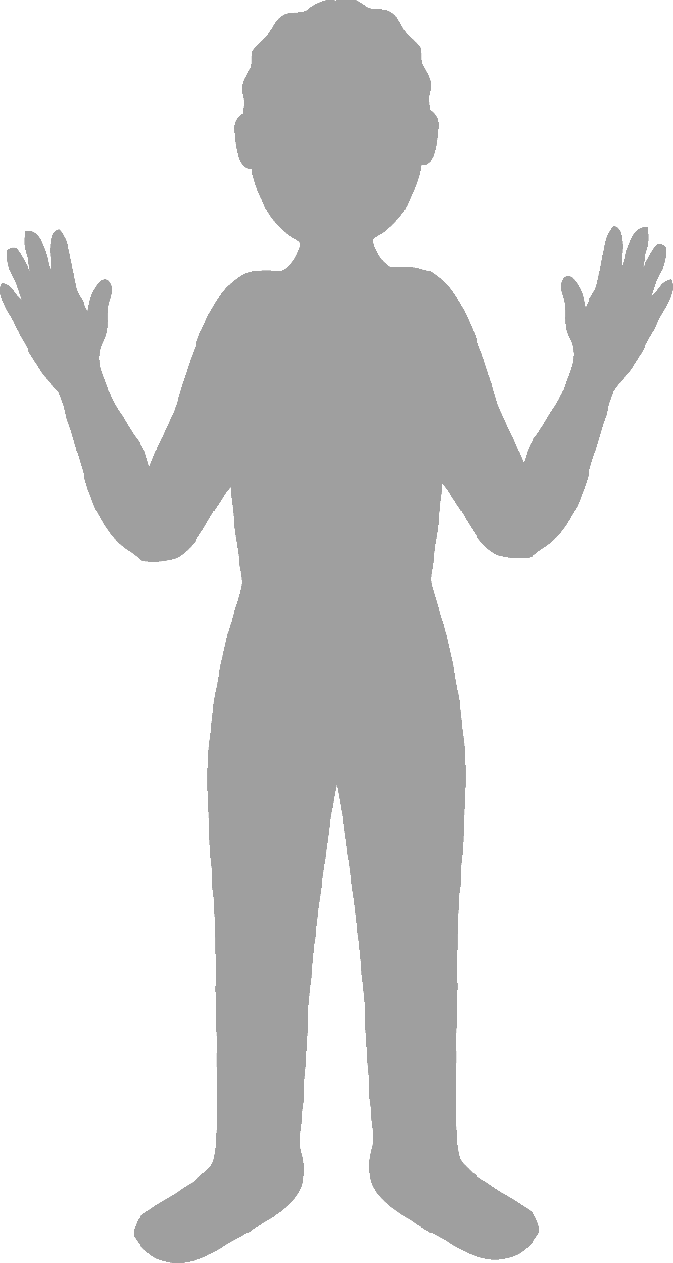

**Body parts**

English/Portuguese

face

finger

leg

foot

elbow

pé

(peh)

cotovelo

(coh-toh-veh-loh)

mão

(m-ou)

hand

perna

(p-air-na)

dedo

(de-doh)

rosto

(hoss-toh)