English/Polish

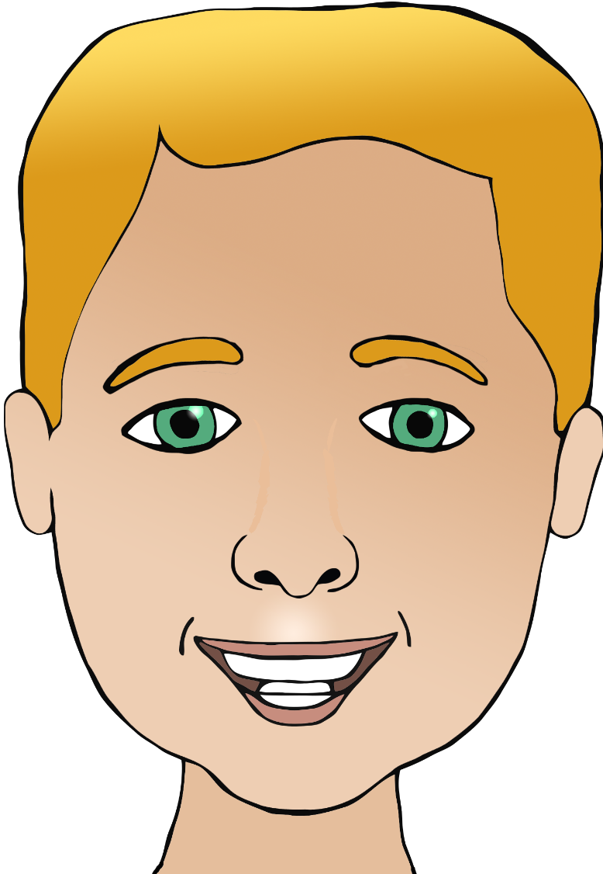

**Parts of the face**

nos

(noss)

usta

(oo-stuh)

ucho/uszy

(oo-koh/oo-shuh)

ear/ears

mouth

head

eye/eyes

nose

włosy

(vwor-seh)

oko/oczy

(o-k-o/o-chay)

hair

głowa

(g-woh-va)

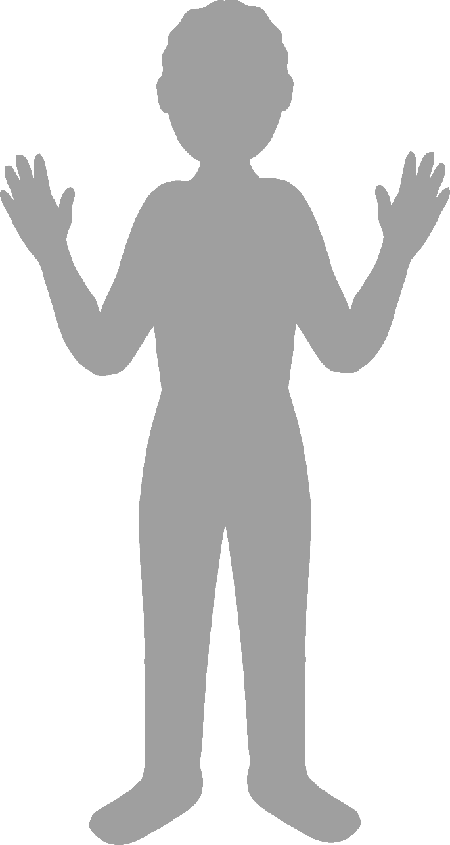

**Body parts**

English/Polish

face

finger

leg

foot

elbow

stopa

(stop-uh)

łokieć

(wo-ketch)

ręka

(renka)

hand

noga

(no-gar)

palec

(palets)

twarz

(t-varsh)