English/Malay

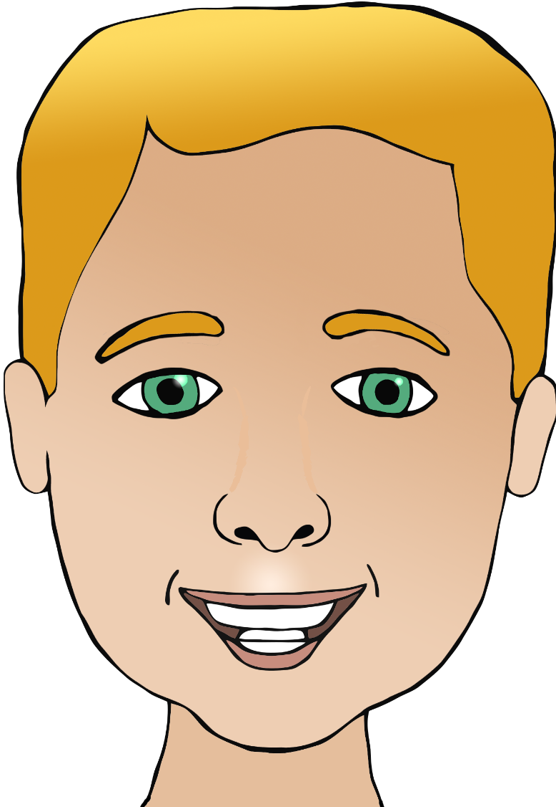

**Parts of the face**

kepala

(kuh-pa-lah)

mulut

(moo-loot)

telinga

(teh-ling-a)

mouth

head

nose

rambut

(ram-boot)

mata

(mutta)

hair

hidung

(hee-doong)

eye

ear

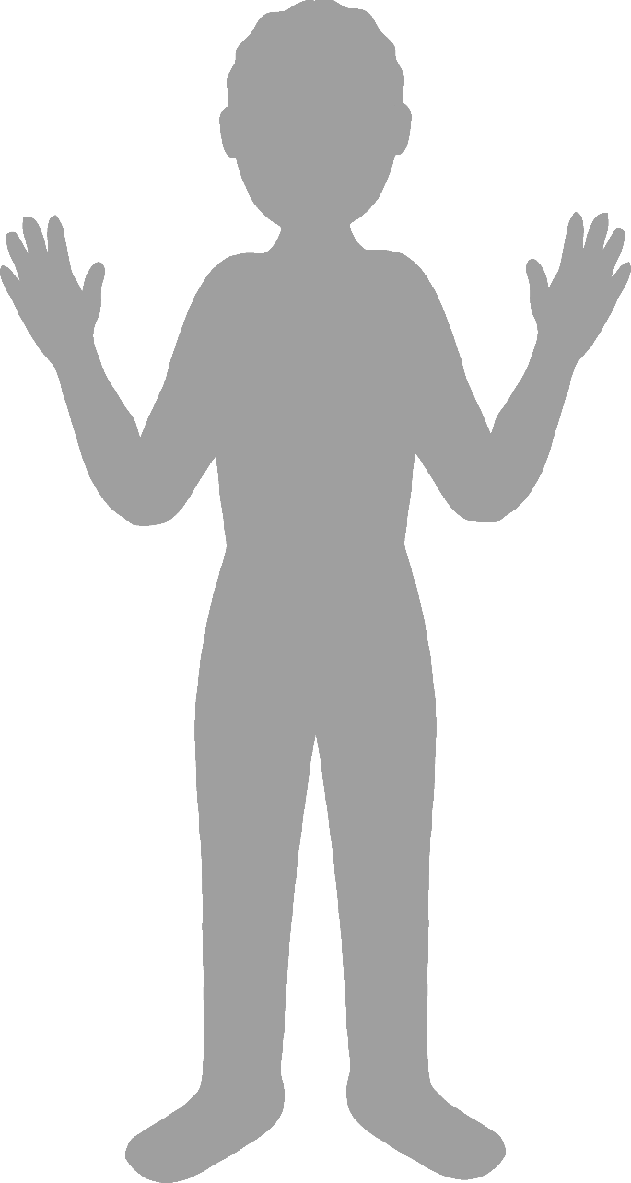

**Body parts**

English/Malay

face

finger

leg

foot

elbow

siku

(see-koo)

hand

muka

(moo-ka)

tangan

(tung-un)

jari

(jar-ee)

kaki *

(kar-key)

kaki *

(kar-key)

*In Malay the words for leg and foot are the same.