English/Japanese

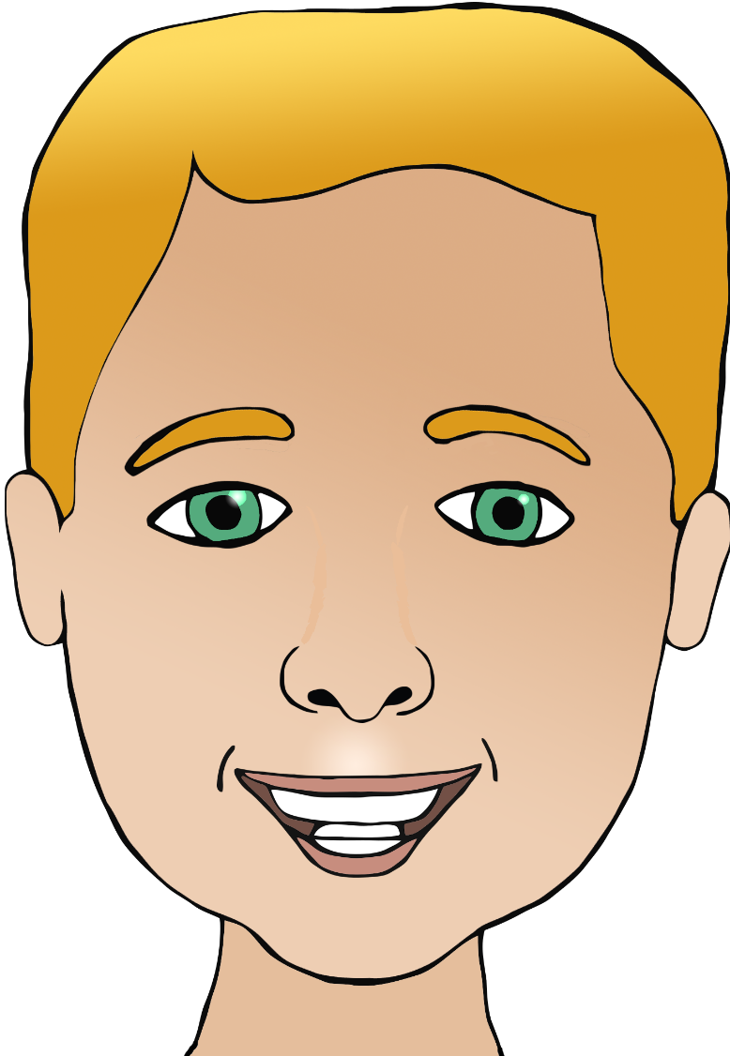

**Parts of the face**

mouth

head

nose

hair

くち

(koochi)

はな

(ha-nah)

みみ

(mee-mee)

め

(meh)

あたま

(at-a-mah)

かみ

(kam-ee)

ear

eye

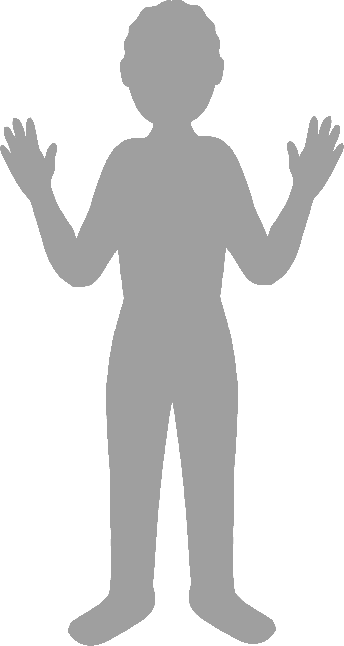

**Body parts**

English/Japanese

face

finger

leg

foot

elbow

hand

あし

(ash-ee)

ひじ

(hee-jee)

て

(teh)

あし

(ash-ee)

ゆび

(yoo-bee)

かお

(k-ou)

★ The words for leg and foot are the same in Japanese (hiragana text).