English/Italian

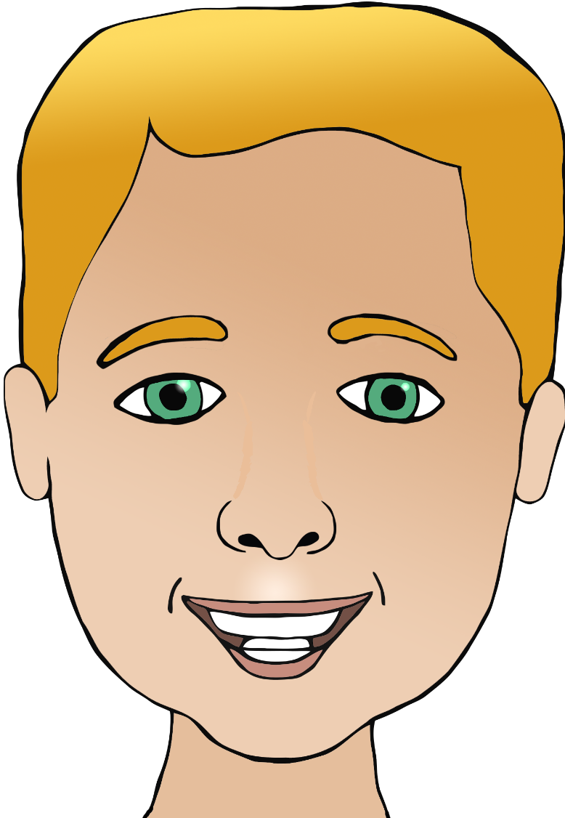

**Parts of the face**

nose

(nar-zoh)

capo

(car-po)

bocca

(bow-ka)

ear/ears

mouth

head

eye/eyes

nose

capelli

(ca-pell-ee)

occhio/occhi

(oh-kee-oh/oh-kee)

hair

orecchio/orecchie

(or-eck-ee-oh/

or-eck-ee)

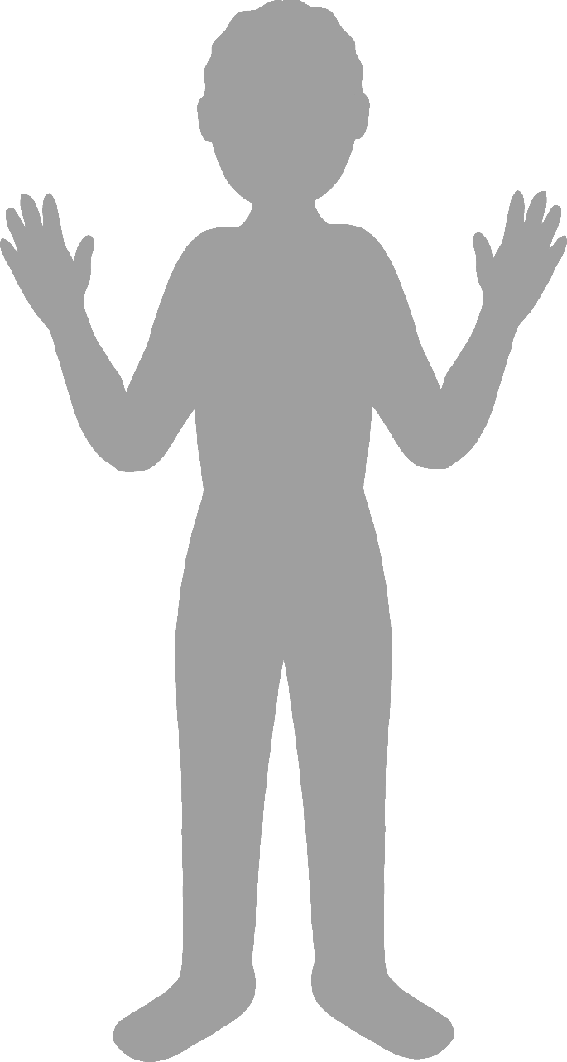

**Body parts**

English/Italian

face

finger

leg

foot

elbow

gomito

(gor-mee-toh)

mano

(mar-noh)

hand

dito

(dee-toh)

viso

(vee-zoh)

piede

(pee-air-day)

gamba

(gam-bah)