English/German

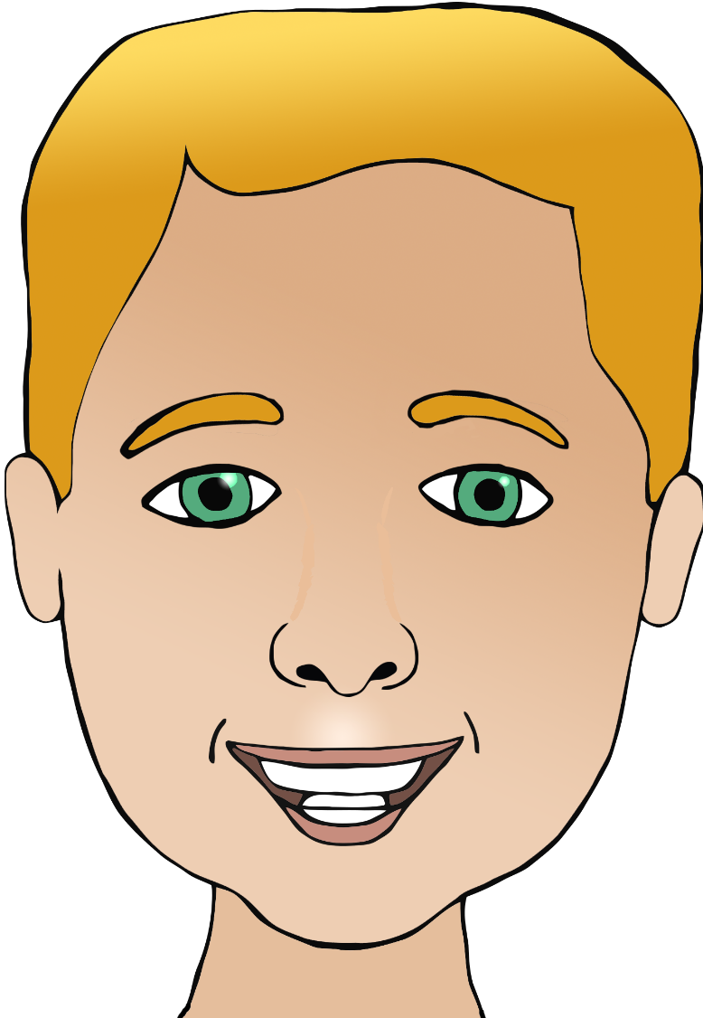

**Parts of the face**

Nase

(nar-zuh)

Mund

(moont)

a

Ohr/Ohren

(or/oren)

ear/ears

mouth

head

eye/eyes

nose

Haar

(har)

hair

Kopf

(kopf)

Auge/Augen

(ou-guh/ou-gun)

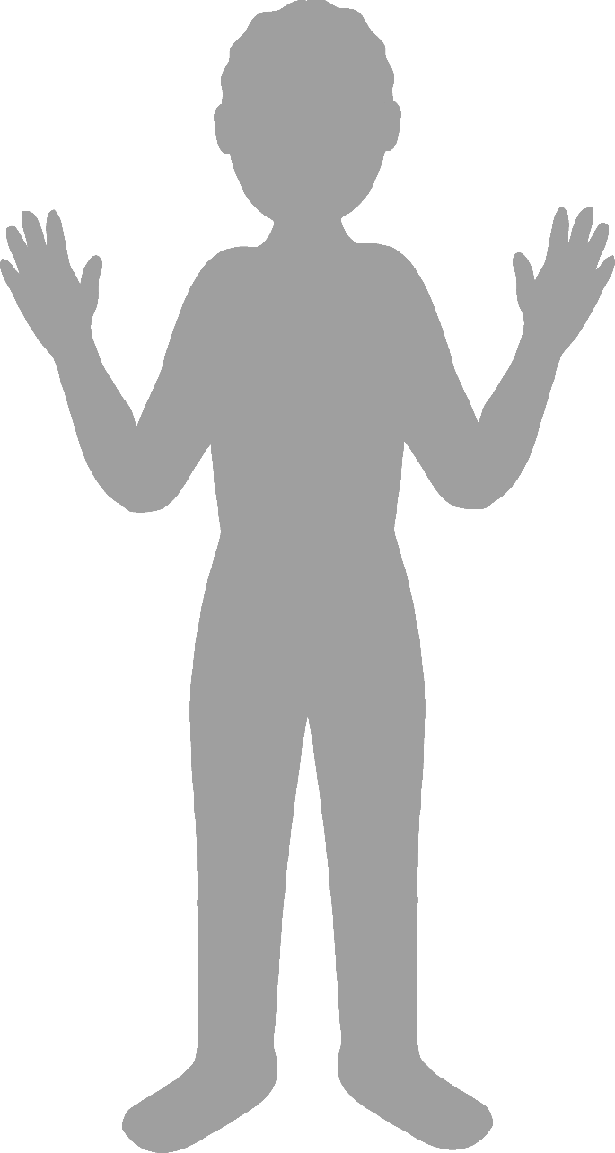

**Body parts**

English/German

face

finger

leg

foot

elbow

Fuß

(foos)

Hand

(hant)

hand

Bein

(b-eye-n)

Ellbogen

(elbow-gn)

Finger

(fing-uh)

Gesicht

(guh-zisht)