English/French

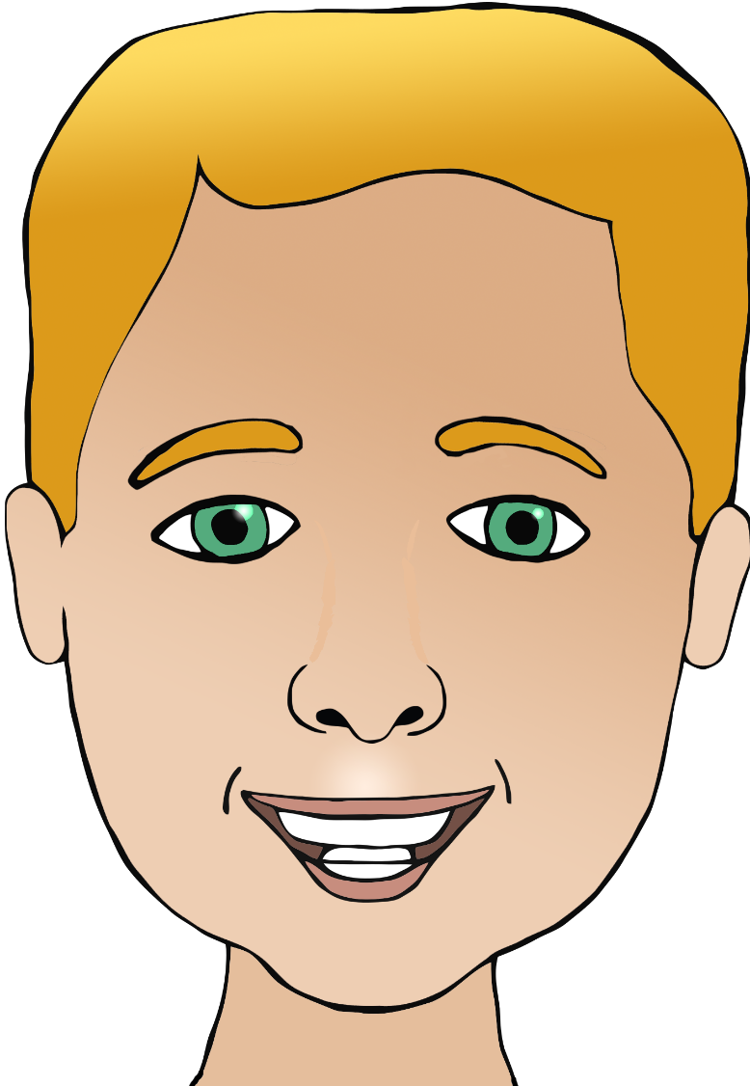

**Parts of the face**

nez

(nee)

tête

(tet)

bouche

(boosh)

orielle/orielles

(or-ay/or-ay)

ear/ears

mouth

head

eye/eyes

nose

cheveux

(sher-vur)

(

hair

œil/yeux

(oy/yur)

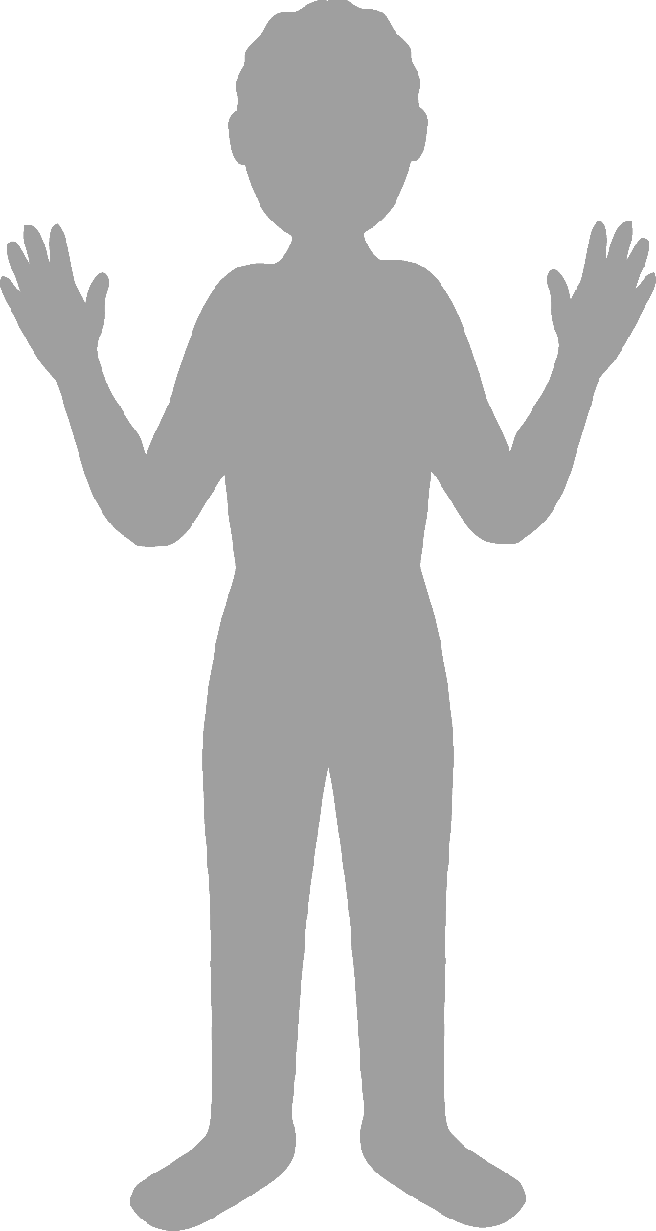

**Body parts**

English/French

face

finger

leg

foot

elbow

coude

(cood)

main

(muh)

hand

Pied

(pee-yay)

jambe

(jhom-b)

doigt

(dwuh)

visage

(vee-zarj)