English/Chinese (Mandarin)

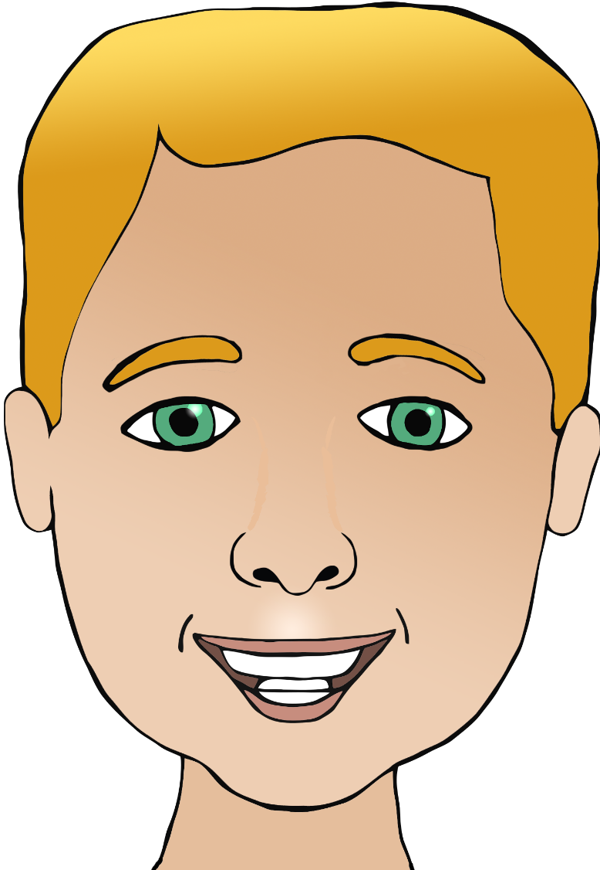

**Parts of the face**

mouth

head

nose

hair

嘴巴​

(zway-ba)

耳 朵​

(err-doh)

头​​

(toh)

鼻子​

(beez)

眼 睛​

(y-air-n jing)

头 发​

(toh-fa)

eye

ear

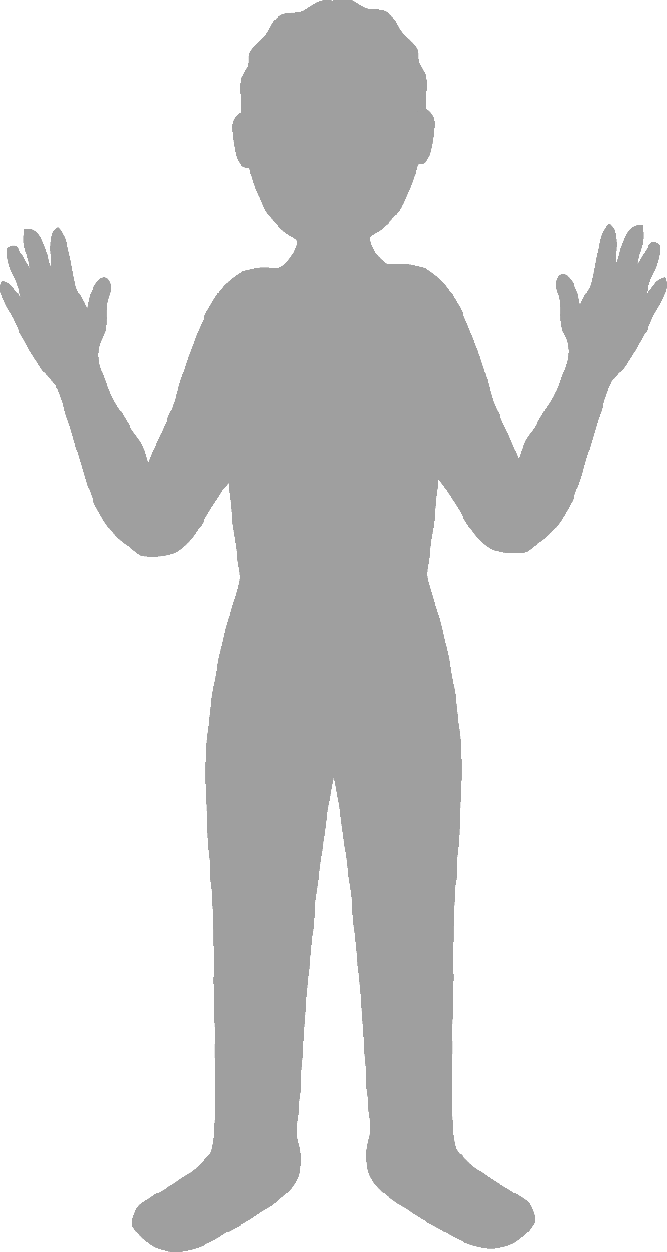

**Body parts**

English/Chinese (Mandarin)

face

finger

leg

foot

elbow

hand

脚

(j-ou-ju)

手肘

(show-jow)

手

(show)

腿

(tway)

手指

(show-ju)

面对

(m-yen-dway)