Exercises - A5 Cards

© 2021 Little Owls Resources

N.B. Fold along the line and laminate before use.

Exercises

Jogging

Run from one spot to another and then back.

© 2021 Little Owls Resources

© 2021 Little Owls Resources

Exercises

Star Jumps

Stand with arms at your sides. Then jump, spreading your arms and legs wide.

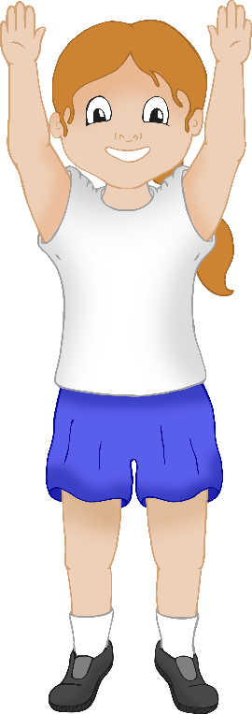

© 2021 Little Owls Resources

Exercises

Stretch up tall and then touch toes

Stretch up tall on your tiptoes and then bend down to touch your toes.

© 2021 Little Owls Resources

Exercises

Hopping

Stand on one leg and then hop!

© 2021 Little Owls Resources

Exercises

Balance on one leg

Stand on one leg. Then try to stay as still as you can for as long as you can!

.

Exercises

Push Up

On all fours bend your arms, then straighten them again.

© 2021 Little Owls Resources

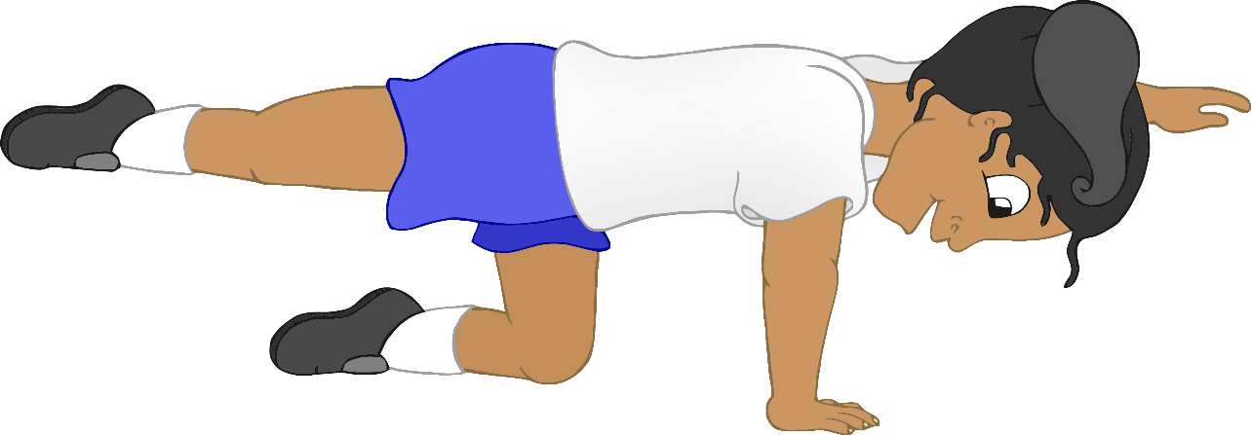

© 2021 Little Owls Resources

Exercises

Balancing Table Pose

On all fours reach one arm forwards and the opposite leg backwards. Hold that position.