Exercises

Jogging

© 2021 Little Owls Resources

Run from one spot to another and then back.

Exercises

Star Jumps

© 2021 Little Owls Resources

Stand with arms at your sides. Then jump, spreading your arms and legs wide.

Exercises

Stretch up tall and then touch toes

© 2021 Little Owls Resources

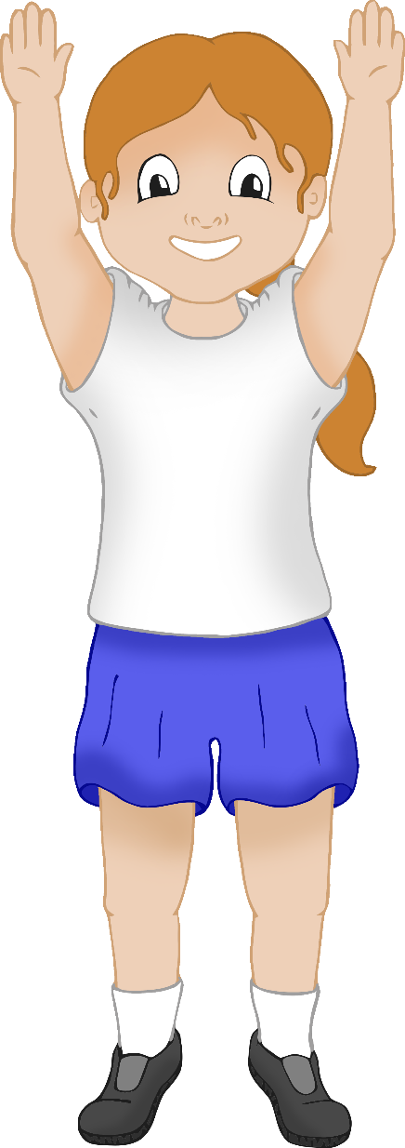

Stretch up tall on your tiptoes and then bend down to touch your toes.

Exercises

Hopping

© 2021 Little Owls Resources

Stand on one leg and then hop up and down!

Exercises

Balance on one leg

© 2021 Little Owls Resources

Stand on one leg. Then try to stay as still as you can for as long as you can!

Exercises

Push Up

© 2021 Little Owls Resources

On all fours bend your arms, then straighten them again.

Exercises

Balancing table pose

© 2021 Little Owls Resources

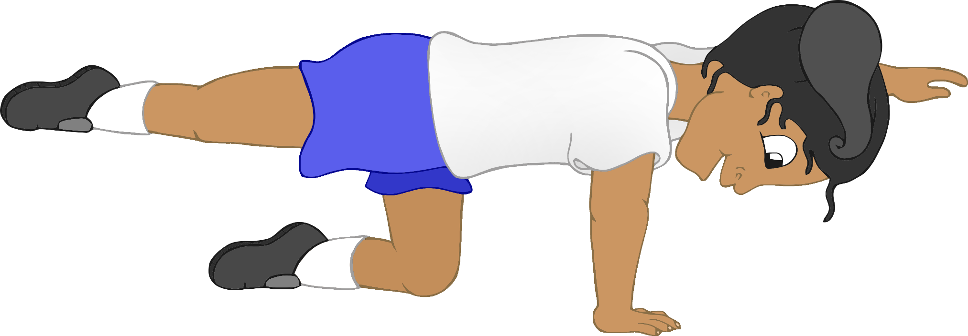

On all fours reach one arm forwards and the opposite leg backwards. Hold that position.